Safe work Australia

Occupational noise-induced
hearing loss in Australia

Overcoming barriers to effective noise control and hearing loss prevention

August 2010

Acknowledgements
This publication was funded by the Australian Government Department of Health and Ageing through the Hearing Loss Prevention Program.

Principal authors
Dr Perri Timmins and Mr Oliver Granger

Contributing authors
Dr Steve Cowley, Ms Susan Leggett, Ms Liz Walker, Dr Cassandra Govan, Dr Adeline Ong, Mr Rob Mercer, Ms Jacquie Norton, Mr Grant Hutchinson, and Ms Rachel Imms

Other contributors
Ms Pam Gunn, Mr Beno Groothoff, Dr Joe Crea, Dr Marion Burgess, Mr Phillip Chindamo, Dr Jenny Job, Mr Wayne Creaser, Dr Gaminda Ganewatta, Mr Richard Webster and Dr Peta Miller

Data gathering
Inside Story Knowledge Management Pty Ltd (focus group discussions), Sweeney Research Pty Ltd (quantitative surveys), Instinct and Reason (face-to-face interviews)

Disclaimer
The information provided in this document can only assist you in the most general way. This document does not replace any statutory requirements under any relevant State and Territory legislation. Safe Work Australia is not liable for any loss resulting from any action taken or reliance made by you on the information or material contained on this document. Before relying on the material, users should carefully make their own assessment as to its accuracy, currency, completeness and relevance for their purposes, and should obtain any appropriate professional advice relevant to their particular circumstances.
To the extent that the material on this document includes views or recommendations of third parties, such views or recommendations do not necessarily reflect the views of Safe Work Australia or indicate its commitment to a particular course of action.

Copyright Notice
© Commonwealth of Australia 2010
ISBN 978-0-642-331512-6 PDF
This work is copyright. Apart from any use as permitted under the Copyright Act 1968, no part may be reproduced by any process without prior written permission from the Commonwealth available from the Attorney-General’s Department. Requests and inquiries concerning reproduction and rights should be addressed to
Commonwealth Copyright Administration
Attorney-General’s Department
3–5 National Circuit
Barton ACT 2600
Email commonwealth.copyright@ag.gov.au
Web www.ag.gov.au

Table of Contents
Acknowledgements ii
Disclaimer ii
Copyright Notice ii
Table of Contents iii
Acronyms v
Glossary vi
Summary viii
Overview and purpose viii
Epidemiology viii
Noise management and hearing conservation ix
Barriers to effective noise control ix
Enablers and interventions x
Conclusions x
Chapter 1 Introduction and overview 1
Chapter 1 Highlights 1
1.1 The effect of loud noise on hearing 2
1.2 The extent of the problem 5
1.3 Other effects of occupational noise and ONIHL 10
1.4 Noise management and hearing conservation programs 13
Remaining questions 14
Chapter 2 Barriers and enablers in the ONIHL literature 15
Chapter 2 Highlights 15
2.1 Prevention of ONIHL 15
2.2 Risk perception 18
2.3 Organisational factors 20
2.4 Information and knowledge 21
2.5 Legal requirements 22
2.6 Financial incentives 22
Remaining questions 23
Chapter 3 Economic factors 24
Chapter 3 Highlights 24
3.1 Costs associated with noise exposure and ONIHL 24
3.2 Benefits of effective noise control 28
3.3 Conclusions 31
Remaining questions 33
Chapter 4 Barriers and enablers studies 34
Chapter 4 Highlights 34
4.1 Focus group discussions 34
4.2 Nation-wide survey of workers 39
4.3 Nation-wide survey of employers and managers 48
4.4 Semi-structured interviews 56
Remaining Questions 66
Chapter 5 Overcoming barriers and enhancing enablers 67
Chapter 5 Highlights 67
5.1 Work health and safety and behaviour change models 67
5.2 Noise control interventions 72
5.3 Noise control and ONIHL prevention cost-benefit analysis 77
Remaining Questions 80
Chapter 6 Conclusions and implications for policy 81
Appendix A Review of the literature on selected nonauditory effects of noise exposure 86
Risk of accidents 86
Psychological effects 88
Productivity and performance 90
Employee absenteeism 91
Appendix B Survey tables and graphs 93
Abbreviations 93
Workers survey 94
Managers 119
References 154

Acronyms
CATI computer-assisted telephone interviewing
dB decibel
dB(A) A-weighted decibel
dB(C) C-weighted decibel
dBHL decibel hearing level
EASHW European Agency for Safety and Health at Work
HSE Health and Safety Executive, UK
LAeq,8h 8-hour equivalent continuous A-weighted sound pressure level
NIOSH National Institute for Occupational Safety and Health, USA
NOHSC National Occupational Health and Safety Commission
OHS occupational health and safety
ONIHL occupational noise-induced hearing loss
PHPs personal hearing protectors
PTA pure tone average
WHO World Health Organization

Glossary
Age-related hearing loss Loss of hearing that progresses with age.
Also known as presbycusis.
Audiometry A test to measure an individual’s hearing threshold level.
Barrier A factor that reduces the likelihood that effective noise controls are being used or will be adopted.
Buy-quiet policy Policy to purchase equipment that is the quietest practicable.
Decibel The unit used to indicate the relative magnitude of sound pressure level and other acoustical quantities, abbreviated as ‘dB’.
Effective noise control An action, procedure or device to eliminate noise from the workplace or reduce noise to safe exposure levels.
Enabler A factor that increases the likelihood that effective noise controls are being used or will be adopted.
Fatalism The belief that an adverse outcome is largely beyond one’s control.
Hearing impairment Hearing loss that causes some degree of disability.
Hearing loss Reduced ability in a person to detect sound.
Hearing threshold level The quietest sound a person can detect at a particular frequency relative to young people with normal hearing.
Hierarchy of controls A hierarchy of risk control measures elimination, substitution, control of the hazard at its source, control along the transmission path, administrative controls and personal protection.
Incidence Number of new cases of ONIHL during a defined period.
Intervention A program, strategy, or specific measure aimed at eliminating or minimising a risk.
Noise Any unwanted or damaging sound.
Occupational noise Noise experienced in the workplace.
Personal hearing protectors Devices worn over the ears or inserted into the ear canals with the aim of protecting a person’s hearing against noise.
Plant Any tool, equipment, machinery or fitting used in the workplace.
Prevalence Number of cases of ONIHL at a defined point in time.
Pure Tone Average Hearing thresholds levels averaged across certain tested frequencies.
Self-efficacy The confidence a person has in their ability to take action on or deal with a specific issue.
Sound Energy in the form of pressure waves that move through air and other media and are capable of exciting in a listener the sensation of hearing.
Sound pressure level The relative magnitude of sound pressure expressed in decibels referenced to 20 micropascals.
Temporary threshold shift Temporary hearing loss, usually as a result of short-term exposure to loud noise.
Tinnitus Ringing, buzzing or other noises in the ear or head in the absence of any external sound source.

Summary

Overview and purpose
Occupational noise-induced hearing loss (ONIHL) is a significant health and economic problem in Australia. Between July 2002 and June 2007 there were about 16 500 successful workers’ compensation claims for industrial deafness involving permanent impairment due to noise. The economic burden of ONIHL is borne by workers and their families, business owners and managers, and the wider society. Exposure to excessive occupational noise is associated with many adverse effects besides loss of hearing. It has also been linked to annoyance and fatigue and to serious health conditions such as hypertension. Proper workplace and equipment design and adequate management practices can control occupational noise levels and workers’ exposure, thereby reducing the risk of hearing loss and other adverse outcomes. However, research suggests that several personal and institutional factors affect stakeholders’ willingness, ability or opportunity to implement or use the most effective noise control and hearing loss prevention strategies.
The present report describes the outcomes of an investigation of the key factors (‘barriers’ and ‘enablers’) that influence the effective control of occupational noise and prevention of ONIHL. The overall aim of the project was to provide stakeholders with a greater understanding of why a preventable condition such as ONIHL still occurs among Australian workers despite the fact that each jurisdiction in Australia has regulations for exposure to occupational noise. The findings will also assist stakeholders in the design, implementation and evaluation of strategies and interventions for facilitating more effective occupational noise control.

Epidemiology
The World Health Organization defines disabling hearing impairment in adults as permanent hearing threshold level of 41 decibels or greater. At this level of impairment most people can only distinguish words spoken at one metre if they are spoken in a raised voice.
There are many causes of hearing loss, including infections, tumours, structural problems, exposure to certain chemicals and pharmaceuticals (ototoxins), ageing, and exposure to loud noise. Exposure to loud noise from all sources accounts for about 20% of adult-onset hearing loss, although some research suggests that this proportion may be considerably higher. About 75% of moderate or greater hearing loss worldwide is adult-onset.
Damage to hearing can occur from exposure to very loud noise for a short time or prolonged exposure to moderate noise levels. Some factors, such as ototoxic chemicals, may interact with noise to produce hearing loss that is greater than that associated with the combined effects of the individual causes.
There is very little reliable information available on how many workers in Australia are exposed to or affected by excessive levels of noise. Based on two separate modelling approaches, the Australian Safety and Compensation Council estimated that 10.5–12% of the workforce was exposed to excessive noise in 2001–02. From findings of a study in South Australia during 1994 and 1995 involving a representative population-based survey and audiometric assessment, an estimated one in six people aged 15 years and over have mild or greater hearing loss in the better ear from all causes.

Noise management and hearing conservation
The National Standard for Occupational Noise [NOHSC1007 (2000)] sets the maximum daily occupational noise exposure level at an eight-hour equivalent continuous A-weighted sound pressure level (L_{Aeq,8h}) of 85 dB(A) and, for peak noise, a C-weighted peak sound pressure level (L_{C,peak}) of 140 dB(C). In addition, a code of practice [NOHSC 2009 (2004)] outlines the noise management program that workplaces need to implement when the National Standard is exceeded.
The preferred solution to excessive noise exposure is to completely eliminate the source of the loud noise. When this is not possible or practical, the legal requirement is to minimise exposure through a hierarchy of controls such as the following
- substitute the noise source with quieter machinery or processes
- isolate the noise source from workers
- apply engineering solutions (e.g. fit mufflers, redesign the noise source, and install noise guards or enclosures)
- apply administrative solutions (e.g. schedule noisy work for when fewest workers are present, provide signs and quiet areas for breaks), and when none of the above are reasonably practicable
- provide personal hearing protectors (e.g. ear muffs and plugs).
Within this hierarchy, priority is given to the source of the noise, followed by the path of transmission and, as a last resort, the exposed worker. A comprehensive hearing conservation program or noise control program should include strict adherence to the hierarchy of controls as well as assessments of noise exposure and hearing education with respect to risks, solutions and responsibilities and training on noise control and personal protection.

Barriers to effective noise control
The occupational noise literature highlights several personal and institutional factors that reduce the likelihood that effective noise controls will be adopted in the workplace. These so-called barriers to effective noise control and ONIHL prevention include a belief that the term ‘hearing conservation program’ refers only to personal hearing protection and audiometry. In addition, the gradual, hidden and often uncertain course of hearing loss tends to reduce its priority as a work health and safety issue. Other important barriers identified in the literature include the belief that noise control is difficult, the belief that personal hearing protectors are uncomfortable and interfere with warning signals, the perceived stigma associated with admitting to having hearing loss, and the lack of managerial commitment to work health and safety.
A series of research studies undertaken for the present project investigated these and other potential barriers (as well as potential enablers) in detail. The studies included focus groups with workers, managers and employers nation-wide surveys of over 1100 workers and 1000 managers and employers and in-depth face-to-face semi-structured interviews with 50 employers, managers, work health and safety representatives and union representatives. Each study focussed on five at-risk industry groups (construction manufacturing transport & storage agriculture, forestry and fishing and hospitality & entertainment), although the surveys also included noise-exposed people from other industries.
Overall, findings from the studies suggest that the strongest barriers include an over-reliance on personal hearing protectors, infrequent and improper use of personal hearing protectors, lack of prominence of noise as a serious work health and safety issue, and lack of consideration of potential benefits of effective noise control. Other important barriers include
- business size (small or medium-sized businesses are less likely than large businesses to have effective noise control)
- insufficient knowledge of the effects of loud noise on hearing and hearing loss on quality of life
- belief that noise control costs too much
- belief that hearing loss is inevitable (‘fatalism’)
- belief that hearing loss ‘will not happen to me’ (‘optimism’)
- low confidence about being able to do anything about noise (‘self-efficacy’)
- high inertia about doing something about noise and hearing loss, and
- work cultures that are resistant to change.

Enablers and interventions
This research project found that increased awareness, prominence, self-efficacy, economic and regulatory incentives, and managerial commitment are the most promising enablers of the adoption of effective control. Based on these findings, several intervention strategies are proposed for overcoming barriers to effective noise control and ONIHL prevention. The major interventions are
- Provide education about the dangers of exposure to loud noise, the risk of hearing loss, the effect of hearing loss on quality of life, and the available noise control and hearing loss prevention options. The findings of the present research suggest that this may be achieved by visits from regulators, the influence of peers and role-models, and by other social marketing strategies.
- Raise awareness of the potential benefits of effective noise control by developing easily accessible and useable noise control cost-benefit models and templates. Business owners and managers could access these templates from government or industry websites. Government and industry education campaigns could be used to make employers and managers aware of the templates availability and purpose.
- Increase the likelihood and visibility of the enforcement of existing noise control regulations. Many participants in the current research project acknowledged a need for greater enforcement of noise control regulations by the work health and safety regulatory authorities. In addition, there was a belief that increasing the legal and economic consequences of non-compliance (i.e. raising the level of the sanctions as well as the likelihood of sanction) may increase the economic relevance of noise control and hearing loss prevention.

Conclusions
A clear message from the present research is that both regulatory enforcement and education are vital for achieving more effective noise control and ONIHL prevention. Employers, managers and workers need to be made aware of the real risks and available solutions – and they need clear, concise, and readily available guidance on how to achieve these solutions. At present, there appears to be too many employers, managers and workers who believe that noise control is too expensive, too difficult, or simply not worth worrying about.

Chapter 1 Introduction and overview
Loss of hearing caused by excessive exposure to high levels of noise in the workplace is a significant health and economic problem in Australia. Between July 2002 and June 2007 there were about 16 500 successful workers’ compensation claims for industrial deafness involving permanent impairment due to noise. Exposed workers bear the health burden resulting from occupational noise. However, workers and their families, business owners and managers, and the wider society at some point all bear a significant portion of the economic costs of preventing and/or incurring what is often referred to as occupational noise-induced hearing loss (ONIHL).
The harmful effects on hearing of exposure to loud noise are well known. Besides hearing loss it has also been linked to annoyance and fatigue and to serious health conditions such as hypertension and heart disease. Proper workplace design, equipment and training can control occupational noise levels and workers’ exposures, thereby preventing hearing loss and many of the other effects. However, research suggests that several personal and institutional factors affect stakeholders’ willingness, ability or opportunity to adopt or use the most effective noise control and hearing loss prevention strategies. Among the most important of these factors are reliance on personal hearing protectors, lack of knowledge of the effects of noise exposure, low perceived risk of hearing loss, and lack of managerial commitment and support.
The present report describes the outcomes of a multi-faceted study of the key factors (‘barriers’ and ‘enablers’) that influence the effective control of occupational noise and prevention of ONIHL. The overall aim of the project was to provide stakeholders with a greater understanding of why a preventable condition such as ONIHL still occurs among Australian workers despite the fact that each jurisdiction in Australia has regulations for exposure to occupational noise. The findings will also assist stakeholders in the design, implementation and evaluation of strategies and interventions for overcoming barriers and strengthening enablers to more effective occupational noise control

Chapter 1 Highlights
- About one in six adults in Australia have mild or greater hearing loss due to all causes.
- Exposure to loud noise is the most common preventable cause of hearing loss and impairment
- Occupational noise accounts for about 10% of adult-onset hearing loss.
- Between July 2002 and June 2007 there were about 16 500 accepted workers’ compensation claims in Australia for deafness due to exposure to noise. The manufacturing, construction, and transport and storage industries accounted for 65% of these claims.
- Based on modelling of workers’ compensation claims and hearing test data, about 12% of the workforce was exposed to excessive noise in 2001/02.
- Besides hearing loss, occupational noise is associated with tinnitus, cardiovascular disease, depression, increased risk of accidents, and decreased productivity.
The remainder of this chapter provides an overview of the problem and sets the scene for the report on the present study. In Chapter 2 we review the literature on the key factors that act as barriers and enablers to the adoption of effective noise controls and ONIHL prevention. In Chapter 3 we take a closer look at the role of economics in noise control and ONIHL prevention by examining the literature on the costs associated with occupational noise and ONIHL. We also examine how consideration of the often unexpected benefits of noise control and ONIHL prevention may act as an economic incentive for more effective control. In Chapter 4, we analyse the data we have collected from focus groups, nation-wide self-report surveys, and semi-structured face-to-face interviews. Chapter 5 contains a review of behaviour change models and social marketing strategies and suggestions of how they may be adapted to overcome noise control and ONIHL prevention barriers. We also bring together the findings of previous chapters to provide a cost-benefit model for adopting effective noise control. Chapter 6 contains our conclusions and suggestions for the way ahead.
  - The effect of loud noise on hearing
Deafness, hearing loss, and hearing impairment are terms often used interchangeably to describe the complete or partial loss of the ability to perceive sound. The term ‘deafness’ can sometimes be confusing. In some places it includes those who are totally deaf and those who are ‘hard of hearing’ while in others it excludes the hard of hearing (Shield 2006). There are also several definitions of hearing impairment (Mathers et al. 2003 Shield 2006). Consequently, grades of hearing impairment often cannot be compared directly across studies.
The World Health Organization (WHO) defines disabling hearing impairment in adults as a permanent hearing threshold level of 41 decibels (dB) or greater (Table 1.1). This is based on the unaided hearing threshold in the better ear and is averaged over the 0.5, 1, 2, and 4 kHz frequencies. A hearing threshold level of 41–60 dB is considered ‘moderate impairment’ and the beginning of disabling hearing impairment because, at this level of impairment, an individual is able to distinguish words spoken at one metre only if they are spoken in a raised voice (WHO 1991 2009). Hearing aids are usually required at this level of impairment (WHO 2009). In contrast, the WHO defines a hearing threshold level of 26–40 dB as ‘slight impairment’ as the individual can distinguish normally-voiced words spoken at one metre (WHO 1991 2009).

Table 1.1 WHO grades of hearing impairment
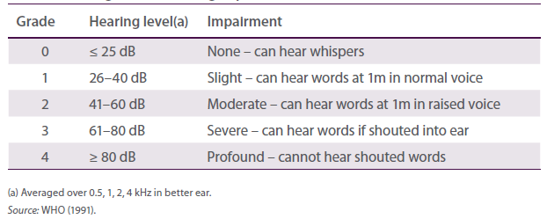
The causes of hearing loss include infections, tumours, structural problems, ageing, and exposure to noise and certain chemicals and pharmaceuticals (‘ototoxins’). Estimates from the 2000 Global Burden of Disease study suggest that worldwide 70% of mild (slight) or greater hearing loss, 75% of moderate or greater hearing loss and 87% of severe or greater hearing loss is adult-onset (Mathers et al. 2003 Smith 2004). The major causes of adult-onset hearing loss are ageing and noise (Dobie 2008). Age-related hearing loss is mostly the damage to the hearing-related structures and nerves that occurs from various sources over time rather than from biological deterioration (ageing) alone (Dobie 2008). On the other hand, exposure to excessive levels of noise (i.e. levels considered hazardous to the hearing of most people) affects hearing by changing the physiology of the inner ear, particularly the so-called hair cells (see Boxes 1 and 2 for key definitions and concepts).
Noise is often defined simply as unwanted sound. However, this definition can be misleading as any loud sound, whether wanted or not, can damage hearing. The relationship between noise and hearing loss has been the focus of numerous studies, undertaken mainly in the 1950s, ’60s and ’70s (see for example Burns & Robinson 1970). However, the effects of occupational noise on hearing have been known for a long time. In the 18th century, the damaging effects of noise on the hearing of coppersmiths were described (Ackley & Limb 2007). By the 1880s, conclusive evidence was found for greater hearing loss among workers exposed to elevated noise levels compared to workers in quieter jobs (Barr 1886).
Exposure to loud noise from all sources is the most common preventable cause of hearing loss and impairment (Dobie 2008 WHO 1997). This can mean exposure to very loud noise for a short time or prolonged/repeated exposure to moderately loud noise. Also, the cumulative and non-linear nature of the risk of hearing loss associated with noise exposure means that this risk can increase significantly with separate brief periods of exposure throughout a work day or shift (Thorne et al. 2006).
Noise-induced hearing loss can begin immediately or gradually and may be temporary or permanent. Depending on the intensity of the noise and the duration of exposure, hearing loss can range from a small shift in the threshold at which sounds at different frequencies can be detected to total deafness. Hearing loss may affect one or both ears, although not always to the same extent (Davis 1989 Wilson 1997).
The first indication of noise-induced hearing loss is usually a shift in the pure-tone threshold in the 3–6 kHz frequencies. That is, a significantly louder tone than previously is required for an individual to detect a tone at these frequencies. Threshold shifts in these frequencies indicate a hearing loss in the upper part of the frequency range for human voices (Nelson et al. 2005). Research in Sweden has shown that with moderate noise-induced hearing loss 90% of a conversation in a quiet environment can be heard compared with 98% by someone with unimpaired hearing (Aniansson cited in Hallberg 1996). However, in a noisy environment, such as a party, only 40% of a conversation can be heard by someone with moderate noise-induced hearing loss compared with 75% by someone with unimpaired hearing (Aniansson cited in Hallberg 1996). Temporary threshold shifts can occur after brief exposure to loud noise (see Box 1).
Noise-induced threshold shifts can usually be observed as a characteristic ‘notch’ in the 3–6 kHz range on an audiogram. However, notches can also occur in non-noise exposed people (Demeester et al. 2009). Continued noise exposure can cause the notch to worsen and spread to neighbouring frequencies (Gates et al. 2000). In contrast, age-related hearing loss is usually characterised by a progressive threshold shift beginning with the higher frequencies (Thorne et al. 2006). Audiometric assessment—which in the industrial setting usually means pure tone air conduction audiometry—can often (but not always reliably) distinguish noise-induced effects from age-related effects (Dobie 2008), but it cannot distinguish the effects of occupational noise from other noise sources. Further, although the onset of hearing loss can occur within the first 5–10 years of noise exposure (Albera et al. 2010 Rösler 1994), pure tone audiometry cannot always detect early stages of hearing damage, which is often the noise-induced component (Hallberg 1996 Thorne et al. 2006). However, the early stages of ONIHL may be detected through a technique called otoacoustic emissions testing (Sliwinska-Kowalska et al. 1999).
Exposure to noise in the workplace (‘occupational noise’) has been estimated to account for about 10% of the burden of adult hearing loss in western countries (Dobie 2008 Nelson et al. 2005). A similar proportion is likely to be attributable to non-occupational noise sources such as the environment, entertainment venues and personal music players (Dobie 2008). Some research points to a considerably higher proportion attributable to noise, but these studies tend to lack the rigour of the work by Dobie and Nelson and colleagues.

Box 1 Sound and hearing loss
Sound is energy in the form of pressure waves that vary rapidly as they move through air and other media. When sound waves enter the ear they stimulate cells in the cochlea (‘hair cells’), which convert the vibratory sound energy into electrical impulses (neural signals) that travel via the auditory nerve to the brain where they are interpreted. When stimulated by sound waves the hair cells bend back and forth. One hypothesis is that loud sounds cause damage by bending the hair cells too much. Hence, hearing loss occurs when hair cells are damaged to the point that they can no longer move back and forth freely. Since cochlear hair cells cannot be replaced, destroyed hair cells result in permanent hearing loss.
Sound frequency (perceived as pitch) is the number of pressure variations per second and is measured in hertz (Hz). A bass drum, for example, produces low pitch sounds while a flute produces high pitch sounds. The magnitude or intensity of a sound (perceived as loudness) is measured by the sound pressure level in units of decibels (dB). The sound pressure level is 20 times the logarithmic ratio of the pressure of a particular sound to that of a reference of 20 micropascals, namely the quietest sound detectable by a young person with normal hearing. Due to the logarithmic nature of the decibel scale, doubling the intensity of a sound of, for example, 50 dB increases the sound pressure level to 53 dB rather than 100 dB.
The decibel is used to describe both noise exposure and hearing loss. Whereas sound magnitude is measured as the sound pressure level (dBSPL), hearing threshold (as displayed on an audiogram) is measured as the hearing level (dBHL). The decibel is a relative measurement unit that only has meaning when a reference is specified. In the case of hearing level the reference is normal hearing of young people in the population. Therefore, 0 dBHL represents the quietest sound detectable at each frequency by young people with normal hearing. That is, it is a value relative to the population norm rather than representing the total absence of sound. Hence, 40 dBHL, for example, represents a hearing threshold that is 40 decibels higher than that of young people with normal hearing. An individual’s hearing threshold is the quietest sound (pure tone) detectable at a particular frequency. Thresholds averaged across certain tested frequencies give the pure tone average (PTA). The typical pure tone audiometric test includes frequencies at 0.25, 0.5, 1, 2, 4, and 8 kHz, which includes the speech frequency range of 0.3–4 kHz. Occasionally, 3 kHz and/or 6 kHz are included. Many epidemiological and population-based studies of ONIHL rely on PTAs that include 0.5, 1, 2, and 4 kHz frequencies.
The perceived loudness of sounds varies with sound frequency as well as with dB level. To account for this, a spectral sensitivity factor (A-filter) is used to weight sound pressure levels to de-emphasised lower and higher frequencies and emphasise the mid-range frequencies to which the human ear is most sensitive (i.e. around the 1–6 kHz range). These A-weighted sound pressure levels are expressed in units of dB(A).
Sources Gates & Hoffman (2008) Pederson (1989) Roeser et al. (2000) Thorne (2006).
In general, hearing losses from different causes are additive. However, some factors may interact with noise to produce synergistic effects. That is, the hearing loss can be greater than that associated with each of the individual factors or the sum of the effects of the individual factors. The combined effects of noise and age usually manifest into mild impairment at about the age of 50 years (Dobie 2008). The international standard for estimating noise-induced hearing loss—ISO 1999 (ISO 1990)—is based on the notion that the relative contribution of noise and ageing is almost additive. That is, the assumption is that both types of hearing loss progress at an independent rate and their sum is slightly less than the total hearing loss (Lee et al. 2005 Macrae 1991). However, other research suggests a more complicated relationship between age and noise (Albera et al. 2010 Gates et al. 2000 Rosenhall 2003 Rösler 1994). For example, animal studies have shown that early noise-induced damage makes the ears more vulnerable to the effects of ageing (Kujawa & Liberman 2006).

Box 2 Important features of sound
- Sound energy expressed as magnitude or intensity doubles with every 3 dB increase in sound pressure level.
- To most people an increase of 10 dB is perceived as a doubling in loudness but is actually closer to a 10-fold increase in energy.
- Doubling the distance from the noise source results in a 6 dB decrease (i.e. quartering) in sound pressure level.
- According to the ‘equal energy hypothesis’, the total amount of sound energy received by the ear is proportional to the amount of damage caused. Therefore, increasing the sound pressure level by 3 dB, for example, requires halving the exposure time in order to receive the same amount of sound energy and impact on hearing.
Many chemicals are known to be ototoxic that is, they can damage the hearing organs and nerves. Ototoxic chemicals commonly found in work environments include organic solvents (e.g. toluene and styrene), asphyxiants (e.g. carbon monoxide), heavy metals (e.g. lead and mercury), pesticides and herbicides (Morata 2003). Recent animal and human research suggests that some ototoxins may have an additive or synergistic effect in the presence of noise (Hodgkinson & Prasher 2006 Morata 2007 Śliwinska-Kowalska et al. 2003 2007). However, there is still much to learn about ototoxin dose-response relationships and the noise levels that would be considered safe in the presence of ototoxins.
Individuals with hearing impairment often deny the problem to themselves and to others (Shield 2006). This denial, particularly when the chief cause of hearing loss is noise, can lead to prolonged exposure and delayed treatment, thereby worsening the problems associated with the hearing loss (Shield 2006).
  - The extent of the problem
ONIHL is one of the most common occupational diseases (Groothoff 2007 Nelson et al. 2005). However, there is little information available on how many workers in Australia are exposed to or affected by loud noise. This is due partly to the substantial costs and difficulties associated with obtaining representative exposure and epidemiological data and the lag in time between exposure and impairment or diagnosis.
Consequently, as with many chronic diseases and disorders, it is difficult to say how many people in Australia at any one time (the prevalence) have some degree of hearing loss. Knowing how many new cases occur each year (the incidence) is even more challenging. Without accurate estimates of the prevalence and incidence of ONIHL, it is difficult to identify the magnitude and impact of the problem and the effectiveness of interventions.

Prevalence and incidence of ONIHL in Australia
There are no ongoing direct measurements of existing cases or new cases of ONIHL in Australia. However, there are four main sources of information that can be used to obtain rough estimates of ONIHL prevalence and incidence
- self-report health surveys
- audiometric studies
- burden of disease studies, and
- workers’ compensation claims.

Self-report health surveys
Large surveys of ONIHL are uncommon. However, population-based health surveys can at least provide estimates of the prevalence of self-reported hearing impairment in the community. For example, the Australian Bureau of Statistics periodically conducts the National Health Survey. Based on responses to the 2007–08 survey, 12.4% of people in Australia aged 15 years and over, and 33.2% of those aged 65 years and over, had partial or complete deafness (ABS 2009). These percentages have not changed since the previous survey in 2004–05 (Table 1.2).

Table 1.2 Prevalence of self-reported partial or complete deafness in Australia, from all causes
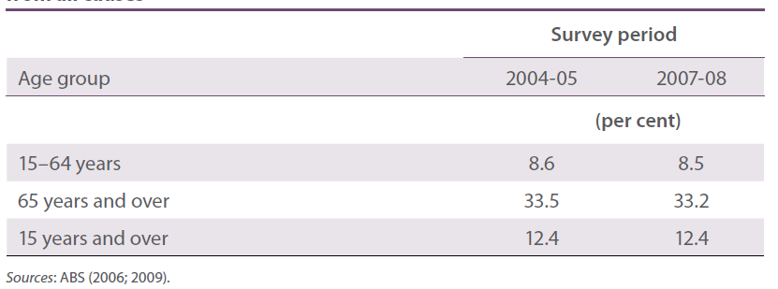
The National Health Survey, and similar surveys, rely on respondents’ self-reports of their conditions and circumstances. This means that, besides the attribution of the cause of hearing loss being problematical, misclassification of conditions is common. For example, when compared to audiometric assessments, self-reports of hearing loss from the South Australia Health Omnibus Survey gave a 46% false positive rate and a 17% false negative rate (Wilson et al. 1998). The authors of the study concluded that the degree of misclassification associated with the self-reported hearing loss rendered the data practically invalid for planning purposes (Wilson et al. 1999). On the other hand, other research suggests that selfreports of hearing loss have performed reasonably well in identifying subjects with hearing impairments (Sindhusake et al. 2001). Also, many studies have used questions that have been validated against subjective measures (e.g. Palmer et al. 2002 Tak & Calvert 2008 Wilson et al. 1998). Importantly, as an alternative to audiometric assessment, self-reported hearing loss is inexpensive and quick to administer. However, audiometric assessment is still considered to be the best method for estimating prevalence of hearing loss even though it is an expensive and sometimes impractical option.

Audiometric studies
Perhaps the best estimate of the prevalence of hearing loss among adults in Australia comes from an examination of data from three consecutive administrations of the South Australian Health Omnibus Survey and subsequent audiometric assessment of 50% of respondents reporting a hearing disability (Wilson et al. 1998 1999). In this study, 689 people aged 15 years and over who reported some degree of hearing loss in a representative population survey in South Australia during 1994 and 1995 had their hearing assessed by audiological methods. Also tested were 237 people from the same survey who reported no hearing loss. The researchers concluded that, when considering hearing loss from all causes in the better ear, 16.6% of people aged 15 years and over in South Australia had mild or greater hearing loss and 2.8% had moderate or greater hearing loss (Wilson et al. 1999). When considering hearing loss in the worse ear, 22.2% had mild or greater loss and 7.6% had moderate or greater loss (Wilson et al. 1999). According to Wilson and colleagues, measurements based on the worse ear are often used to indicate prevalence of the disorder whereas measurements based on the better ear are indicative of disability.
The results from the South Australian study compare well with the findings of international audiometric studies, which typically measure hearing thresholds over the frequencies of speech (0.5, 1, 2 and 4 kHz). For example, audiograms from the British National Study of Hearing have shown that 16.1% of adults in the United Kingdom have mild or greater hearing loss and 3.9% have moderate or greater loss in the better ear (Davis 1989). The corresponding figures for the worse ear were 26.1% and 9.3% respectively. From the audiometric component of the 2003–04 National Health and Nutrition Examination Survey, 16.1% of adults aged 20–69 years in the United States of America (USA) have mild or greater hearing loss (Agrawal et al. 2008).
Wilson and colleagues’ (1998) findings have been used for more recent estimations of hearing loss in Australia. For example, Access Economics used these data to estimate that 3.55 million Australians in 2005 had some hearing impairment (hearing threshold levels of 25 dBHL or greater) in the worse ear, which is equivalent to a prevalence of hearing impairment in Australia of 17% (Access Economics 2006).

Burden of disease studies
Adult-onset hearing loss ranks as the fifth leading cause of burden of disease in developed countries (Mathers et al. 2004). However, current estimates of the global prevalence of adult-onset hearing loss are hampered by a lack of data from many countries. A recent study examined a WHO collection of around 3000 international hearing assessment studies published or produced between 1980 and 2008 (Pascolini & Smith 2009). Out of the 3000, only 53 studies from 31 countries were found to provide prevalence data for bilateral hearing loss from representative, population-based studies with clearly-defined hearing threshold levels.
There is also a lack of consistency across international studies. As mentioned above, hearing impairment is often defined differently across studies. Other differences include how studies are designed, how hearing and ears are examined and how hearing loss is described (e.g. in terms of bilateral or unilateral, better or worse ear, etc.). This lack of consistency makes it difficult to combine survey results to derive accurate and reliable global estimates.
Some work has been undertaken to overcome the scarcity and inconsistency of hearing studies. For example, one study examined the results of 26 audiometric studies from 18 different countries.
Comparing the results, it was estimated that 413 million people worldwide in 2000 had some level of adult-onset hearing impairment in the better ear, of which 187 million had moderate or greater hearing impairment (Mathers et al. 2003).
Global burden of disease studies estimate that exposure to occupational noise accounts for 16% of the disabling hearing loss in adults worldwide, ranging from 7–21% in the various subregions (Nelson et al. 2005). This range is explained partly by (1) the lower prevalence of age-related hearing loss in developing countries due to lower life expectancy and younger populations and (2) a rising prevalence of ONIHL in some developing countries as their manufacturing and construction sectors expand (Dobie 2008). In developed economies, including Australia, 7–10% of the burden of adult-onset hearing loss has been attributed to exposure to occupational noise (Concha-Barrientos et al. 2004 Dobie 2008 Nelson et al. 2005).
The 2003 Australian Burden of Disease and Injury Study used data from Wilson and colleagues (Wilson et al. 1999) to estimate that there were about 246 430 new cases of adult-onset hearing loss (25 dBHL or greater) in Australia in 2003 (Begg et al. 2007). About two-thirds of these cases occurred in working age (i.e. 15–69 years). When the 7–10% attribution rate is applied to the 2003 Australian Burden of Disease and Injury estimates there may have been 11 600–16 500 new cases of ONIHL in working-age adults in Australia in 2003.

Workers’ compensation claims
In the five years between July 2002 and June 2007 there were about 16 500 accepted workers’ compensation claims in Australia for deafness due to exposure to noise (Figure 1.1). About 99% of these claims were associated with long-term exposure. Over these five years, the manufacturing, construction and transport and storage industries accounted for 65% of claims. In the financial year 2006–07, the mining, electricity/gas/water supply, and construction industries had the highest claim rates, with 1.8, 1.7 and 1.3 claims per 1000 workers, respectively. In that year, males aged 55–64 years accounted for almost 50% of accepted claims.
The incidence of ONIHL as recorded in workers’ compensation claims is likely to be influenced by the extent of reporting. It may be argued that greater awareness of the consequences of noise exposure is likely to increase reporting. For example, the number of workers’ compensation claims for ONIHL in Washington State (USA) increased more than tenfold in the decade to 2006—an increase which has been attributed, at least in part, to a reporting phenomenon (Daniell et al. 2006). On the other hand, a study in Victoria comparing a sample of notifications of abnormal audiometric screening tests and subsequent workers’ compensation claims for industrial deafness suggest that no more than one in four eligible workers make a successful claim (Benke & Groenewald 1988).
ONIHL is typically a long-latency condition and this may affect whether or not a workers’ compensation claim is eventually submitted. Research from Israel suggests that subjective assessment of hearing impairment, severity of hearing loss as measured by audiometry, and the presence of symptoms such as tinnitus, impaired verbal communication, and dizziness are major determinants in workers’ decision to submit a compensation claim for ONIHL (Poshnoi & Carel 2004). As noted by the authors, these factors usually neither present nor are acted upon until the hearing loss has progressed to a relatively advanced stage (Poshnoi & Carel 2004). Benke and Groenewald (1988) found that, on average, there was an 18 month delay between the date of the most recent notification and the submission of a claim. It is therefore likely that workers’ compensation claims data will be complicated by difficulties in determining responsibility for the impact of age-related hearing loss and non-occupational noise exposure. Overall, workers’ compensation statistics are likely to underestimate considerably the incidence of ONIHL in Australia.

Prevalence of occupational noise exposure
Estimating the prevalence of noise exposure in Australia is even more difficult and problematical than estimating the prevalence of ONIHL. There are difficulties in collecting data, privacy issues, and the high likelihood that noise levels vary over time. Although exposure can sometimes be estimated from the prevalence of hearing loss, individual sensitivity to noise varies and other factors known to vary must be held constant.
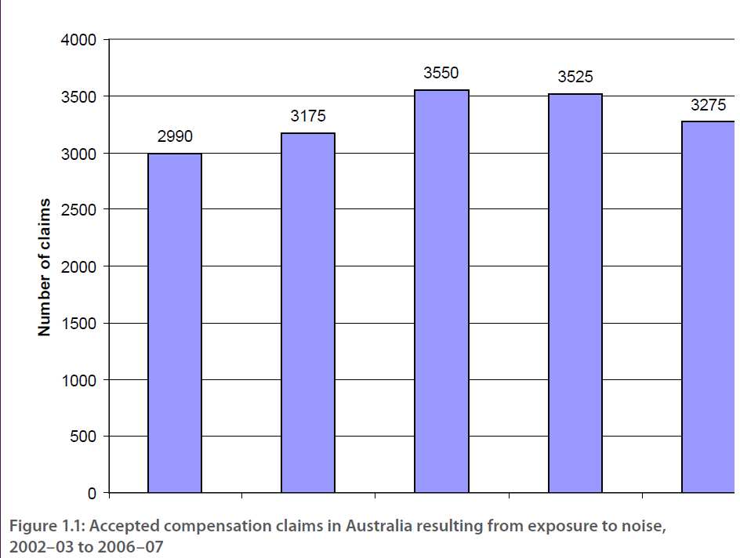
Using two modelling approaches, the Australian Safety and Compensation Council (ASCC) estimated that between 900 000 and 1 million workers (about 10.5–12% of the workforce) were exposed to excessive noise in 2001–02 (ASCC 2006). One model was based on workers’ compensation claim rates from at-risk occupation groups. The other model involved extrapolation of hearing test data gathered in the early 1990s from at-risk workers in industries in Western Australia (Monley 1994 Monley et al. 1996). Both approaches involved several assumptions.
Since 1991, Western Australia’s workers’ compensation legislation has required all employers operating noisy workplaces to test their workers’ hearing. These data would establish hearing loss baselines. Between 1 March 1991 and 29 November 1994, 89 500 noise-exposed workers were tested, representing 11.4% of the Western Australian workforce (Monley et al. 1996). Because only employers who believed that their workplaces were noisy (above LAeq,8h 90 dB(A)) were required to test workers’ hearing, and the extent of compliance with this requirement cannot be determined, 11.4% cannot be regarded as a valid estimate of the rate of exposure to excessive noise. However, Monley (1994) suggests that at least for Western Australia, these data may be a useful starting point until reliable and valid Australian occupational noise exposure data are available.
Many studies have used workers’ self-reports of exposure to excessive noise. For example, 30% of a sample of 3000 workers in New Zealand reported exposure to loud noise a quarter of their work time (Eng et al. 2010). From self-reported surveillance data, an estimated 13% of workers in the USA in the late 1980s were exposed to noise at 85 dB(A) or greater (Gun 1988). Data from the National Occupational Exposure Survey in the USA from 1981–83 suggest that about 17% of workers in the industries surveyed were exposed to noise at 85 dB(A) or greater at least once per week for at least 90% of the working weeks in a year (CDC/NIOSH 1988). From responses to the 2005 Workplace Health and Safety Survey in the United Kingdom, 19% of workers reported exposure, or the immediate effects of exposure, to loud noise (Hodgson et al. 2005). Like many others, this survey used ‘raise voice to converse’ as the subjective measure of noise exposure.
Although often used, subjective measures of noise exposure lack precision and, when used alone, are of limited epidemiological value. For example, Ahmed and colleagues (2004) found that the question ‘do you have to shout to make yourself heard at work because of noise?’ correlated with noise above 85 dB(A) with 70% accuracy. A derivation of this question using ‘raise voice’ instead of ‘shout’ has also been found to correlate well with noise above 85 dB(A) (Neitzel et al. 2009). The need to shout in order to converse at an arm’s length (about one metre away) has been equated with noise above 85–90 dB(A) (Palmer et al. 2002).
In the absence of collaborating information, responses to self-report noise exposure questions can be misleading. So, spending just three hours a day, for example, in noise where you need to shout to converse at an arm’s length can represent anything from relatively safe exposure at about 85 dB(A) to hazardous exposure at about 90 dB(A).
  - Other effects of occupational noise and ONIHL
Exposure to loud noise in the workplace is most often associated with hearing loss and impaired communication. It is also common for occupational noise to have harmful effects that are independent of or accompany hearing loss. For example, there is evidence that exposure to excessive noise can cause foetal hearing impairment (ASCC 2006 El Dib et al. 2006 Smith & Broadbent 1991). Tinnitus is a ringing or buzzing sound experienced in the ear or head in the absence of any external sound source. It can range from mildly irritating to disabling. In serious cases, tinnitus can lead to sleep loss, stress, depression, and suicide. There are many potential causes of tinnitus, of which exposure to loud noise is often cited as the most common (Axelsson & Prasher 2000). Although tinnitus is usually associated with hearing loss it may precede hearing loss by a considerable amount of time.
Occupational noise has been linked to potentially serious health conditions such as quickened pulse rate and hypertension (Babisch 2008 Lang et al. 1992 Melamed et al. 2001 Sbihi et al. 2008 Verbeek et al. 1987 Willich et al. 2006 Zhao et al. 1991). Indeed, much of the research into the link between occupational noise and adverse health effects has focused on the potential role of noise as a risk factor for cardiovascular disease (Abel 1990 Kristensen 1989).
Exposure to loud noise, from all sources, has been linked to adverse psychological and social effects (Table 1.3). These include anxiety, depression, fatigue and sleeplessness (Melamed & Bruhis 1996 Raffaello & Maass 2002 Smith & Broadbent 1991). It has been found to affect memory (IEH 1997 Willner & Neiva 1986) and decision making (Siegel & Steele 1980) and to increase post-work irritability (Melamed & Bruhis 1996) and annoyance (Butler et al. 1999). Some of these effects can have further consequences. For example, fatigue and sleeplessness can increase the risk of occupational accidents (Chau et al. 2004 Lavie 1981 Léger et al. 2002 Lindberg et al. 2001).
Occupational noise has been found to decrease job satisfaction in those performing complex jobs (Melamed et al. 2001). In combination with hearing loss, it interferes with recognition of speech and warning signals and contributes to balance dysfunctions (Kilburn et al. 1992), all of which can increase workplace accident rates (Dias & Cordeiro 2007 Moll van Charante & Mulder 1990 Noweir 1984 Picard et al. 2008). For example, Moll van Charante and Mulder (1990) studied the identification of imminent danger warning signals at a shipyard and found that exposure to noise greater than 82 dB(A) and hearing loss greater than 20 dBHL were each safety hazards. In that study, noise exposure and hearing loss accounted for a total of 43% of the shipyard’s injuries (Moll van Charante & Mulder 1990).
Research has demonstrated a link between occupational noise and employee absenteeism (Cohen 1976 Elvhammar 1981 Fried et al. 2002 Noweir 1984). On the other hand, there is very little research on the relationship between occupational noise and employee turnover. A Swedish study found a correlation between reduced workplace noise exposure and a reduction in annual employee turnover from 77% to 44% (Elvhammar 1981). However, the potential confounding factors limit the reliability of attributing this change to the reduction in noise exposure alone. Despite these caveats, a link between occupational noise and employee turnover has been inferred by examining effects of occupational noise on the factors that influence employee turnover, such as job satisfaction (e.g. Melamed et al. 1992).
Although some researchers have found a significant positive relationship between occupational noise and worker productivity or performance (e.g. Noweir 1984), others have concluded that the relationship is either not significant or complex (Levy-leboyer & Moser 1988). Inconsistent and counterintuitive findings can sometimes be explained by Broadbent’s arousal theory (Broadbent 1971) which suggests that the relationship between background noise and performance typically follows an ‘inverted U’ shape. That is, at a certain level noise is associated with an optimal level of arousal that produces optimal performance but below or above this level performance decreases (Bies & Hansen 2003 Taylor et al. 2004).
Hearing loss in itself may lead to other problems (Table 1.3). These include reduced involvement in family activities and increased relationship stress (Hallberg 1996), social stigma and isolation (Hallberg 1996 Hetu 1996), depression (Arlinger 2003), reduced overall quality of life (Shield 2006), and reduced earnings (Kochkin 2007 Mohr et al. 2000).
Noise exposure can have adverse effects even when hearing remains unaffected. That is, some of these effects, such as annoyance, may result from exposure to noise levels that are significantly below those considered hazardous to hearing. For example, there is evidence that relatively low levels of noise may reduce worker performance and productivity by negatively affecting concentration, levels of stress, annoyance, job satisfaction and motivation (Evans & Johnson 1998 Kjellberg et al. 1996 Mital et al. 1992). Research shows that even noise at levels as low as 65 dB(A) or less can negatively affect the psychological well-being of workers and negatively affect performance and productivity (Aniansson et al. 1983 Banbury & Berry 1998 Bhatia et al. 1991). A number of studies on the effects of office noise have found evidence for decreased mental performance as a result of low-level noise (Banbury & Berry 1998 Smith 1988 Sundstrom et al. 1994). In particular, intermittent noise has been found to be more distracting and annoying than constant noise (Loewen & Suedfeld 1992).
Appendix A contains a more detailed review of the literature on the effects of occupational noise with respect to the risk of accidents, psychological effects, productivity and performance, and employee absenteeism. The research reviewed above and in Appendix A suggests plausible and demonstrable relationships between exposure to occupational noise (both excessive and relatively low) and adverse effects on health, social wellbeing and productivity. Many of the adverse effects have important implications for business. However, the effects of noise exposure are difficult to predict and many of the proposed relationships are complicated and not always observable.

Table 1.3 Nonauditory effects of noise exposure and hearing loss
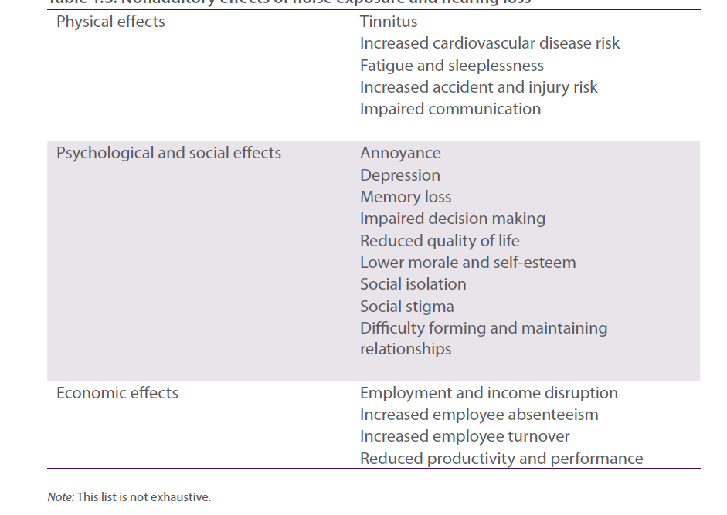
The relationship between occupational noise and nonauditory effects, such as increased stress and annoyance, is influenced not only by the level and length of noise exposure but also by individual sensitivity to noise and by factors such as the controllability and predictability of the noise. For example, people sensitive to noise are more likely to be negatively affected by noise of both high and low intensity (Bhatia et al. 1991). In addition, people with impaired hearing are more likely to be annoyed by low level noise when the noise interferes with speech intelligibility (Aniansson et al. 1983).
The complexity of some of these relationships is illustrated by a study of the impact of occupational stress on health and work performance (Tafalla & Evans 1997). The study consisted of 33 male college students who were asked to solve arithmetic calculations under differing conditions of noise and effort. The participants were randomly assigned to either a condition of randomly intermittent background noise with peaks of 90 dB(A) or to a quiet condition of 45 dB(A). Some participants were then manipulated to increase their motivation to work with more effort. When effort was manipulated, the noisy environment significantly increased physiological stress but had little effect on task performance. Conversely, when effort was relaxed, the noise did not increase physiological stress but significantly worsened task performance. These findings suggest that increasing effort to compensate for working in excessive noise may not worsen performance but it may worsen health (Tafalla & Evans 1997).
  - Noise management and hearing conservation programs
All Australian jurisdictions refer to the National Standard for Occupational Noise [NOHSC1007 (2000)]. This standard is based on the measurement and calculation procedures in Australian Standard AS/NZS 1269 and sets the maximum daily noise exposure level at an eight-hour equivalent continuous A-weighted sound pressure level (LAeq,8h) of 85 dB(A) and, for peak noise, a C-weighted peak sound pressure level (LC,peak) of 140 dB(C).
Limiting exposure to below the national standard over a working lifetime should prevent hearing loss in excess of 10 dBHL in 95% of the exposed population (Lutman 2000 NOHSC 1989). Therefore, the standard does not represent a safe level of noise exposure for everybody (Standards Australia 2005). In contrast, limiting long-term noise exposure to 80 dB(A) or less would prevent ONIHL in almost all workers (Kateman et al. 2007 Lutman et al. 2008).
A code of practice [NOHSC 2009 (2004)] outlines the noise management program that workplaces need to implement when workers are exposed above the national standard. A noise management program is a plan for protecting workers’ hearing. It typically includes a determination of the noise levels in the workplace, identification of which individuals are potentially exposed, and a set of noise management measures. These measures can include a ‘buy-quiet’ policy, implementation of engineering controls, regular audiometric testing, and the provision of training, information, and personal hearing protectors. For regulatory purposes, the provision of personal hearing protectors (PHPs) is not considered to reduce exposure to noise. That is, the national standard states that noise exposure levels are to be measured irrespective of the use of PHPs. However, if supplied and used appropriately, PHPs reduce the amount of sound received by the ear thereby reducing the risk of harm.
The preferred solution to excessive exposure to loud noise is to completely eliminate the source of the noise. When this is not possible or reasonably practicable, the legal requirement is to minimise exposure through a hierarchy of controls. From highest to lowest ranking the hierarchy of controls, in general, includes the following
- substitute the noise source with quieter machinery or processes
- isolate the noise source from workers
- apply engineering solutions
- apply administrative solutions, and
- provide personal hearing protectors.
Engineering controls include redesigning or modifying the noise source or workplace, fitting silencers and mufflers, undertaking regular maintenance, and installing noise guards or enclosures. Administrative, or procedural, controls include scheduling noisy work for when fewest workers are present, placing warning signs and providing quiet areas for breaks. Ear muffs and ear plugs are the most common types of PHPs and should only be relied upon when none of the high-order controls are reasonably practicable.
Within the hierarchy of controls, highest priority is given to the source of the noise followed by the path of transmission and, finally, the point of reception (the exposed worker). The general notion is that preventative action by the worker should be the last resort. Therefore, a comprehensive noise management program would include strict adherence to the hierarchy of controls as well as noise exposure and hearing assessments education with respect to risks, solutions and responsibilities and training on noise control and personal protection. However, Thorne (2006) observed that it is common for one or more components of a comprehensive program to be missing. A major reason for this is overreliance on PHPs (Thorne et al. 2006). With this in mind, the term ‘noise management program’ or ‘noise control program’ rather than ‘hearing conservation program’ is believed to place a greater emphasis on noise elimination or isolation instead of PHPs (Thorne et al. 2006).
In the next chapter we review the literature on the factors (‘barriers’ and ‘enablers’) that influence the motivation and ability to adopt and use effective noise control and ONIHL prevention strategies.

Remaining questions
- How many workers in Australia continue to experience the consequences of excessive exposure to loud occupational noise?
- How many workers in Australia are exposed to loud noise? Is this proportion falling and, if so, how quickly?

Chapter 2 Barriers and enablers in the ONIHL literature
Understanding the barriers and enablers associated with effective work health and safety provides an avenue for intervention and the potential for reducing the numbers of occupational fatalities, injuries and diseases. In this report, ‘barriers’ are factors that reduce the likelihood that effective noise control and ONIHL prevention measures are being used or will be adopted. For example, a major barrier to the implementation of effective noise control appears to be the commonly held perception that the term ‘hearing conservation program’ describes a process focused exclusively on personal hearing protection and audiometry (Kateman et al. 2007). Another barrier is the common belief that noise control is difficult (Foster 1996), which leads to many workplaces adopting PHPs rather than more effective higher-order controls (Williams et al. 2007 Williams 2007).
Conversely, ‘enablers’ are factors that increase the likelihood that effective noise control and ONIHL prevention measures will be adopted. The term enablers is used interchangeably with terms such as ‘interventions’ and ‘solutions’ as many enablers are actually the removal or reduction of a barrier and therefore should not be regarded necessarily as a distinct factor. In this chapter we review the literature on factors that may act as barriers and enablers to the adoption of effective noise controls. We begin with a general discussion of the prevention of ONIHL.

Chapter 2 Highlights
- Major barriers to effective noise control include lack of knowledge of the nature of noise and noise control low perception of the risk of noise (low prominence and visibility) over-reliance on and low actual use of PHPs low self-efficacy high fatalism perception that noise control is too costly.
- A major enabler of effective noise control is good management commitment to work health and safety.

2.1 Prevention of ONIHL
A major reason why occupational noise remains a problem today is that noise control was not historically a consideration at the design stage of equipment and production processes (Gibson & Norton 1981). Research in the early 1980s found little evidence of a concerted effort to reduce noise in Australian industry despite increasing public awareness of noise at that time (Gibson & Norton 1981). There is no indication from the literature today to suggest that this position has changed and although noise control solutions have been known for a long time (Larsen 1953), they are often not implemented in Australian workplaces (Foster 1996). Malchaire (2000) proposed a noise control strategy but suggested that resources, competence in acoustics, and motivation for noise control in industry is limited. Research from Western countries suggests that health promotion initiatives are largely inadequate at preventing ONIHL (Borchgrevink 2003). A global review of ONIHL compensation data in 2002 found no world-wide solution to the problem (Hinchcliffe 2002). This is largely due to the fact that each country has its own degree, pattern and rate of industrialisation that gives rise to hazardous noise exposures. Consequently, each country deals with the problem based on the disease patterns and available resources within that country (Hinchcliffe 2002).
An understanding of the basis of any noise problem is essential before steps can be taken to develop and implement an effective solution. In their noise control guidebook for the mining industry, Mitchell and Else (1993) recommend that persons with the responsibility for managing noise should answer the following questions before investigating options for solving a problem (1) Where does the noise come from? (2) How is the noise conveyed to the receiver? (3) Who are the receivers? and (4) Why are they being exposed? Therefore, the problem should be analysed in terms of the source of the noise, the pathway via which the noise is transmitted, and the receivers exposed.
A hierarchy of risk control measures has been developed to guide health and safety practitioners towards selecting ‘safe place’ methods in preference to ‘safe person’ approaches to hazard management (Ellenbecker 1996 NOHSC 1990). Such a hierarchy generally comprises elimination of the noise source as the preferred option followed by substitution by different, quieter equipment or processes (a buy-quiet policy) then engineering controls that attenuate the noise close to the source engineering controls along the transmission path administrative controls such as exposure time restrictions and job rotation and, finally, the wearing of PHPs such as ear muffs and ear plugs (Mitchell & Else 1993). Risk control is achieved using any of these intervention methods individually or in combination.
Little is known about the actual use of control and prevention strategies in workplaces. The available research suggests that employers are most likely to implement administrative strategies and, in particular, personal protective equipment (Roelofs et al. 2003). Despite a widespread acknowledgement that controls from the top of the hierarchy of risk controls should lead noise reduction strategies in the workplace, provision of PHPs is the most common and often the only means of protecting workers’ hearing (El Dib et al. 2006 Kateman et al. 2007 WHO 1997). Technical and economic reasons are often given for this situation (El Dib et al. 2006). Many explanations have also been provided for the low usage rate of PHPs in practice, including the discomfort of wearing PHPs and low perceived risk of harm (El Dib et al. 2006). The issues associated with discomfort, the inability to hear warnings, and the perceived incompatibility of PHPs with other personal protection equipment have been known for many years and have been treated in detail by authors such as Else (1975 1981), Park and Casali (1991), Svensson and colleagues (2004), and, more recently, Carruth and colleagues (2007). The latter studies found that communication interference was a major determinant in worker decisions about wearing PHPs.
Serious concerns about the incidence of ONIHL remain in the USA even more than 20 years after the implementation of Occupational Safety and Health Administration (OSHA) hearing conservation regulations (Daniell et al. 2006). For example, in a study of worksites with relatively high rates of ONIHL claims across eight industries in Washington State most participating companies had important shortcomings in their hearing conservation programs, including the underuse of PHPs (Daniell et al. 2006). In addition, most of the companies had been inspected by the State OSHA at some point in time but only 9% had received a notice related to noise or hearing conservation. Similarly, it has been argued that there has been little incentive for the construction industry in the USA to eliminate or reduce noise (Neitzel et al. 1999). Despite the existence of hearing conservation regulations there has been little enforcement, as illustrated by the issuing of only 45 noise and 19 hearing conservation-related citations out of 18 000 construction site inspections in 1999 (Neitzel et al. 1999).
Similar trends were found during a study of five major commercial construction sites in Brisbane, Australia, by inspectors from Workplace Health and Safety Queensland (WHSQ 2003). Findings included noise levels in the mid-80 to high-90 decibels, a sceptical view on and low use of hearing protectors, and generic statements in work plans regarding noise controls, which were not implemented, monitored or reviewed. The negative attitude towards hearing protectors was often related to the inability to hear the ‘real’ dangers on site when wearing them. Few improvement notices were issued where it could be proven that workers had been excessively exposed to loud noise.
A report on the approach taken by the National Institute for Occupational Safety and Health (NIOSH) to reduce noise exposure during long-wall mining operations includes evidence that ONIHL continues to be a problem despite extensive work with engineering controls during the 1970s and 1980s (Bauer et al. 2007). To address the issue, the Mine Safety and Health Administration published Health Standards for Occupational Noise Exposure that requires exposure reduction and the adoption of all feasible engineering an administrative controls. Research on the likely impact of the regulations estimated that 11% of projected hearing impairments would be prevented in metal/non-metal mines due to the implementation of engineering controls while 46% of impairments would be prevented as a result of the use of PHPs (Garvey 2000). Conversely, an estimated 58% of projected impairments would be prevented in coal mines by the implementation of engineering controls while 22% would be prevented by the use of PHPs (Garvey 2000). The most promising results to date are in the areas of increased use of soft-foam ear plugs and increased exposure monitoring (Bauer et al. 2007).
Large-scale exposure surveillance systems for either noise exposure or ONIHL incidence are uncommon. Singapore’s Ministry of Manpower has an internet-based noise exposure surveillance system, which reports a reduction in noise levels in that country’s high risk workplaces (MOM 2004). Other countries with mandatory hearing conservation programs record ONIHL incidence and, based on reduced incidence rates, have reported some success in reducing noise exposure (Kateman et al. 2007). For example, the Finnish Institute of Occupational Health claim that the number of reported cases of ONIHL decreased from about 2000 annual cases to less than 1000 annual cases during the years 1987–2002 (Riihimaki et al. 2004). However, it is important to note that an apparent reduction in cases may be influenced by confounding factors such as reporting changes and employment rates.
Audiometric testing has been suggested to result in more positive attitudes towards noise control and hearing loss prevention. The requirement for audiometric testing of workers exposed to noise is a part of noise regulations in some jurisdictions but only reflected in codes of practice in others. However, it forms an essential component of noise management programs. It is often also an important component of pre-employment medical examinations, for both compliance purposes and as a means of encouraging hearing protection use (Witt 2007). Further, Irwin (1997) advises that assessing workers’ hearing is a way of assessing the effectiveness of preventive measures. However, audiometric testing does not appear to have a significant effect on actual hearing protection use (Williams et al. 2004a). Rather, it has the potential to become a visible noise-related activity with little being done to control noise levels or exposure. Given the irreversible nature of ONIHL and the possibility that early damage will not be detected, it can be argued that audiometry is not a satisfactory means of monitoring either exposure or ONIHL (Witt 2008). However, in combination with a comprehensive noise management program it is effective in establishing the early stages of ONIHL and can therefore prevent further deterioration.

2.2 Risk perception
Among the reasons workers often cite for not always using PHPs are that they interfere with warning signals and that they simply cannot be bothered (WHSQ 2003). Related to these reasons is the common sentiment that hearing loss is neither shocking nor life-threatening and is therefore not perceived to be serious (Leinster et al. 1994). Raised awareness of the extent and seriousness of ONIHL has been suggested as a fundamental requirement for changing these perceptions (Noble et al. 1991). The argument that improved perception of the risks associated with noise exposure will affect the extent to which employers adopt noise control measures and the extent to which employees will use PHPs has intuitive appeal. However, there are few empirical studies supporting this argument (Arezes & Miguel 2008).
Whether or not people accept hazards such as occupational noise is related to the qualitative characteristics of the hazard (Williamson & Weyman 2005). According to Williamson and Weyman, these characteristics include the following
- the nature of the hazard (familiarity and experience of the risk, understanding of the cause-effect mechanism, degree of uncertainty, voluntary exposure to the risk, artificiality of the hazard)
- the consequences of the hazard (geographically and across time)
- fear of the consequences of the hazard
- delayed effects (the prominence of the risk is a function of the delay in adverse consequences)
- reversibility (potential to restore original state)
- negative impact on the individual, social and cultural values
- personal control over the risk, and
- trust or distrust of institutional control of the risk.
Much of the research on risk perception associated with occupational hazards has been undertaken from the psychometric tradition and focuses on individual risk perception and the effects this has on personal safety behaviours. Arezes and Miguel, for example, have published a number of empirical examinations of matters relating to risk perception and the use of PHPs (Arezes & Miguel 2005a 2005b 2008). The authors conclude that the way in which workers perceive the risk of noise exposure plays an important part in their safety behaviour (e.g. use of PHPs). However, the authors also suggest that workers are poor judges of the current level of risk and that improving their risk perception is of paramount importance and should be considered in the design of hearing conservation programs (Arezes & Miguel 2008). Further, risk perception associated with noise exposure may be influenced by the logarithmic decibel scale and the subjectivity of noise levels (Hale & Else 1984). For example, a three decibel change in noise level represents a doubling of noise energy while subjective discomfort doubles at 10 decibel increases. Therefore, subjective risk perception is often not related linearly to the objective or actual risk.
Some research also points to a disconnection between perceived risk of ONIHL and serious concern of the consequences of noise exposure. For example, from a survey of 1514 employees within 48 companies across Britain (and in-depth case studies within 10 of those companies) 54% believed that the noise levels in their workplace would ‘definitely’ or ‘probably’ damage their hearing but only 19% described themselves as ‘very worried’ that they might lose their hearing (Leinster et al. 1994). Where workers did express a view about noise they focussed on acute issues such as annoyance, stress and disturbance rather than chronic risk to hearing (Leinster et al. 1994). This was despite some workers reporting sleep disturbances, headaches and temporary threshold shifts.
ONIHL is perceived to be less serious than it is in reality because of the lack of knowledge about the full nature of the disability (Noble et al. 1991). Noble and colleagues suggest that it is difficult to identify the disability with anything less than total loss of hearing and that everyone involved, including the impaired person, is led to ignore or misattribute the effects. The authors note that the ‘relatively low’ risk associated with non-occupational exposure can cause the trivialisation of ONIHL risk in the workplace. However, as leisure and occupational noise exposures are cumulative, prevention of noise-induced hearing loss would not only be beneficial to people’s lives and careers but also to society as a whole.
The gradual, hidden and often uncertain course of ONIHL is largely responsible for the common lack of motivation among workers to prevent it (Svensson et al. 2004). In a survey of manufacturing and mail distribution workers in Sweden, 95% of respondents were aware that loud noise could damage their hearing and 90% considered that hearing loss would be a serious problem (Svensson et al. 2004). Despite 85% of respondents suggesting that they believed that PHPs would protect their hearing, a small proportion always used the devices when exposed to loud noise (Svensson et al. 2004). In addition, 55% of respondents reported that they could not hear warning signals while wearing hearing protectors and 45% indicated that they considered the PHPs to be uncomfortable.
The slow progression of ONIHL and its occurrence at a time of life when many people are also experiencing age-related hearing loss (presbycusis) can lead to the condition being under-recognised (Verma et al. 2002). But even when hearing loss is recognised, there can be reluctance on the part of the individual to acknowledge it to others or to act upon it. The stigma associated with hearing loss has been identified as an important reason for this concealment (Hass-Slavin et al. 2005 Williams et al. 2002).
In many occupations and workplaces, conditions such as hearing loss are accepted as inevitable (NAL 2004). Such ‘fatalism’ is an important barrier to achieving risk control. Fatalism is the belief that an adverse outcome is largely beyond human control (Davison et al. 1992). It can be based on notions of luck, inevitability, fate and destiny (Davison et al. 1992). In one study, participants acknowledged that noise was damaging their hearing but they also felt that ONIHL was an unavoidable part of their job and that, compared to other risks associated with their work, it was acceptable (Hong et al. 2008). In another study, dairy farmers accepted the unavoidability of noise exposure and inevitability of hearing loss (Hass- Slavin et al. 2005). This acceptance was attributed to the absence of completely reliable, effective, and workable solutions (Hass-Slavin et al. 2005).
There is some evidence that promoting the use of PHPs is more effective if the focus is on workers’ perceived self-efficacy rather than, for example, strict enforcement and associated disciplinary action (Arezes & Miguel 2005a 2005b Williams et al. 2007). Self-efficacy is the situation-specific confidence that a person has in their ability to cope with a behaviour change or action. For example, participants in a study of rural workers with hearing loss realised that preventive action should be taken to avoid further loss, but these feelings did not translate into positive action because they did not believe that it was possible (Williams et al. 2004b). It has been suggested that self-efficacy can be raised if the PHPs are improved and factors such as comfort are addressed (Arezes & Miguel 2005b).
Fear is sometimes used within behaviour change campaigns and has at times been used with programs to encourage hearing protector use (Stephenson et al. 2005). In general, fear campaigns have been found to be less effective than campaigns using positive messages (Hastings et al. 2004 Stephenson et al. 2005).

2.3 Organisational factors
Organisational factors have been found to be important determinants of occupational noise control. For example, there is a well-established and recognised requirement for management to be strongly committed to the control of workplace risks such as noise. A study of 48 organisations across the United Kingdom (UK) involving in-depth case studies found senior management commitment to be the most important factor governing achievements in hearing conservation (Leinster et al. 1994). The authors suggest that there needs to be leadership from senior management, clear allocation of relevant operational responsibilities among middle managers in production areas, and technical competence. These recommendations are expressed as advice within the 1990 Worksafe Australia guide to noise control (Worksafe Australia 1990). The guide suggests that a well-managed noise reduction program has the potential to create a climate supportive of other health and safety initiatives and to strengthen an organisation’s overall health and safety program. It also suggests that much of the experience gained in planning and implementing the noise program will be transferable to other health and safety issues and that by providing concrete evidence of an organisation’s commitment to work health and safety, a good noise control program will contribute to improved workplace relations (Worksafe Australia 1990). However, market research in the late 1980s consistently found that occupational hearing loss was not a matter of public concern and that even to most managers it was a matter of peripheral interest only (Waugh 1991).
Constructs labelled as ‘safety climate’ and ‘safety culture’ have been associated with the adoption of hearing conservation programs and the use of PHPs (Arezes & Miguel 2008 Svensson et al. 2004). However, the meaning of these constructs is not always made clear or defined well in the context of contemporary work in the area. Nevertheless, one common theme from this work is that a perception that management places high importance on hearing protection is a key ingredient for positive change(Leinster et al. 1994). Consequently, ‘safety climate’ and ‘safety culture’ remain two paradigms within the work health and safety literature in which management commitment is considered to be a key factor (Arboleda et al. 2003 Cooper 2000 Parker et al. 2006 Yule et al. 2007 Zohar 1980).
There is a recognition that poor attitudes towards safety and lack of management systems reduces the likelihood of effective risk control (Williamson et al. 1997). Systems such as these are often presented via documented management policies such as a written hearing conservation or noise control program. For example, companies in the UK with a written policy on noise have been found to perform consistently better than others in regard to ONIHL prevention (Leinster et al. 1994). Conversely, policies that are not supported by managerial commitment are less effective (Leinster et al. 1994).
It has been argued that management typically does not take into account problems in regards to communication and the hearing of warning signals when they opt to implement a personal hearing protection program (Svensson et al. 2004). They also tend to select devices that offer maximum attenuation, even in relatively low noise environments, hence overlooking the problems that overprotection can cause. Through his PhD research into the efficacy of personal hearing protection, Else (1976) found that the problems of over-protection not only lead to communication difficulties but also a greater chance of the wearer removing the device in the noisy environment. Removal of devices for even short periods while exposed to loud noise can result in the wearer receiving a harmful dose (Standards Australia 2005).
Management responsibilities are stressed in the NIOSH guide to preventing occupational hearing loss, which offers practical guidance on the measurement and control of noise (Franks et al. 1996). Unfortunately, a common feeling that noise control may seem to be overwhelming may lead to a decision that control is not feasible and to a reliance on PHPs (Franks et al. 1996 Neitzel 2002). One suggested solution to this incorrect perception is to prioritise the noise sources and deal with each in succession (Chesson 1986 Neitzel 2002).

2.4 Information and knowledge
A lack of knowledge about effective noise control measures appears to be a barrier to their adoption. Malchaire (2000) proposed a strategy for controlling occupational noise and suggested that, although there are many books and guides regarding hearing conservation programs, they tend not to give clear definitions of the program objectives. Rather, they usually give a list of components often with very complex steps necessary to achieve them. It is suggested that the scientific community must take some responsibility for failing to offer simple and inexpensive means for employers to address noise problems (Malchaire (2000).
The importance of giving companies clear and detailed noise control measures is illustrated by a study of 14 workplaces in New South Wales which investigated whether engineering noise controls recommended from a previous survey were being implemented (Foster 1996). The study found that noise control was often considered a low priority, especially in companies which were struggling to survive in difficult economic times. However, eight of the 14 participating companies implemented some of the recommended noise controls (Foster 1996). In particular, companies with a work health and safety officer were more likely to have embarked on the original survey, although in two cases senior managers had initiated the survey and the recommendations were implemented. Of the five companies where an inspector had requested the survey, only one had implemented any of the recommendations. The costs and difficulty of engineering controls were major factors in the implementation of the recommendations for both small and large companies. Unless a productivity gain was made, expensive and difficult noise control measures were often not undertaken. Where control solutions were relatively easy and cheap, an attempt was usually made to implement them. However, most companies were keen to use their own employees, expertise and materials to solve problems and reduce the cost. Noise controls were more likely to be implemented if detailed drawings and designs were provided (Foster 1996). Overall, Foster concluded that important determinants of the success of a noise management plan include a well-informed and motivated management the presence of a noise policy plan and a motivated and knowledgeable person to drive the program the ease and practicability of implementing the noise controls and the provision of engineering detail for noise control.
Fosters’ findings are consistent with a more general study of the implementation of the recommendations of occupational hygiene reports (Peretz et al. 1992). That study surveyed 100 factories in Israel where hygiene survey reports had previously been provided. It was found that only 51% of recommendations were fully implemented, 33% were not implemented at all, and 16% were only partiallyimplemented. It was concluded that several factors can increase the likelihood of the implementation of recommendations, including increasing the knowledge of industrial hygiene among senior managers, increasing the knowledge of workers regarding hazards in the workplace, strengthening the position of the person responsible for safety, introducing additional legislation and increasing enforcement, providing a summary of the survey results and recommendations to the highest levels of management, and adding engineering details to survey recommendations.
A survey of 48 companies in the United Kingdom found that 60% had applied some engineering controls before the introduction of the 1990 Noise at Work Regulations (Leinster et al. 1994). However, most had not developed these controls as far as they might. There was a presumption among managers in 10 of the companies that engineering controls are expensive, but there was little evidence of them having thoroughly investigated suitable options. There was a perception among the surveyed managers that compliance with the Noise at Work Regulations may place their businesses at a competitive disadvantage against businesses in countries where compliance with such regulations was not required. Hass-Slavin et al. (2005) found a similar perception among farmers in Ontario, Canada, who considered noise controls to be either financially impractical or scientifically impossible.

2.5 Legal requirements
Each jurisdiction in Australia has occupational noise regulations that require a focus on engineering noise control in preference to the use of personal protective equipment. The National Occupational Health and Safety Commission similarly emphasised noise reduction at source in preference to reliance upon PHPs (NOHSC 2004). However, among all workers’ compensation claims reported, ONIHL is relatively minor and does not generally receive the attention afforded to other more traumatic injuries. While workplace inspections address matters of noise exposure, most result in a requirement that noise levels are assessed and that PHPs are provided and used.
In 2006, SafeWork SA conducted a survey to establish the level of awareness and compliance in relation to noise legislation and guidance. Data were collected by questionnaires (one for workers and one for managers), a walkthrough audit and noise level measurement. Results of the project suggest widespread ineffective noise management despite knowledge of the hazard and the various approaches to addressing its severity (SafeWork SA 2008). Within the 113 representative workplaces selected for the survey, the authors report a relatively low awareness of the noise standard and code of practice. Also evident was that personal hearing protection was the first form of noise exposure ‘control’ opted for despite the regulatory requirement for higher-order controls to be used if reasonably practicable. The authors recommend a detailed and multifaceted approach for increasing awareness of and compliance with the noise standard and code of practice and for generally reducing the occurrence of ONIHL over the long term (SafeWork SA 2008).

2.6 Financial incentives
Clayton (2002) suggests that attempts to influence behaviour for achieving safer workplaces represents an indirect approach to work health and safety opposed to the more direct approaches of legislation and other compliance-related mechanisms. As Clayton (2002) notes, this is most commonly seen in savings associated with insurance premium pricing for customers demonstrating good work health and safety performance. In relation to occupational noise control, Gibson and Norton (1981) suggest that effective controls will probably only be adopted if they are inexpensive or lead to additional benefits, such as improved productivity.
The suggestion that the adoption of higher-order work health and safety controls rely on savings or gains is relevant to the notion of award and incentive schemes that are designed to overcome financial barriers to achieving positive work health and safety outcomes. These schemes achieve desired outcomes through the encouragement and reinforcement of positive behaviour. For example, a study of a work health and safety award program in the United Kingdom found improved opportunities for acquiring work through tender processes and the strengthening of community relations (Walker & Tait 2000). Work health and safety managers also received recognition from senior management for their efforts in improving work health and safety performance in their organisations (Walker & Tait 2000). Such award schemes comprise a particular form of financial enabler.
Goldberg (1998) makes the distinction between traditional incentive programs—the limitations of which tend to reward the underreporting of issues rather than positive performance—and safety incentives that reward risk control selection and implementation. Singapore’s Ministry of Manpower scheme is a recent example of the use of tax incentives that reward ‘control action’ at the national level (Goldberg 1998 MOM 2010). The scheme for noise controls includes an accelerated depreciation program that helps organisations absorb the costs of implementing engineering controls in the workplace.
In the next chapter we examine more closely the role of economic factors in controlling noise and preventing ONIHL. This includes a review of the literature on the economic costs associated with occupational noise and ONIHL and a review of noise control business case studies that demonstrate the often ignored and unexpected benefits of noise control and ONIHL prevention.

Remaining questions
- What are the most important barriers to effective noise control?
- How amenable to change are these barriers?

Chapter 3 Economic factors
In Chapter 1 we highlighted the various consequences of excessive exposure to occupational noise. In the previous chapter we reviewed the literature on barriers to effective noise control and occupational noiseinduced hearing loss (ONIHL) prevention and suggested that an important barrier is the lack of awareness of the actual costs of noise exposure and potential benefits of effective noise control. In this chapter we review these costs and benefits from the perspective of the business owner, employer or senior manager that is, the person with the greatest responsibility and opportunity to implement effective noise control in the workplace. The first section contains a discussion of the cost of noise exposure and ONIHL on business productivity, employee absenteeism and turnover, and workplace accidents. In the second section we use business case studies to highlight how effective noise control can lead to additional benefits that may have positive effects on the productivity of the business as well as the health and wellbeing of the workers.

Chapter 3 Highlights
- Workers’ compensation liability alone is not an incentive for noise control.
- Occupational noise may reduce business productivity through employee absenteeism, turnover and accident rates.
- Noise control benefits include improvements in productivity, efficiency, work quality, machine life, and worker communication and morale.
- Noise control benefits include reductions in energy and maintenance costs, absenteeism, and accidents.

3.1 Costs associated with noise exposure and ONIHL
A case of ONIHL may mean higher workers’ compensation insurance premiums and litigation for the business owner. However, avoiding costs from workers’ compensation liability alone does not appear to be an economic incentive to implement controls beyond those legally required (EPA 1976 Gibson & Norton 1981). Regular audiometric testing of workers is often seen as a cost with no returns but the returns may be high in the prevention of litigation. Workers’ compensation is one measure of direct hearing loss costs but it is an inadequate estimate of the true total cost of ONIHL. That is, the potential total cost to the business is likely to be underestimated considerably if it does not include costs such as those associated with lower business productivity and higher employee absenteeism, turnover, and accident rates. Failure to consider these costs, and other difficult to measure costs such as lower morale and damaged reputation, can lead to the perception that investment in occupational noise control provides neither positive return on investment nor sufficient rate of return on investment.
The rate of return on investment is of particular concern for small and medium-sized businesses because many operate with a short-term view and relatively small capital base. Business decisions are based on financial analysis which is concerned only with the costs and benefits that appear in business accounts (see Box 3). Losses associated with lower productivity from noise-affected workers are largely intangible and not counted in business accounts. Thus, identifying noise-related impacts on work outcome and business profitability, and measuring them in monetary terms (i.e. dollar value), is an important aspect of persuading business owners and managers to provide effective noise control measures.
Long-term consequences of ONIHL include the cost of providing health care services, loss of human resources available for productive activities, and change in the quality of life of affected individuals. These outcomes are not always measured immediately in monetary terms but society at large bears the eventual costs. Hence, although the benefits produced through actions to reduce the incidence of ONIHL are not often considered in business decision making they do matter in public policy making. Therefore, the challenge is to identify the short- and long-term effects of ONIHL and their economic consequences in order to achieve better decision making at all levels of responsibility.

Box 3 Costs and benefits
‘Costs’ are expenses or losses. They can be tangible (have a market value), intangible (have no market value), direct (immediate or obvious consequence of the action or practice) or indirect (secondary or flow-on consequence of the action or practice) (BTE 2001). The illustration below combines direct-intangible and indirect-intangible costs as a single category.
A fine arising from poor safety standards is a direct cost to the business. On the other hand a subsequent reduction in staff morale is an intangible cost. That is, it is related to the poor safety standards and has productivity and profit implications but is difficult to quantify in monetary terms. A subsequent reduction in profit – occurring from the cost of the fine, reduced productivity of low-morale staff, and other factors such as lost business opportunities and associated profits – is an indirect cost of the poor safety standards. That is, it is possible to assign a monetary value but not all of it may be due to the poor safety standards.
‘Benefits’ are gains or reduced losses. They can also be tangible, intangible, direct or indirect.
Workers’ compensation is the most readily identifiable and available ‘indicator’ of the cost of ONIHL to business. However, it has been estimated that workers’ compensation costs comprise only about 7% of the total cost of exposing a worker to excessive noise (NOHSC 1991). Factors such as productivity, absenteeism, and staff turnover are likely to be considerable cost areas (Table 3.1) so too might workplace accidents associated with occupational noise exposure and/or ONIHL. However, besides being two decades old, the figures in Table 3.1 are based on assumptions with little supporting evidence and should be treated with caution. Also, productivity is probably not a totally separate cost in that it would be affected in part by factors such as employee quality, absenteeism and turnover (Business Roundtable 1982).

Table 3.1 Estimated annual costs of exposing an employee to excessive noise
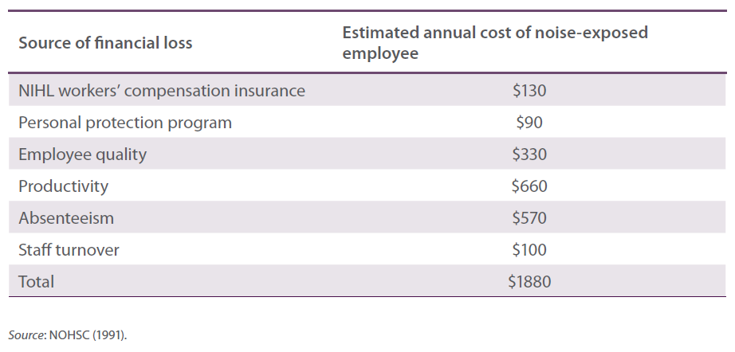
Lack of reliable and valid data makes it difficult to quantify productivity losses due to occupational noise exposure and ONIHL. However, as suggested above, occupational noise may also reduce business productivity indirectly through related factors such as employee absenteeism, turnover and accident rates. There is very little Australian data on the relationship between occupational noise and these factors and almost no data on the associated costs (BTE 2000). What the available literature can establish is plausible links between noise exposure and the various indirect effects (see Chapter 1 and Appendix A). It may be argued that business owners and managers are more likely to take note of these effects when they are reflected in the business cash flow or profits.

Productivity
Economic productivity is the ‘value of output obtained with one unit of input’ (Piana 2001, p1). In a similar vein, physical productivity is the ‘quantity of output produced by one unit of production input in a unit of time’ (Piana 2001, p1). Productivity directly affects the financial performance and profits of a business. If the employees’ productivity levels fall the business will produce less output from the same level of input, resulting in lower profits for the business. Therefore, it is reasonable to expect a business to act on anything that affects the productivity levels of employees.
There is little research quantifying the effect of excessive occupational noise exposure on productivity. A few studies suggest that noise may decrease worker productivity by 0.5–2.0% (EASHW 2005 NOHSC 1991 Noweir 1984). A study of textile workers in Egypt found that workers exposed to noise above 90 dB(A) were 1.4% less productive than their non-exposed workmates (Noweir 1984). Although small, this difference was statistically significant.
The Finnish Broadcasting Company introduced what they intended to be a comprehensive noise reduction program (EASHW 2005). The intervention included a range of assessment, education, training and monitoring activities as well as engineering solutions and a more comprehensive and user-focussed personal hearing protection program. Based on the 2004 value of the euro, the intervention cost over €150 000 but resulted in benefits such as improvements in work quality, use of work time and job satisfaction (EASHW 2005). The improvement in work quality and efficiency of the 85 production crew members was reported as 0.5%, saving €17 000 per year. In addition, an estimated €2500 is expected to be saved with every case of avoided ONIHL (EASHW 2005). However, it was not shown how these estimates were obtained. Despite the lack of detail on how the benefits were estimated, this example covers the key elements of a persuasive business case for investing in effective noise control. That is, it details the initial capital investment, provides an estimate of the saving associated with the desired outcome (i.e. fewer ONIHL cases), lists the additional benefits, and attempts to quantify a productivity dividend. Unfortunately, as illustrated below, noise control and ONIHL prevention business cases rarely include all of these elements.

Employee absenteeism
Employee absenteeism is unscheduled absences from the workplace. It is a costly problem for employers because it reduces the productive capacity of a business. If the employer chooses not to replace the absent employee, the cost is equal to the value of production lost as a result of the absence. If the employer chooses to replace the absent employee, the cost covers all associated items, such as recruitment, training and the interim staff shortage. For example, the annual cost of workplace stress related absenteeism to the Australian economy has been estimated to be $5.12 billion a year, of which the direct cost to Australian employers is $3.48 billion a year (Econtech 2008).
Along with dust, heat and fumes, excessive occupational noise is a physical characteristic of the workplace that has long been recognised as a contributor to absenteeism (e.g. Knight 1973 Melamed et al. 1992). One explanation for the relationship between noise and absenteeism is that noise contributes to detrimental physiological effects that reduce workers’ capacity to perform their duties (Clarke 1984). Another explanation is that an unpleasant work environment increases a psychological aversion to return to work each day (EPA 1976).
A Swedish study of the impact of mechanising a forge in 1974 reported reduced occupational noise levels from 96 dB(A) with peaks of 110–115 dB(A) to 80–88 dB(A), a reduction in absenteeism from 13.8% to 8.5%, and a reduction in annual turnover from 77% to 44% (Elvhammar 1981). However, the reported fall in absenteeism could have been due to a combination of factors in addition to reducing workers’ noise exposure, including the elimination of monotonous work, the proportional increase in skilled work and the reduction in the staff numbers from 44 to 28. Nevertheless, the economic gain due to lower absenteeism was calculated to be equivalent to US$7300 in 1974.

Employee Turnover
Employee turnover is the ratio of the number of workers that have to be replaced in a given time period to the average number of workers (Phillips 1990). Employers incur both the direct and indirect costs of turnover. Direct costs are related to recruitment and training. The list of potential indirect costs is long and includes the following
- loss of productivity, increased overtime payments
- reduced service and/or product quality
- costs associated with increased risk of accidents for new employees
- customer service disruption
- loss of client revenues and/or reimbursement, and
- deterioration of organisational culture and employee morale (Phillips 1990).
Good studies of the economic relationship between noise exposure and employee turnover are rare (see Elvhammar 1981, described above). Nevertheless, several studies have investigated the cost of employee turnover per se. For example, an American study found the cost in retail supermarkets to be $2286 (in 2000 US dollars) per non-union cashier and $34 735 per store manager (Blake 2000). Other studies in the USA have estimated the direct cost of turnover to be at least $2500 (2004 US dollars) per long-term care worker (Seavey 2004) and $2307 (in 2004 US dollars) per health worker (Waldman et al. 2004). In addition, indirect costs per health worker were between $4061 and $10 709 (Waldman et al. 2004).

Accident rates
Both occupational noise and hearing loss can interfere with workers’ recognition of warning signals and verbal communication and hence contribute to the risk of workplace accidents (Kilburn et al. 1992 Moll van Charante & Mulder 1990). Reducing accident rates has the potential to reduce workers’ compensation liability, employee absenteeism and turnover while increasing business productivity. For example, the combined effects of noise exposure and hearing loss have been found to contribute to over 40% of injuries in a shipyard in the Netherlands, which was equated with an absenteeism rate of 3.5 person-years per year (Moll van Charante & Mulder 1990). However, Holland and Cross (1995) suggest that the accident-reducing benefits of noise control are extremely difficult to cost and any value offered is very difficult to justify.

3.2 Benefits of effective noise control
In the previous section we described how exposure to excessive occupational noise and cases of ONIHL can lead to costs above those of implementing noise controls and paying workers’ compensation insurance. Avoiding these costs can be seen as a benefit of investing in effective noise control. Effective noise control can also benefit a business’ bottom line by generating indirect (or ‘flow-on’) gains which are often unexpected and not considered at the time of making the investment.
As with the literature on the costs of ONIHL, there is very little empirical research that quantifies the benefits of effective noise control. Possible reasons for this scarcity of research include (1) the technology and practices of noise control have only recently proven cost-effective, (2) researchers and business owners have not recognised why it would be worthwhile to measure the cost-effectiveness of noise controls, and (3) it is often difficult to measure the costs of noise exposure and the benefits of reducing it.
The noise management literature contains business case studies where noise control was the main focus of the activity. In most of these case studies reduction in noise levels was the only benefit reported. However, there are several case studies from Australia and overseas that provide anecdotal evidence of additional benefits resulting indirectly from noise control. Commercial enterprises and researchers have used these case studies to demonstrate the cost-effectiveness of properly controlled noise.

Noise control business case studies
EARS Australia’s description of their Exhausted Air Recycling System (EARS) provides a rare illustration of quantified benefits of effective noise control. According to EARS Australia, these benefits result from the decrease in noise production and increase in the power of air compression their system is claimed to deliver. That is, fitting with EARS can reduce the noise level of an impact wrench from 93.1 dB(A) to 69.1 dB(A) at the operator’s ear when free running and from 92.7 dB(A) to 88.2 dB(A) when tightening wheel nuts (EARSA 2008b). In addition, it is claimed that by fitting EARS on a 11 kW screw compressor in order to generate the same air volume as a 20 kW screw compressor, $25 000 (2008 Australian dollars) can be saved over 10 years from savings on energy costs ($21 000) and capital costs ($4000) (EARSA 2008a).
The economic benefits reportedly associated with EARS Australia’s product are more of an advertisement than a case study. Work health and safety literature from Australia, the USA, the UK, and the European Union contains case studies from businesses that successfully and cost-effectively reduced noise at work. Besides reporting the noise reduction achieved, these case studies often highlight other benefits of noise controls. However, it is rare for benefits to be quantified in monetary terms. It is also important to note that business case studies, especially those provided by parties with commercial interests, are often selected for their positive impact. That is, those cases that demonstrate no appreciable additional benefit, let alone a financial loss, may not be properly represented. Nevertheless, the value of case studies is that they illustrate the benefits that are possible, even if the likelihood and magnitude of the benefits remain largely unknown.

Australia
Three case studies from businesses in Australia show that proper control of noise at the source can not only reduce the risk of hearing loss but can also reduce machine wear, increase production speed, and increase profits (Scannell 1998). Further, by examining noise sources, solutions were found that did not require the adoption of enclosures, which the author noted can often be inconvenient and sometimes fail to achieve adequate noise reduction if there are openings for product or operator access (Scannell 1998).
The first case study involved a power press that, on average, generated 96 dB(A) at the operator position. For the cost of one day’s labour and about $50 in materials, the vibration in the power press fly wheel was reduced and resulted in a 10 dB(A) reduction in noise levels and an extension of the machine’s life by eight years. In the second case study, fitting a vibration damping device to a band saw reduced noise levels close to the machine by 21 dB(A) from the pre-fitting 91 dB(A). The reduction in vibration also improved the quality of the cut and extended blade life (Scannell 1998). In the third case study, $5 vibration damping straps were fitted to castings of a lathe. The straps reduced the noise at the operator’s position by 16 dB(A) from the pre-fitting 94 dB(A), improved the cut quality, reduced machining cycle time, and extended machine life (Scannell 1998).
A noise control program in an Australian subsidiary of a multinational manufacturing company included a buy-quiet policy and engineering controls such as total and partial enclosure of the noisy equipment (NOHSC 1991). In addition to reduced noise levels, the program removed the need for PHPs for most of the workers and improved worker morale. An important aspect of this case study was the need to present management with sufficient evidence of the need for the noise control program.

United States of America
An estimated US$137 million in compensation was paid in 2005 to more than 18 000 United States Department of Navy veterans with hearing loss. In response to this problem, the Department of Navy developed a model that allows the calculation of the return on investment of noise control measures for whole ships and specific hazardous noise areas (Bowes et al. 2006). The return on investment model predicts a 151 to 171 return on investment from noise abatement engineering methods. This return is expected to come from avoided costs related to hearing conservation programs, personnel protection devices and additional recruitment. Other benefits of noise reduction—such as the impact on personnel morale, life quality, and mission capability—are identified but not quantified or included in the calculations. Bowes and colleagues note that the calculator tool needs to have sufficient sophistication to give realistic solutions while being simple enough to encourage use.

United Kingdom
In 1991 the Health and Safety Executive (HSE) aimed to encourage users and manufacturers to make proper use of existing technology. Part of the strategy to achieve this aim was to show how noise reduction at source can be a better and cheaper option if proper investigation and analysis of machine operation and noise generation is applied (Herbert & Miles 1991). Examples of noise treatments were taken from the footwear industry. The authors concluded that worthwhile noise reductions could be achieved without modifications that would compromise their operation. In addition, they concluded that the cost of applying the noise controls at the time of machine building would be minimal and would also provide long-term energy savings (Herbert & Miles 1991).
A collection of 60 business case studies published in 1995 contained nine cases that reported benefits additional to a reduction in noise exposure (HSE 1995). One case study reported savings from reduced compressed air consumption by replacing equipment with an improved design. Benefits reported in the other eight case studies include increased equipment life and strength, avoided purchase of new equipment, and improved work quality and productivity.
Another, more recent collection published by the HSE describes 60 case studies from the food and drink industry (HSE 2002). Thirty-nine of the cases included a reduction in noise to below 90 dB(A). Of these 39 case studies, 16 identified additional benefits. However, none of the additional benefits were quantified in monetary terms. Nevertheless, among these 16 cases the noise control solutions increased work efficiency and communication, made the workplace and equipment easier to clean and maintain, reduced product and equipment damage, reduced expenditure on energy and hearing protectors, and reduced the risk from manual handling, cuts, falls, slips and trips (HSE 2002). It was also reported that removing the requirement to wear hearing protectors made staff happier (HSE 2002).
The benefits of engineering noise controls are further demonstrated in a report containing three case studies (Wilson 1990). The first case study described how modifying the housings and fitting dampeners on a cigarette making machine reduced noise levels by 3–4 dB(A) from the usual operator noise levels of 92–93 dB(A). This retro-fit was low cost and did not affect normal operating procedures. The second case study involved redesigning the cooling fan and air flow of a vacuum cleaner to reduce noise levels at one metre distance from approximately 78 dB(A) to 67 dB(A). It also achieved a considerable reduction in the annoying tonal qualities of the noise. This improvement in noise level and quality was considered a feature of the vacuum cleaner that could be marketed. The third case study concerned reducing noise levels of multi-spindle automatic lathes. The manufacturer improved the production process to ensure the gearbox was accurately aligned with the motor, reducing gearbox vibration and reducing noise by 7 dB(A) from operator levels of 87–90 dB(A). This noise reduction cost very little and met customer standards (Wilson 1990).

European Union
The European Agency for Safety and Health at Work describes 19 cases studies of European businesses implementing noise controls (EASHW 2005). Eighteen of these case studies did not place a monetary value on any benefits resulting from reducing workplace noise. The remaining case study examined the process of reducing noise exposure in television and radio broadcasting in Finland and reported an improvement in efficiency and quality of the work.
A case study from a large manufacturing company in Sweden involved 70 projects to improve noise, layout, ventilation and lighting conditions (Elvhammar 1981). The annual return on investment—based on improved work efficiency—was greatest with noise (23% annual return) compared with layout (16%), ventilation (11%) and light (8%). It was also reported that machinery noise reduction yielded an annual return on capital investment of 115% compared with noise screens (79%), enclosures (34%), and sound absorption (1%). However, it was noted that it was not possible to deduce from this case study if there was a correlation between noise reduction and efficiency, costs and annual return (Elvhammar 1981). Determining these cost savings/reductions is difficult for two reasons first, the factors of noise, layout, ventilation and lighting conditions cannot be separated out secondly, these interventions occurred concurrently with a downsizing exercise, which may have contributed to the findings.

3.3 Conclusions
Work health and safety legislation requires business owners to implement controls that are ‘reasonably practicable’. That is, business owners are not required to implement controls that would incur unreasonable costs, even though cost is not the only determinant of ‘practicable’. In addition, government agencies in Australia are required by the Office of Best Practice Regulation to demonstrate that the costs of proposed interventions are justifiable to business. These provisions require sufficient information on which to build an economic case that can justify the cost of controlling noise exposure and identify costs and benefits measured in dollar values. Similarly, evidence is required if one were to argue that spending the minimum to comply with work health and safety laws will often be a false economy compared to the potential savings and gains that may result from higher investments.
In many instances there is an obvious relationship between noise exposure and control and the resulting costs and benefits (Table 3.2). However, business owners (and researchers) often do not recognise that such costs and benefits exist or why it would be worthwhile to consider and quantify them. Also, indirect costs and benefits are generally difficult to measure and typically cannot be estimated from a single data source. Further research is required that involves both a meaningful reduction in the occupational noise level and adequate control of potential confounders, including difficult to measure variables such as employee morale.
The available research provides some, but not conclusive, evidence that excessive exposure to occupational noise and/or resulting ONIHL can lead to costs that are greater than those of implementing effective noise controls. Unfortunately, the few available studies suggest that these costs are often not considered. There is little reliable research on the indirect costs of occupational hearing loss, such as lost productivity, lost current and future earnings, lost potential output and increased accident rates. Much more research, with better control of confounding factors, is required for these costs to be established firmly and quantified.
Noise control business cases can be found which demonstrate that, in addition to reducing exposure to hazardous noise, effective noise control can reduce the cost of energy and maintenance as well as improve efficiency, quality, safety and wellbeing. These benefits (savings and gains) come mostly from engineering controls and eliminating noise at source. However, such benefits are often not anticipated (i.e. they are usually indirect) and are often difficult to measure (i.e. intangible). On the other hand they can often be demonstrated on a case-by-case basis. For example, effective noise control and the resulting benefits may sometimes simply require having inexpensive and straightforward engineering and administrative solutions pointed out to the manager on-site. However, more evidence is needed before a compelling and reliable argument can be made to implement controls for their likely short- and long-term benefits as a matter of course.
Overall, the research suggests that excessive noise can affect a business’ overall productivity and that reducing noise exposure and/or preventing ONIHL may lead to benefits such as higher morale and greater productivity. However, a key message from the literature is that legislation, and the prospect of enforcement and significant sanction, will be the only driver of the pace and extent of occupational noise control unless additional, more effective controls are demonstrated to be inexpensive or result in economic benefits (Gibson & Norton 1981 Neitzel 2002). Therefore, greater awareness of evidence-based costs and benefits and acceptable ways of measuring them are needed to facilitate more effective noise control and ONIHL prevention.
In the next chapter we report on a survey designed to explore noise control issues, including costs and benefits. In Chapter 5 we provide an example of a possible occupational noise control cost-benefit analysis model that considers the key factors that have emerged from the literature reviewed in the present chapter and from findings of our empirical studies outlined in the next chapter.

Table 3.2 Costs and benefits of noise exposure, ONIHL and noise control
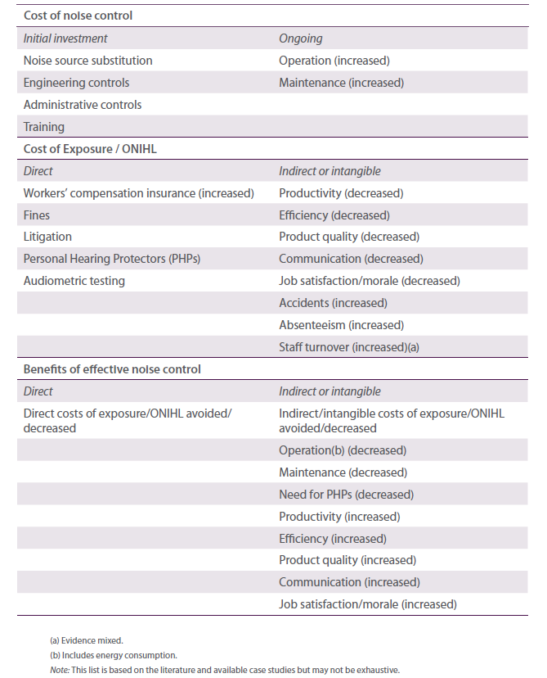

Remaining questions
- Which benefits from effective noise control and ONIHL prevention can be quantified?
- Which of these benefits can be used as noise control incentives?

Chapter 4 Barriers and enablers studies
In this chapter we report on the findings of several data collection activities designed to examine the main barriers and enablers to effective noise control and ONIHL prevention. Each of these studies (focus group discussions, nation-wide surveys, and face-to-face interviews) were essentially explorative and qualitative in nature and their results should be interpreted with due caution. The focus group discussions and interviews had small samples and the surveys involved quota sampling, which gives a non-probability sample. Therefore, population estimates cannot be made and hypothesis testing has been kept to a minimum. Appendix B contains technical details of the survey studies along with detailed tables and graphics of the results.
Throughout this chapter, the term ‘workers’ is used to represent employees and, unless otherwise indicated, the term ‘managers’ is used to represent business owners, employers, senior managers, and work health and safety managers and representatives. These terms are sometimes used interchangeably.

Chapter 4 Highlights
- ONIHL has low prominence as a work health and safety issue.
- Knowledge of the effects of noise could be better.
- The risk of workers’ compensation for ONIHL is not an enabler for noise control.
- 46% of workers provided with PHPs do not wear them at least most of the time while working in loud noise and 31% never wear them.
- About 50% of workers provided with PHPs at least sometimes remove them while working in loud noise.
- Nearly 90% of managers believe that their noise control is effective, but most of this refers to PHPs.
- Large businesses are more likely than small or medium sized businesses to have higher-order noise controls.
- Besides lower noise, morale is the noise control benefit most often considered before investment and experienced after investment.
- Increased productivity and safety were other commonly perceived benefits of noise control.
- Perceived cost of noise control was seen as a barrier.
- Insufficient knowledge regarding implementing noise controls is common.
- An over-reliance on PHPs as the primary, if not only, noise management measure is common.
- Peers and role models are seen as a good way to educate workers and managers about noise control and hearing loss prevention.

4.1 Focus group discussions
The initial data collection phase of the project comprised focus group discussions and follow-up interviews among workers and managers from the following five industries in which the risk of ONIHL is high Manufacturing Construction Transport and Storage Hospitality and Entertainment and Agriculture, Forestry and Fishing.
The major aim of this study was to provide content and direction for the nation-wide surveys of workers and managers. Specifically, the focus group discussions sought to gain a rudimentary sense of the following
- barriers and enablers for the prevention of ONIHL (including awareness of noise levels in the workplace, awareness of risk to hearing, types of noise control measures, availability and use of hearing protectors, conditions that make a noisy environment, and the relationship between a noisy environment and productivity)
- perceived costs and benefits of effective noise control (including types of costs in achieving a workplace free of hazardous noise, costs to employers such as loss of productivity, and perceived costs to employees such as medical costs), and
- perceived types of benefits gained from a workplace free of hazardous noise.

Methodology
Workers and managers were interviewed separately. Each stream covered the same topics although managers provided more detailed information regarding perceived costs and benefits.
Four 90-minute focus group discussions were conducted with workers from manufacturing, construction, transport and storage, and hospitality and entertainment. Participants were grouped according to their industry so that industry-specific stories were recorded and case studies pertaining to each industry developed. This optimised the group dynamic and ensured group homogeneity essential to an effective focus group discussion. The focus group discussions each comprised 6–7 workers and were conducted in two locations, Sydney and Canberra.
In total, 27 workers attended the focus group discussions. Each focus group included a range of ages (20–60 years) and a range of business types within each industry. Participants were predominantly male across all industries, with most female participants coming from entertainment or hospitality.
All participants worked in a noisy environment as defined by the need to raise their voice when communicating with someone one metre away. At least two participants in each group stated that they wore PHPs at least most of the time when working in loud noise. In this way, a range of views and experiences about ONIHL and the wearing of PHPs were included in each workers group. A range of company sizes were also represented within each workers group.
As part of their inclusion in the study, all participants were required to complete a pre-discussion questionnaire and a post-discussion follow-up interview. This provided each individual the opportunity to reflect on their own journey and the key issues identified in the group discussion that resonated most strongly with them personally. Personal shifts in attitudes to ONIHL and preventative/protective measures were recorded and key factors driving such claimed attitude change noted.
Five 2-hour focus group discussions comprising 4–6 managers were conducted across the five industries.
In addition, 10 telephone interviews were conducted as a means of boosting the sample and capturing individual information. Within each focus group there was a range of business types from each industry, a range of business sizes, and males and females who worked in an environment that was noisy at least sometimes.
Participants from small and medium-sized companies with up to 199 employees and large companies with over 200 employees were at all times interviewed separately due to the potential for divergent attitudes and behaviour related to ONIHL and the concern that professional work health and safety managers in large companies may restrict owners of smaller businesses from revealing their true attitudes and behaviours.
In total, 24 managers attended the group discussions and a further 10 took part in an in-depth telephone interview. One of the focus group discussions was conducted with five farmers in the Goulburn area. Each of these participants owned their own farm, usually as part of a family business.

Findings

Prominence of ONIHL as a work health and safety issue
This study found ONIHL—or industrial deafness as it is better known among workers—to have low prominence among almost all participants as a work health and safety issue. Most participants believed that hearing loss was not the result of an accident or a one-off incident and there were no immediate life threatening and visible consequences of hearing damage. Rather, ONIHL was believed to be incremental and lacked urgency. The majority of participants did not rate it as highly as other potential workplace injuries.
Perhaps because deafness was considered to be such a long term, cumulative illness with publicly invisible symptoms that are only suffered decades after exposure has occurred, there was broad complacency about hearing loss in this study. The consequences of hearing loss did not appear to be taken seriously by almost all but those who were already severely afflicted. Noise was generally accepted by most participants and it was not necessarily considered detrimental. Many participants, especially younger ones, considered noise as just a function of life, such as a part of their leisure time. There was also a widely held belief among participants that hearing loss is simply part of the natural ageing process.
Many participants did not understand enough about the cause-effect connections between noise and hearing loss. One major reason for the failure to make this link is the time lag between exposure to excessive noise and experience of irreversible long-term impairment. The workplace exposures that cause long-term hearing loss were not well understood by the majority. There was also a poor understanding among most participants of what caused short-term hearing damage. According to participants, immediate, short term symptoms of hearing damage generally occur away from the noise source and at night or on weekends rather than at work. This failure to link cause and effect underpinned a current reluctance observed among a majority of both workers and managers to adopt preventative action.

Barriers to effective noise control
This study revealed several barriers to the adoption of behaviour consistent with the prevention of ONIHL. For example, active avoidance of the issue of ONIHL was evident among some managers. A small group of managers was even resistant to a discussion of the issue. This group was reluctant to learn more about noise and ONIHL within the group environment because of their reported concern for additional costs in the areas of capital investment, insurance premiums, compensation claims, and PHPs for their workers.
Active avoidance was also evident among workers. For example, there was a range of barriers to the wearing of PHPs, which workers often regarded to be uncomfortable and in some instances to even add to their risk levels. The decision to wear PHPs was therefore a process of managing differing levels of risk and in many instances a decision against wearing them was reported as the result.
About half the workers taking part in this study expressed the broad belief that the level of noise to which they were personally exposed was not problematic. This belief has acted against the decision to wear PHPs when needed and is in spite of the fact that recruiting specifications determined that employees worked in high risk industries where they ‘needed to raise their voice when communicating with someone one metre away’.
The majority of workers and many managers of smaller companies maintained that noise that was intermittent was less damaging. Decisions to dress in protective apparel were therefore weighed against the length of exposure and the time allotted to the task and a judgement was then made regarding the level of risk generated by the noise exposure compared with the need to gather and dress in PHPs. Intermittent noise is therefore a major problem that requires separate and individual communications focus. The common underestimation of the harmful effects of exposure to excessive noise suggests that intermittent loud noise may in some ways be more problematic than continuous noise. This study found unexpected intermittent noise especially concerned those who wished to protect themselves but who were not expecting to need to do so. While they comprised a small group of workers, it seems that communication of the need for consideration for others is also required when discussing intermittent noise.
Strategies to address barriers to wearing of PHPs must also note the prevalent belief observed in this study, especially among industries with ongoing noise (e.g. manufacturing and hospitality), that the wearing of PHPs prevents one from doing their job well. The risk to hearing needs to be established relative to other risks encountered (e.g. failure to hear machinery or vehicles) in such environments and alternative behaviours need to be seriously considered. Many workers claimed that supervisors often requested those working in continuously noisy environments to remove their PHPs so that they could be spoken to directly. Alternative practices in this regard need to be established.

Education and training issues
In concordance with the admitted invisibility of the issue of ONIHL among participants, this study found little common knowledge regarding the following
- what constitutes a hazardous environment (e.g. decibel levels regarded as harmful, duration of damaging noise, the relative danger of continuous noise versus intermittent noise, the level of damage that is potentially caused by which machinery/activity)
- effective PHP procedures (e.g. the relative effectiveness of ear muffs and plugs and how to insert ear plugs correctly), and
- issues surrounding how to source information (e.g. managers and workers alike claimed to have difficulty sourcing information about ONIHL and noise control).
Potential channels of communication for correcting these knowledge gaps may include videos at induction and work health and safety training meetings, or perhaps in lunch rooms fact sheets and flyers on specific issues such as ear plug insertion techniques work health and safety manual insertions (most employers and work health and safety managers complained that there were none at present) and brochures or letters direct to employers. While ONIHL was found to lack physical visibility and urgency as a health issue among the majority of both workers and managers in this study, a discussion of the ramifications for the quality of life of those participants with permanent hearing loss had a major impact on the majority of workers in particular.
The irreversibility of the symptoms when compounded by the perceived severity of such conditions as tinnitus had a major impact on these participants. Ramifications for a person’s quality of life generated a significant pause for thought among most participants in the worker groups. Attending the group discussions motivated a few managers to raise the topic of preventative measures at their workplace the next day, and a post group telephone follow-up one week after the group sessions highlighted the extent to which almost half the employees had either positively altered their claimed behaviour in relation to wearing PHPs or claimed to have actively flagged the issue with their workmates.
Tinnitus (ringing or buzzing in the ears or head) was something everyone agreed is to be avoided.
Tinnitus is important as a centrepiece in communications strategies which aim to register the resultant diminished quality of life for long-term sufferers. It carried significant shock value for all worker participants and their responses suggest that testimonials may prove to be a significant motivator for behaviour change. Several case studies of tinnitus sufferers were exposed in this research. Their stories of personal suffering and the impact that tinnitus had on their quality of life significantly affected and shocked all other worker participants in the group discussion and gave a visible and human face to an otherwise invisible condition. Managers were less directly exposed to the plight of tinnitus sufferers in their group discussions but a majority of those attending also expressed concern when the impact of tinnitus on a person’s quality of life was described.
How to insert ear plugs correctly also needs be communicated. Very few workers or managers taking part in the study were aware that there was a correct insertion technique. As a result, considerable discussion focussed on the difficulty of ensuring that ear plugs did not fall out once inserted. Perhaps appropriate insertion techniques need to be communicated to managers who could pass such key information on during weekly toolbox talks where demonstrations would be feasible. If not already the case, insertion instructions need also to be included in ear plug packaging.
Signs may reinforce appropriate behaviour at key points of exposure. Some discussion in this study among workers in larger companies noted that when signs were in place managers and workers felt obliged to follow their instructions. However, one key finding was that communication strategies must adopt an industry-specific approach and include solutions that are relevant to the particular circumstances.

Organisational culture
Four distinct work cultures have been identified in this study, exhibiting a range of attitudes towards work health and safety issues and the wearing of hearing protection. All have in common a current lack of knowledge and awareness of ONIHL, with some more actively resistant than others to acknowledging excessive occupational noise in their workplace. For the minority who were more actively resistant, the additional cost to their bottom line of implementing solutions to the problem gave rise to their concern. The four work cultures, or ‘organisational segments’, are
- proactive protection—large organisations which usually have 200 or more employees and have the manpower to enforce policy
- laissez-faire—mid-sized companies that are supportive of work health and safety policies but do not have the manpower to supervise workers and their wearing of PHPs
- disassociated—mid-sized companies who are concerned about work health and safety but noise is not on their agenda), and
- active discouragement—small companies somewhat ignorant of work health and safety principles who discourage all employees from wearing PHPs.
The ‘laissez-faire’ segment requires employees to take initiative for their own personal protection whereas the ‘disassociated’ segment is completely unaware of ONIHL as an issue. In the ‘active discouragement’ segment time spent fitting PHPs represents money lost. Many of those working in the ‘proactive protection’ segment were distressed to hear that other workers worked in environments that did not actively promote PHPs. It is something they now take for granted as being normal and sensible workplace behaviour.
All manager participants expressed some sensitivity to the acknowledgement of possible ONIHL occurring at their work site, fearing workers’ compensation claims. While it was generally believed that an ONIHL claim was on balance unlikely to succeed due to the incremental nature of the condition and the time lapse between the cause and the onset of irreversible symptoms, most businesses represented in this study remained cautious to the possibility.

Financial incentives for noise control
The promotion of successful hearing loss compensation claims was felt by all managers taking part in this research to be the only way that ONIHL would be taken seriously and understood as a significant issue.
Most managers felt that attitudes would be quickly modified if hearing damage compensation claims were well known to be successful.
New machinery acquisition provides an opportunity to address noise reduction. The findings of this research suggest, however, that it will take some time before reduced noise exposure provides a major reason to purchase a machine. It was also suggested by some managers that perhaps some financial relief in the wa of tax incentives for purchasing quieter machines could also be considered to encourage this activity.
In addition, there may be opportunity to address the present difficulty noted in this research for many workers to have their PHPs with them when required. This is especially so for the many employees who worked with intermittent noise. Suggestions in this research focussed on a redesigned tradesmen’s tool belt, which currently has provision to hold a tape measure and other items and could perhaps with some small design adjustment also include a compartment for housing PHPs.
Another design suggestion by many workers involved simply attaching a string to ear plugs so that they could be worn around the neck and put in place easily when required for intermittent noisy tasks. This was reportedly a design feature of the very expensive acoustic ear plugs which seemed to gather support among a majority in the group discussions. However, corded ear plugs have been available for many years and are usually no more expensive than the non-corded variety. Respondents’ lack of awareness of this fact is a concern. It was mentioned that ear plugs should remain inexpensive but with some variation in design and packaging to encourage more frequent use.

4.2 Nation-wide survey of workers
The nation-wide survey of workers had the following main objectives
- determine the type of noise controls at work
- determine if PHPs are provided at work
- measure how often hearing protectors are used
- determine the reasons for not wearing PHPs
- understand attitudes towards hearing loss and workplace noise, and
- understand attitudes towards occupational health and safety in general.
Limitations in time and resources required that this survey and the parallel survey of managers were conducted as self-report surveys using telephone and internet modes of interviewing. Consequently, the survey questionnaires were required to be as short as possible. In addition, the samples were collected by quota sampling, which produces non-probability samples. All of these conditions have consequences for the validity and reliability of the results, which should be interpreted with caution. Statistical findings reported below should be read in conjunction with the detailed tables and graphs in Appendix B.

Methodology
The workers survey consisted of 1108 interviews with workers aged 18 years and over from five atrisk industry groups as well as other industries that experience loud noise (Table 4.1). A mixed-mode approach was undertaken involving computer-assisted telephone interviewing (CATI) and internet-based surveying. Respondents were screened on the basis that they undertook paid work in the two weeks before the interviews and their birthday came next in the household. Specific quotas were placed on industry groups with soft quotas by noise exposure and non-exposure. CATI respondents were randomly selected using a combination of an electronic-based White Pages listing and random digit dialling. The online sample was sourced externally from an online research panel. Each survey took approximately 10 minutes to complete. All interviewers were fully briefed on the research project prior to commencement of interviewing, where all interviewer instructions were cleared through Safe Work Australia. The survey was completed over two weeks in November 2009. Response rates were 29% from the CATI mode and 45% from the internet mode.

Table 4.1 Workers sample
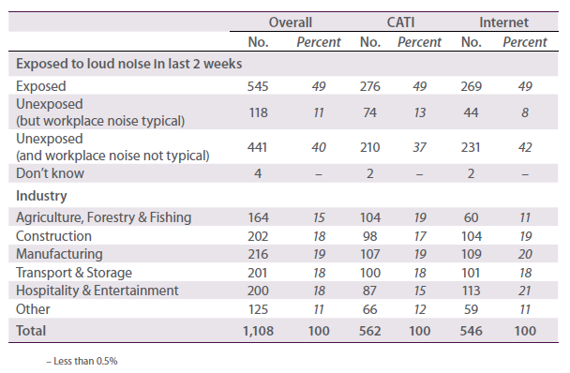

Findings

Self-reported hearing
Nearly two-thirds of respondents generally feel that their hearing is good (Table 4.2). Over one-third experience some degree of hearing difficulty—incidence levels of which may be higher considering results are based on a self-reported assessment. Those working in Hospitality and Entertainment say they are less likely to have trouble hearing although, respondents may not be aware if their hearing is optimal considering that hearing loss can happen gradually and perhaps unnoticed. Furthermore, professions in this industry are often exposed to ongoing levels of noise (e.g. music, live bands, coffee grinders, etc.), and as such, hearing abilities may be affected. Four in 10 respondents experience ringing or buzzing in their ears or head (i.e. tinnitus) with it being continuous for 7%.

Table 4.2 Summary of findings from key questions
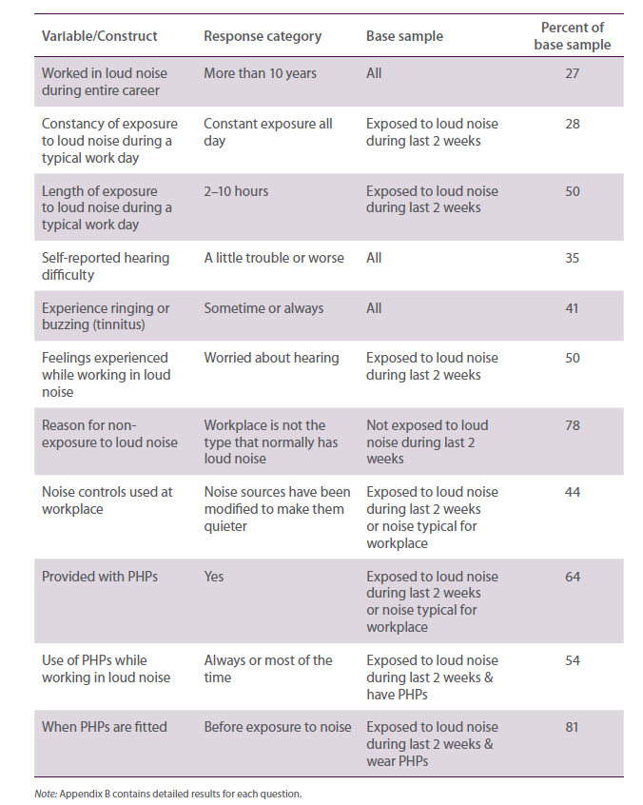

Exposure to loud noise
Just under half (49%) of respondents said that they were exposed to loud noise at work in the last two weeks. Another 11% said that they were not exposed in the last two weeks but noise was typical in their workplace. Workers employed in industries where loud noise is a common workplace hazard have worked in loud noise for several years, increasing the risk of hearing loss. For instance, 34% of workers from this study have been exposed to excessive noise for one to 10 years and 27% for over 10 years.
The degree of daily exposure is fairly high with 61% being exposed for at least several times a day. That is, 33% of exposed respondents work in several loud periods a day and 28% are exposed constantly during the day. Half of the exposed respondents works in loud noise for between two and 10 hours a day. One third usually spends less than two hours a day working in loud noise.
On average, workers spend 4.7 hours a day working in loud noise. However, it should be stressed again that each of the research studies conducted for the present project were essentially qualitative in nature. Therefore, the findings cannot be used to provide representative estimates of the extent of noise exposure, noise-induced hearing loss, or noise control adequacy and use. Despite high reported rates of noise exposure, most workers could identify a quiet area for rest breaks.
Several differences were found between CATI and internet respondents. CATI respondents are more likely to be exposed to loud noise constantly and to have worked in loud noise for over 10 years. This compares with internet respondents who have not been exposed to loud noise as long. This difference may be influenced by the composition of the sample, where internet participants joined their respective industries more recently. Internet respondents are more likely to report working in loud noise for 10 or more hours than CATI respondents who have a higher propensity to work between 6–10 hours a day. While results are inconclusive, they may be potentially influenced by social desirability factors.

Awareness of causes and consequences of noise and hearing loss
There is good awareness of the conditions that cause hearing loss, including the impacts of excessive exposure to noise. For instance, a high 90% understand that exposure to loud noise can result in tinnitus and that continued protection is still needed even when hearing loss has occurred. Workers are aware of potential sources of loud noise (e.g. heavy machinery, forklifts, generators, and pumps being among the most prevalent sources) and that hearing loss does not only happen as a result of ageing.
Although close to seven in 10 intend to wear hearing protectors whenever they work in loud noise, the high awareness levels are not necessarily reflected in how workers behave. Education is needed, particularly within the Transport and Storage and Hospitality and Entertainment industries, to emphasise the need to wear PHPs all the time and not just partly or only when noise levels become uncomfortable.
Greater awareness is needed on how hearing loss occurs. That is, people need to understand that it can begin gradually and accumulate over extended periods of time.

Noise controls
Of the 559 respondents who said they were not exposed to loud noise in the last two weeks, 78% said this was because their workplace was not typically noisy and 72% said it was because noise was well controlled. Sixteen per cent said it was quieter than usual.
Overall, the implementation of noise controls is moderate (Figure 4.1). The most common forms of safeguard include isolating loud machines (48% identifying with this action always/sometimes). Workers who have not been exposed to loud noise recently but where loud noise is typical at their workplace are significantly likely to have this noise control in place (60%). This is followed by the placement of barriers between noise sources and workers (46%)—not as commonly practiced in the Hospitality and Entertainment industry (35%)—and modifying noise sources to make them quieter (44%).
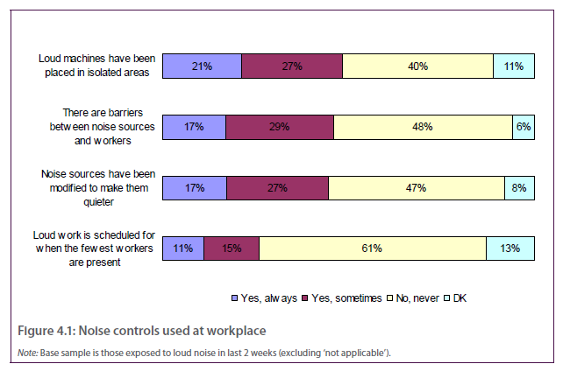
About one quarter reported that loud work is scheduled for times outside of peak periods, when fewest workers are present, which is more common in Agriculture, Forestry and Fishing (38%) than in Manufacturing (18%). Among those who have had no exposure to loud noise in the last 2 weeks, seven in 10 claim that effective noise controls are in place at work.

Personal hearing protectors
Some 64% of workers report having been provided with PHPs. To maximise protection, it is just as important to educate or remind workers that PHPs should be used at all times when in loud noise as it is to provide them. Among those with PHPs, only half wear them always/most of the time when working in loud noise. In particular, those working in Agriculture, Forestry and Fishing (69%), Construction (69%), and Manufacturing (65%) are most likely to wear them, possibly due to the nature of their work. Workers in Hospitality and Entertainment are most at risk with about 60% saying they never wear PHPs. About half of the respondents who wear PHPs sometimes remove them while working in loud noise.
Of those who wear PHPs, 80% put them on prior to experiencing loud noise. Analysis by industry sector and demographics reveals no significant differences. Many who fit their PHPs after experiencing loud noise only wear them when perceived noise levels are unbearable for instance, when the noise gets too loud or uncomfortable. This increases the risk of hearing loss. Some respondents mention fitting the protectors after first exposure as they were not aware that the loud noise was coming. Others underestimated the amount of time they would spend working in loud noise.
Among those who do not always wear PHPs, wanting to engage in conversation with others is the most common reason (48%) (Figure 4.2). Over four in 10 respondents claim that PHPs are not always needed given that they do not work in loud noise for long periods. This belief can be dangerous given that workers are not always conscious of the intensity of noise levels. Noise that appears safe to the untrained or habituated ear could be harmful. The discomfort of PHPs is another common reason for not wearing them. Therefore, it is a good idea for employers to provide a number of different types of hearing protectors from which workers can choose, keeping in mind safety and hygienic factors. For example, ear plugs may be comfortable for some but may not be suitable if they are reused and reinserted with dirty fingers.
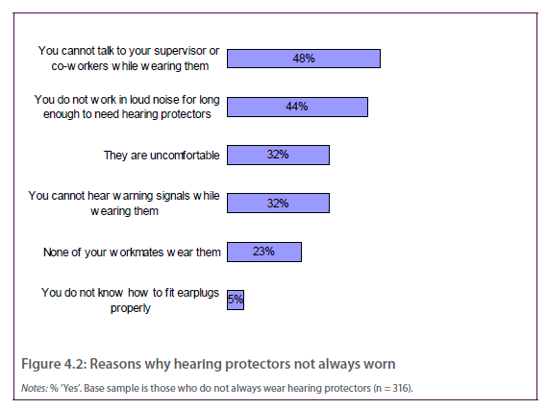
While many workers may be aware of the importance of PHPs, there is clearly a need to increase awareness on why protectors should be worn at all times when exposed to loud noise regardless of duration or frequency of exposure. Managers should continually remind workers that hearing loss can happen so gradually that it can go unnoticed until it is too late.

Industries
Across the five at-risk industries, Construction (83%) and Manufacturing (80%) have the highest provision of PHPs whereas Agriculture, Forestry and Fishing (69%) and Manufacturing (65%) have the highest propensity to wear PHPs when working in loud noise. This is promising considering that studies have shown that workers from these industries experience the highest exposure to occupational noise and the highest number of work-related claims.
Priority attention is needed for the Transport & Storage industry, which is also classified as a high risk industry. Despite this, levels of hearing protection provision (60%) and use (45%) and at-source noise control measures (38%) are reportedly lower than other at-risk industries, excluding Hospitality and Entertainment. This pattern is consistently seen across various aspects, such as ownership of hearing protection (60%) and frequency of usage (45%) of ear protectors, as reported by Transport & Storage workers.
A breakdown by industry shows that workers from Hospitality and Entertainment are at greatest risk of unprotected noise exposure and damaged hearing. For instance, only 30% of respondents have been provided with PHPs and only 18% of these wear them always or most of the time they were in loud noise. A majority of respondents from Hospitality and Entertainment mention noise controls are lacking, with 64% saying no higher-order noise controls are provided. Some attitudinal differences are also evident, with 36% compared with the sample average of 69% believing that PHPs should be worn when working in loud noise. Workers from Hospitality and Entertainment report the highest levels of tiredness, 55%, compared with the sample average of 42%.

Attitudes and beliefs about noise, hearing loss, and work health and safety
Respondents were asked to rate a series of attitudinal and belief statements relating to workplace noise in general. When asked how workers felt when working in loud noise, feelings of irritation (59%) and worry (50%) for their personal hearing are most concerning.
Most respondents (84%) agree that they can recognise when the noise levels are too high (Figure 4.3). This can be regarded as either a positive or negative point. That is, when the noise is perceived as loud workers may be prompted to protect their ears or move away, and so forth. On the other hand, they may put off wearing PHPs until noise levels become intolerable, which can be too late. Regardless, the importance of the proper use of noise controls and PHPs needs to be emphasised.
Moderate to high levels of agreement are seen for other aspects. Seven in 10 agree that PHPs should be worn when working in loud noise, and six in 10 agree that a quieter workplace is a safer and healthier environment for work. Some 40% find that their workmates are unconcerned about workplace noise. This can be significant if peer influence is a factor for not taking precautionary steps, as reported previously by 23% as a reason why PHPs are not always worn.
Nine out of 10 workers believe that vigilance is needed all the time as accidents can happen even if people are careful (Table 4.3). Interestingly, those working in Hospitality and Entertainment are more likely to share this view (97% compared with 91% sample average). At the same time, 56% agree that some work health and safety rules and regulations are not really practical, which may act as a pretext for not following advice and directions.
When asked to think about health and safety issues in general at their workplace, most workers agree that precautionary measures are taken at their workplace, and that management is concerned about the safety of workers. Open communication for workers to provide feedback is promoted at the workplace, with approximately nine in 10 workers agreeing that they are encouraged to report unsafe working conditions. Many also agree that communication from manager-to-worker is good, with 72% agreeing that management keeps workers informed about safety issues. Those exposed to loud noise in the last two weeks are significantly less likely to think that their management is committed to work health and safety issues and open communication than those not exposed. So, there is scope to improve.
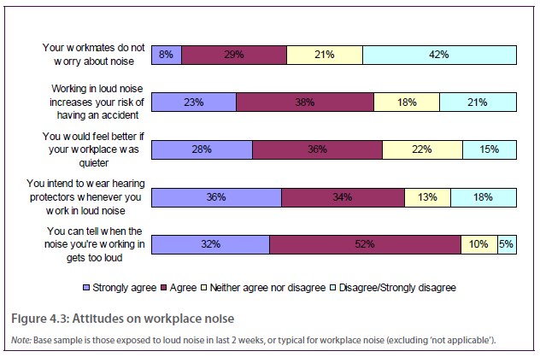
Table 4.3 Summary of findings from attitude and belief items, all respondents
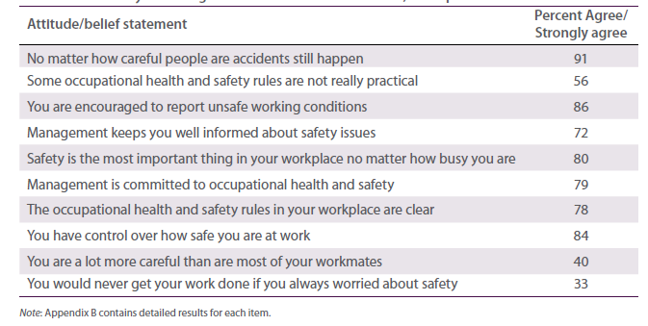
In terms of management of safety issues, most agree that safety is given priority at the workplace, that managers and, to a lesser degree, supervisors are committed to work health and safety issues, and that there is clear communication of safety rules and processes at the workplace.
Regarding workers’ attitudes towards their personal work health and safety, the majority feel that they have control over their personal safety at work. There is however scope to increase the proportion of those who strongly agree (37% strongly agree and 57% agree). Four in 10 strongly agree/agree that they take more care than their workmates—a view more commonly shared among exposed workers (46%) than unexposed workers (34%). One-third of workers are potentially negligent about workplace safety, thinking that too much concern over safety would act as a distraction. More encouraging, 51% share the opposite view believing that safety needs to take priority at all times.

4.3 Nation-wide survey of employers and managers
The survey of employers and managers had similar objectives as the workers survey but with greater emphasis on the provision of higher-order controls and the economic considerations associated with these controls.

Methodology
The survey consisted of 1009 interviews with business owners, employers and managers from industries with noise-exposed workers, focussing on the five at-risk industry groups (Table 4.4). A mixed-mode approach was undertaken involving CATI and internet-based surveying.

Table 4.4 Employers/managers sample
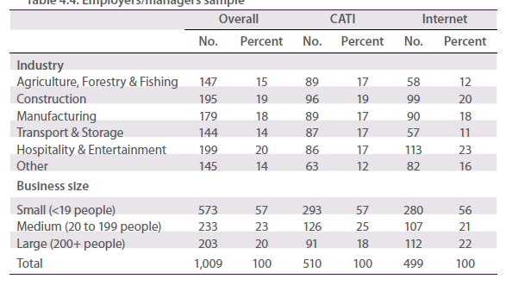Respondents were screened on the basis that they have managerial and/or work health and safety responsibilities with one or more employees or contractors employed in the business. Specific quotas were placed on industry groups with soft quotas by business size. In terms of sample sources among employers and managers, CATI respondents were randomly selected from a purchased list while the online sample was sourced externally from an online research panel.
Each survey took approximately 10 minutes to complete. All interviewers were fully briefed on the research project prior to commencement of interviewing, where all interviewer instructions were cleared through Safe Work Australia. Fieldwork was completed over six weeks from November 2009 to January 2010. Response rates were 62% from the CATI mode and 19% from the internet mode.

Findings

Exposure to loud noise
Of the 1009 respondents, 638 (63%) say they currently produce loud noise at their workplace or have done so in the past. Most managers have themselves worked in loud noise for some time one quarter claim to have worked under conditions with loud noise for one to 10 years and half for over 10 years (Table 4.5). Those in the Construction industry reported the longest duration of exposure with 59% having worked in loud noise for over 10 years.

Table 4.5 Summary of findings from key questions
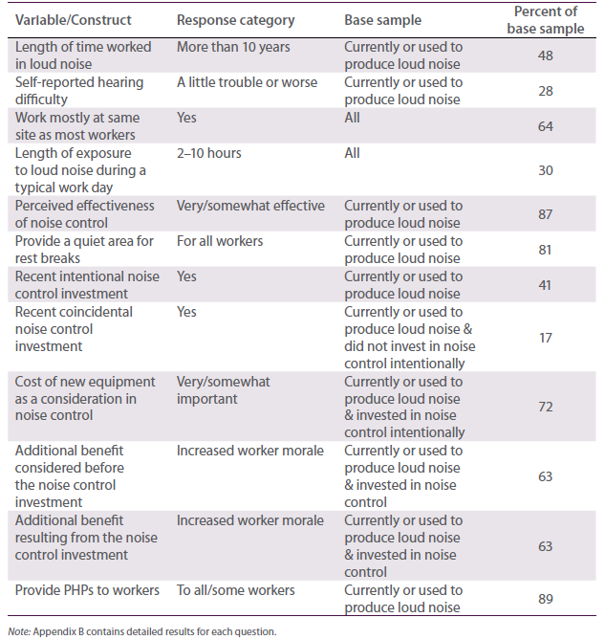Comparisons between responses from workers and managers show that managers have been exposed to loud noise longer than workers (e.g. 48% of managers have worked for 10 or more years in loud noise compared with 27% of workers). A similar pattern is seen across industries. This seems sensible considering that managers have also worked in the industry for a longer period than workers (43% of workers have worked for 11 years or more compared with 65% of managers).
Despite being exposed to workplace noise for many years, only 28% of managers feel that they have trouble hearing, compared with 35% of workers. This pattern is seen across the industries. While 28% may be an accurate figure, it could indicate that managers are not aware of the damage caused by their long-term exposure.
Managers should be encouraged to get their hearing checked. This could also help promote better safety management practices if managers are personally aware of the effects long-term exposure has had on them.
Significant differences are observed between CATI and internet respondents. CATI respondents report lower likelihood of working in loud noise for extended periods (43% work for less than two hours per day compared with 18% of internet participants). A potential explanation is the presence of an interviewer (i.e. social desirability bias), where CATI respondents may be inclined to minimise the actual number of hours of exposure.
Nearly two-thirds of managers work in the same work site as their workers—although exposure levels may differ given the nature of each of their jobs. Manufacturing and Hospitality and Entertainment managers are more likely to share the same worksite as their workers, while those in Construction and Transport and Storage, as well as those from large companies, tend to work at different locations.
Managers have a lower incidence of exposure to loud noise than workers. For example, 57% of managers are either not exposed to occupational noise, or are only exposed for two hours or less on average.
This compares with 33% of workers who are exposed for less than two hours a day, or none at all. More workers (50%) work in loud noise between 2–10 hours than managers (30%). Nonetheless, no significant differences are found between the two groups when comparing those who work in loud noise for 10 hours or more a day.

Noise controls
When asked to think about the noise controls in the company, 87% of managers in workplaces with loud noise describe the controls to be very/somewhat effective. While this is high, 51% describe the measures to be only somewhat effective. The challenge would be to move these numbers into the ‘very effective’ group.
The most common noise controls reported by managers include varying work types to reduce the time or extent workers are exposed to loud noise (73% always or sometimes) and introducing engineering controls by isolating loud machines (69% always or sometimes) (Figure 4.4). Less common noise controls include placing sound absorbing materials on ceilings or walls (currently practiced by 40% of managers) and scheduling loud work for when fewest workers are present (50% of managers say they always/ sometimes do this).
Several significant differences are found across industries. Based on managers’ responses, businesses in Construction are significantly less likely than others to isolate loud machines (59% compared with average of 69%), place physical barriers around noise sources (50% compared with 62% average), and place sound absorbing material on ceilings or walls (33% compared with 42% average). However, they are more likely to schedule loud work when there are fewer workers present (60% compared with =50% average). The practice of placing sound absorbing material on ceilings and walls is more likely to occur within Hospitality and Entertainment businesses than in others. Across business sizes, large businesses have a higher tendency of having these noise controls in place compared to small or medium-sized companies.
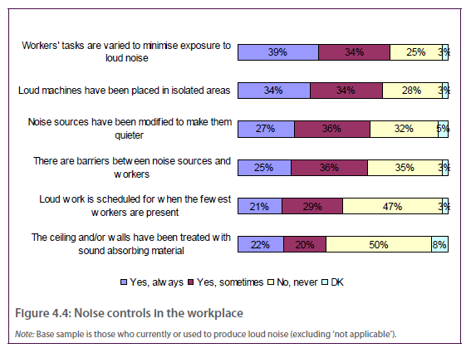
A comparison between workers’ and managers’ responses show that managers are significantly more likely to say that noise controls are used in the workplace—a pattern which is consistent across industries. For example,
- 69% of managers report loud machines are isolated (compared with 49% of workers)
- 63% of managers report modifications to muffle noise sources (compared with 44% of workers)
- 62% of managers report barriers erected around noise sources (compared with 46% of workers), and
- 50% of managers report loud work scheduled for when fewest workers are present (compared with 26% of workers).
Higher agreement is found between managers and workers in terms of the availability of a quiet area for rest breaks. Across all industries nearly all managers (81%) could identify a quiet area for workers to take rest breaks. The only significant difference between managers and workers is found for the Transport and Storage industry, where 99% of managers agree that quiet areas are available compared with 91% of workers.
While it is possible that workers are not as well informed of the measures taken as their managers, results could also suggest that workers feel that more can be done to minimise current levels of exposure to loud noise. Alternatively, managers could have provided a socially desirable response given that their responses could have an impact on their perceived management capabilities. Regardless, there is scope for improvement in the implementation of noise controls.

Investment in noise control
Managers were asked to identify any recent investments in noise control the company had made. Four in 10 managers have recently introduced controls with the intention of reducing exposure to noise. Transport and Storage managers (30%) and small businesses (34%) are less likely to have made an intentional noise control investment, compared with 53% of large businesses. Among the 60% who did not intentionally invest in noise control, only 17% mention that their other recent investments helped reduce noise levels by coincidence. Proportions could actually be higher since managers may not be conscious of this aspect.
When probed about the types of investments made, 49% of those who intentionally invested in noise control invested in PHPs (this highlights a common mistaken belief that PHPs control noise exposure). This investment was more likely to be made by small businesses, which make up a large proportion of the sample. Only 16% purchased new machinery (Figure 4.5). This compares with those who made coincidental investments, where 50% acquired new machinery that resulted in reduced noise levels by chance.
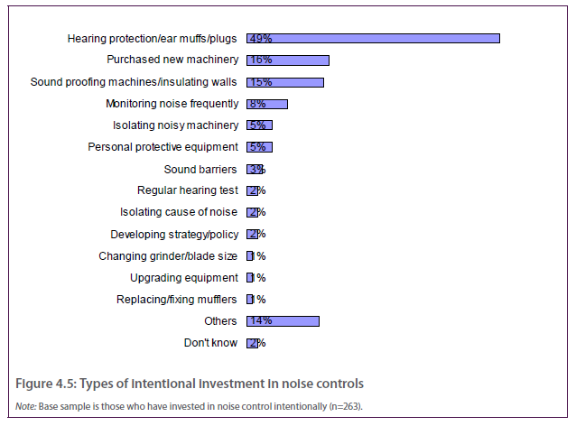
The most important cost consideration for managers when making noise control investments is the cost of new equipment (72% report this consideration to be very/somewhat important). This was followed closely by the cost of engineering controls and equipment maintenance (both 68% very/somewhat important). Each of these types of investments are often more costly than some other measures such as PHPs, the cost of which was considered by 64% to have some degree of importance in their investment choices. The primary influences behind choice of investments differ by industry. For example, while those in Transport and Storage consider the cost of equipment maintenance to be most important, those in Manufacturing as well as Hospitality and Entertainment regard this aspect to be least important and instead deem the cost of new equipment to be more crucial.
Some 66% of respondents report that other benefits apart from improved noise controls were considered before making the investment. The main consideration prior to making the investment is the boost in worker morale (63%), which was also the most common benefit shown (63%). Noise control investment reportedly had minimal impact on staff turnover rates (23%) although, this may not demonstrate its ineffectiveness. Rather, staff turnover may not have been a concern initially since only 29% of managers considered lower staff turnover before making the investment.
Close to 60% intended to reduce the number of accidents as a result of the investment, although only one-third experienced this benefit. In addition to this list of benefits, having the peace of mind that workers are kept safe, enjoying a more pleasant working environment, and knowing that business practices are within work health and safety standards are generally other key benefits mentioned. Increasing productivity (54%) and fewer compensation claims (43%) are other common motivations for noise control investment.

Personal hearing protectors
Close to nine in 10 managers claim that workers have been provided with personal hearing devices. In contrast, 64% of workers attest to this provision. Those in Agriculture, Forestry and Fishing and those in Construction and Manufacturing are the most active in this area, while those in Hospitality and Entertainment are the most passive. It would appear that Hospitality and Entertainment workers have a high risk of hearing loss given current management practices, the nature of the industry, and workers’ nonchalant views about the need for hearing protection. For example, workers in this industry had a lower rate of provision of PHPs and are significantly more likely to think that there is no need to protect hearing after hearing loss has occurred.
There is clearly an opportunity for managers to improve their level of support by continually encouraging workers to use their hearing protectors at all times that they are in loud noise. Managers should go beyond simply supplying PHPs and urge workers to use them. They should also investigate the reasons given for not using them and find solutions to the problem. This can be done through various methods, such as through enforcement methods (e.g. making it a condition of employment like having to wear a uniform), education about the health effects of noise, accountability, and also through role modelling. Management must play their part in providing PHPs but workers are also liable to ensure that devices are worn at all times. Ultimately, however, managers need to be reminded that the provision of PHPs should only be an interim measure while other more permanent controls are identified and implemented.

Attitudes and beliefs about noise, hearing loss, and work health and safety
Most of the 1009 managers surveyed are aware of the causes and consequences of exposure to excessive noise. The statements with highest consensus are that hearing loss can affect one’s qualify of life (95%) and that exposure to excessive noise can result in permanent hearing loss (93%). The majority of managers (92%) also believe in the value of further hearing protection, even when hearing loss has begun. Also, 87% of managers are aware of the correlation between loud noise and tinnitus and 84% are aware of the correlations between loud noise and accidents. A large proportion of respondents (70%) agree that hearing loss is part of a natural ageing process. Despite the high proportion, managers are also aware that hearing loss does not only occur as a result of age that is, that hearing can deteriorate due to excessive exposure to loud noise.
There were no significant differences observed between sub-groups, with managers from the five priority industries sharing similar beliefs about hearing loss. However, there are some notable differences between managers and workers. For example, while agreement levels are still high, managers are significantly less likely to agree that loud noise can cause permanent hearing loss, or that exposure to loud noise can cause tinnitus. Also, managers are more likely than workers to agree that noise increases the risk of accidents (84% compared with 61%). These differences are seen across the industries.
Clearly, management can be more involved in educating workers about the potential health and safety effects of loud noise. These effects include the fact that loud noise can affect one’s sense of balance and concentration, be a source of stress, and can mask sounds of approaching danger or warnings. At the same time, given that workers are significantly more likely to think that there is no need to protect hearing after hearing loss has occurred, stringent enforcement is required to ensure that PHPs are worn at all times.
Looking at attitudes towards work health and safety in general, eight in 10 managers agree that accidents can still happen despite the level of care taken. Close to six in 10 believe that some work health and safety rules are not practical, with the highest levels being in the Agriculture, Forestry and Fishing industry. This raises some concern as it can act as an incentive to disregard the work health and safety rules recommended by authorities. Large companies are significantly less likely than small businesses to agree with these views. It is possible that large companies have safer workplace mentalities owing to the higher compensation costs at these workplaces, as well as better education programs in place.
A significantly smaller percentage of managers (51%) compared to workers (56%) in Hospitality and Entertainment agrees that some work health and safety rules are not really practical. This could be a potential reason for the low level of PHP use in this industry (as reported by workers). That is, while managers may provide workers with PHPs, workers often choose not to use them given the view that to do so would be impractical. For example, there is a perception that it can be awkward for bar attendants to wear PHPs while serving. However, there are legal precedents that make it clear that PHPs must be worn in the hospitality and entertainment industry (e.g. Groothoff v Venues Unlimited Pty Ltd and Young v Hannay and Wildlodge Pty Ltd). On the other hand, a higher proportion of managers than workers in Construction agree that some work health and safety rules are not practical. This may be a serious concern, especially if there is a lack of support from management on the importance of work health and safety.
Regarding internal safety management practices, nearly nine in 10 managers agree that work health and safety rules are clear and that safety takes precedence (Figure 4.6). This compares to eight in 10 workers, which is still high. Compared to the average, there is a higher tendency for Transport and Storage managers to think that their internal work health and safety rules are clear and that safety is given priority in the workplace.
About 50% of managers have considered the prospect of their workers losing their hearing. However, three in 10 claim that they have not considered the likelihood of this happening. For some managers this may mean they have taken extra care to ensure workers’ exposure to noise is prevented. However, for others it may reflect a lack of concern about workers’ safety, at least with respect to hearing. A lower proportion of managers in Agriculture, Forestry and Fishing, and in Construction and Manufacturing have not considered the prospect of hearing loss among their workers.
About half of the respondents believe that accidents in the company are likely, which is considerably high. It is difficult to say why managers think so. For example, it may be due to uncontrollable factors or to inadequate current safety measures. While 17% of managers believe that production goals are more important than safety priorities, a higher proportion (33%) of workers share this view.
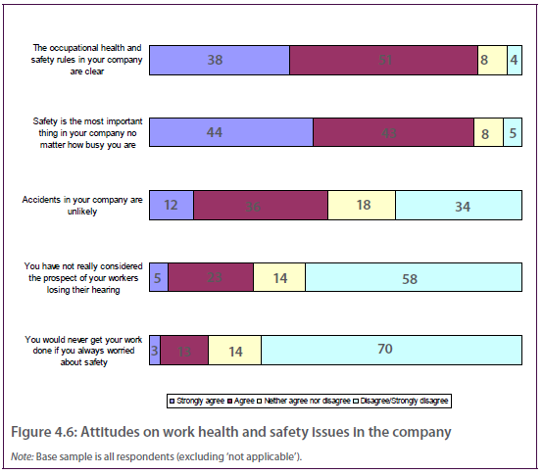
Managers’ attitudes towards safety management in the company are more positive than those of workers. This consistency is seen across the five key industries. Several differences by mode are evident, where CATI respondents are significantly more likely to agree with some statements. Once again, this may be a possible effect of social desirability bias.

Education
Among 192 respondents who gave additional comments, 21% mentioned a greater need for awareness on the topic (compared with 14% of workers). Also, 12% of managers feel that this area should be given more attention and discussion and 7% believe that education outside of work is just as important.
These findings demonstrate that at least some employers understand the role of education in identifying the effects of harmful noise and in the implementation of noise management plans. A step forward would involve helping employers design employee education programs that will enable them to assess their own noise situation and to help them prioritise the measures to be taken. Education has an important role in alerting both managers and workers of the dangers of workplace noise that is, both managers and workers should be involved in the implementation of noise management plans. Continuous evaluation of the effectiveness of the program is also crucial. This would allow past successes and failures to be incorporated in future education programs.

4.4 Semi-structured interviews
The series of semi-structured face-to-face interviews with business owners, work health and safety representatives and union representatives had the following objectives
- determine the level of importance placed on noise prevention relative to other work health and safety issues in businesses that produce loud noise
- explore the reasons for noise to be of high or low concern
- identify levels of awareness and knowledge of what makes exposure to loud noise a work health and safety hazard
- explore the perceived impact of loud noise on the workplace
- explore current measures taken to control noise and their prevalence
- identify the key barriers and triggers to investing in noise controls and subsequently how it may become a priority, and
- identify opportunities to engage with workers about the risks associated with loud noise.

Methodology
The interview sample included participants from small, medium-sized and large businesses in the Manufacturing, Construction and Hospitality and Entertainment (bars, clubs and cafes) industries (Table 4.6). Some participants from the Agriculture, Forestry, and Fishing industry and from the Transport and Storage industry were also included. As this stage of the project was qualitative, there was no attempt to make the sample geographically representative. Nevertheless, the final sample reflected a good spread of industries, business size and respondent role.
The interviews were conducted in February and March 2010. Each interview lasted for about 30 minutes. The questions were structured along a questionnaire similar to that used in the nation-wide survey of managers, but also allowed sufficient time for probing and free comment.
About half of the interviews included businesses that also participated in an onsite noise level measurement undertaken for the project some before the interview, some after. It is therefore possible that these onsite noise level measurements influenced some of the responses with respect to adequacy of noise management, and so forth. However, this study did not rely on random selection to obtain a representative sample, nor random assignment to reduce possible biases. Instead, the main purpose was to explore in more depth some of the key issues covered by the nation-wide surveys, thereby increasing the likelihood that the issues had adequate construct and ecological validity for the project overall.

Findings

Prominence of ONIHL as a work health and safety issue
Exposure to loud noise was found to be of most concern with participants from Manufacturing. Among participants from Construction, exposure to loud noise was less of a work health and safety issue than slips and falls and operation of power tools. Exposure to loud noise did not rate highly among participants in Hospitality and Entertainment. It was found to be much less of an issue in pubs, clubs and bars mostly because many of these businesses did not feel that their workers were exposed to any kind of noise that would be deemed loud.

Table 4.6 Sample composition for face-to-face interviews
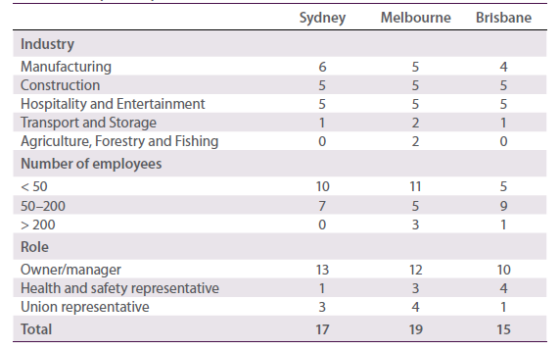
The invisibility of the health risks associated with noise was what union representatives felt made it so dangerous. They noted that the consequences associated with prolonged exposure to loud noise were rarely accepted by owners, managers, or employees and were simply not considered. This was put down to the fact that the adverse effects often took years to manifest.
Noise was deemed to be of higher concern in businesses which acknowledged that (1) workers were likely to be exposed to higher levels of noise and (2) the exposure to noise had high consequences (Table 4.7). Conversely, noise was deemed to be of low concern in businesses in which there was the belief that (1) workers were not exposed to high noise levels or (2) the exposure to noise had none or few perceived consequences.
Noise was deemed to be inconsequential where it was felt that levels did not exceed what was considered acceptable. For instance, in many of the participating clubs the loudest noise was believed to come from the Saturday night band, which was not seen to be ‘loud’ and therefore not a big concern. For others, the noise was acknowledged as loud but only for a moment and only on occasion. Therefore, it was not generally seen as dangerous.
For many, the consequences and level of exposure to loud noise were not concerning because there were perceived to be procedures in place to control it. ‘Control’, however mostly meant the use of personal protective equipment (i.e. PHPs) rather than addressing the noise at the source. For others, the lack of complaints from staff indicated that there were no consequences as a result of the exposure. Using a lack of worker complaints as a reason for not addressing noise was very common in Hospitality and Entertainment and in Transport and Storage. While exposure to loud noise occurred in these industries, there was felt to be no real issue given that there had been no complaints or workers’ compensation claims submitted. It was generally felt that it was up to employees to speak up if there was an issue.

Table 4.7 Risk matrix for exposure to noise High concern
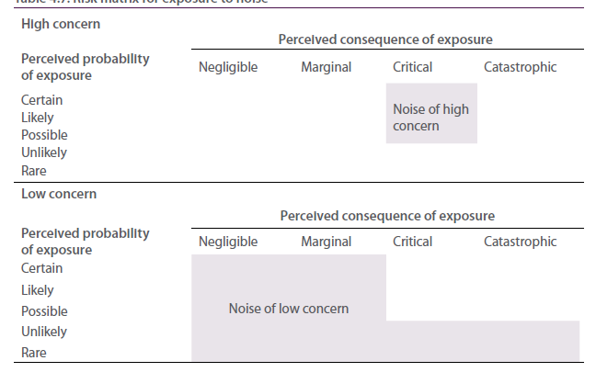

Noise as a potential workplace hazard
The top response for what makes noise a potential workplace hazard was that it contributes to poor communication (raised in 16 interviews). The inability to hear instructions and warnings was seen to affect the ability for people to communicate in a noisy work environment. An increase in the risk of accidents occurring was also raised as a negative consequence of surrounding noise, with this also seen to be a consequence of not hearing warnings (11 interviews). The condition of tinnitus was the third most commonly raised outcome of exposure to loud noise (mentioned in 8 of the interviews). Concentration was also seen to be affected by seven respondents, and six people felt loud noise increases stress in workers. While hearing loss was only raised as a consequence of loud noise spontaneously by six respondents it was likely that it was often felt to be an obvious effect of exposure to loud noise, and therefore not mentioned.
The flow-on effects of hearing loss to one’s personal life and general functioning were rarely mentioned. If they were, it was only among health and safety representatives who had more training in the area. There was generally more awareness of adverse effects such as poor balance and affected perceptions. These broader implications of hearing loss also emerged more often amongst those who had experienced hearing loss in the past or had seen someone else experience it.
The health risks of exposure to loud noise were seen to have the potential to be overlooked and forgotten because of their slow and gradual onset. Long-term hearing loss was something that people were reluctant to address until it was too late. There was some appreciation of the permanent nature of hearing loss however, this sentiment was not widespread.
There was discussion in the interviews of the different effects of prolonged exposure to low intensity sounds and short exposure to high intensity sounds. Some felt that as long as the exposure didn’t occur over long durations then it wouldn’t be harmful. Others felt it depended on the number of decibels the sound reached. This raised the potential to address knowledge gaps to do with noise emissions, exposure and hearing loss.
The major focus in most of the participating industries was on the processes that were traditionally seen to cause loud noise, such as grinding, hammering or live music. This focus assumed noise to be a static phenomenon that was attributed to certain processes and unchangeable. However, one union representative interviewed felt that it was things like poor design of machinery, poor layout of sites, and old equipment that was contributing to most of the high volumes of noise on work sites. This alternate form of thinking about noise better allows people to view noise exposure as something that can, and should, be addressed.
There were many different cues respondents used to judge whether or not a sound was loud enough to be dangerous. Simply having experience in the types of processes that created dangerous noise levels was the main way people judged noise hazards (raised in 16 interviews). Needing to raise one’s voice when talking to others was also mentioned as a key sign that noise levels were becoming a problem. For some, noticeable reductions in productivity were indicative of an overly noisy work environment. Having a noise assessment done emerged as an obvious way of knowing that noise levels needed to be addressed. This was often cited as a trigger to investing in noise controls in that it provided hard evidence of the levels of noise being emitted and the potential consequences to workers’ hearing. Staff complaints and discomfort also alerted people to the fact that noise within the work site was becoming problematic. Other signs included difficulties concentrating, an increase in compensation claims and an increase in errors. It should be noted that compensation claims for hearing loss were reported as rare hence, they were often not seen as a major threat.

Perceived impact of loud noise on the workplace
The interviews revealed views on both positive and negative effects of loud noise on workplaces. In many cases, noise was seen as a critical and positive part of the workplace. For example, in Hospitality and Entertainment noise was considered to provide mood and ambience and to increase staff motivation and productivity. It was felt that music in particular was pleasant and created an atmosphere conducive to working.
In about half of the interviews it was believed that exposure to loud noise had an effect on productivity. In Construction and Manufacturing the absence of noise tended to mean no work was being undertaken therefore, noise was inherently understood as being a core part of being productive. In other words, a work site that produced a lot of noise was a productive one. However, in other workplaces a negative effect of loud noise on productivity was recognised and thought to occur through poor communication. That is, the inability to hear others was felt to result in poor communication which in turn affected productivity.
It was widely acknowledged that noise had the potential to adversely affect workers’ wellbeing and cause fatigue and mistakes as well as reduced productivity. Not being as alert as one ought to be was felt to create a potential for accidents. A link was also made between noise and poorer communication and concentration. Additionally, noise was believed by some to reduce workers’ morale and cause complaints from staff and neighbours.
Although the majority of respondents could not identify or recall an incident in which they were aware of exposure to loud noise causing an accident, almost half felt that noise certainly had the potential to contribute to accidents. This made it difficult to distinguish myth from fact, with some feeling that there was a weak, if any, relationship between noise and accidents.
Very rarely in the interviews was a connection made between exposure to loud noise and staff turnover. In fact, the relationship was acknowledged in only four interviews. Staff turnover rates were simply not seen to be affected by a noisy work environment. Part of the reason for this can be found in the fact that exposure to loud noise is often seen by employees as part of the work they do. Until they change industries, they simply expect the side effects associated with the levels of exposure.
There was a belief expressed in some interviews that loud noise had no impact on the workplace at all. This was coupled with a widespread view that a noisy workplace did not have to be hazardous if PHPs were worn. The use of PHPs was felt to lessen the amount of exposure to the ear and therefore was an adequate precaution against hearing loss.

Controlling loud noise
Respondents generally felt that noise was well controlled on their sites, but equated control with the use of ear plugs and ear muffs. The vast majority claimed that the use of either of these was an adequate form of protection for workers. It was extremely common for PHPs to be the fundamental form of control rather than addressing the noise at the source. While some were aware that the use of PHPs was a ‘band- aid’ solution, others felt that these were appropriate risk-reduction measures.
With the exception of Hospitality and Entertainment, respondents from all industries reported requiring workers to use PHPs to protect themselves against noise. On average it was reported that about three quarters of workers complied with this policy. The general sentiment was that most people were doing the right thing, but there were a few repeat offenders. Employees were generally made aware of their personal protection responsibilities through the induction process. It was felt (incorrectly) by owners, managers and health and safety representatives that the responsibility for wearing PHPs was with individual workers. The issue was also covered during regular toolbox meetings and as a general topic of discussion. The use of PHPs was often the only form of noise protection and it was felt to lessen the amount of exposure to the ear.
For some respondents, it was young people and apprentices who were seen as being the worst offenders when it came to not wearing PHPs. It was reported that some young workers had a tendency to believe that nothing bad was ever going to happen to them. Alarmingly, it was reported that the knowledge that young workers could put in a workers’ compensation claim in the event of hearing loss often became a reason for not wearing PHPs. For others it was the older workers who posed the biggest problem in terms of PHP compliance. Non-complying mature workers felt that they had already done damage to their hearing, so there was no point of further protection. That is, they were of the opinion that there was nothing left to protect. Some respondents felt that these were the most difficult workers to convince because they were highly resistant to change.
In general, the need for wearing PHPs was acknowledged but it was the situational elements, such as the need to go and get them, which was preventing their use. The most common reasons were to do with laziness and complacency, rather than not seeing the need to wear them. PHPs were not routinely used in bars, pubs or nightclubs, except for when using bottle crushing machines. It was acknowledged that ear plugs suitable for the industry were available however, there was no compelling need to purchase them. Also, they were considered to be expensive.
There was a distinct lack of evidence of behaviours that would fit into the top tiers of the ‘hierarchy of control’ that is, engineering controls and noise source substitution or elimination. Where these controls were reported, engineering controls were the most common, with barriers often put up to lessen workers’ exposure. Replacing noisy machinery and/or processes, however, was generally not seen to be practical. This was usually due to the fact that there were thought to be no alternatives for the way things were currently done.
It was found that noise was commonly reduced indirectly through the use of controls for other hazards. Typically, where noise controls were achieved, it was not intentional. Similarly, when machinery or processes had passed their use-by-date, or more efficient processes came to exist, often the replacements were producing less noise than was being emitted previously. Noise controls were often put in place to protect others outside of the workplace. In hospitality and entertainment for instance, barriers were put up around external generators to minimise the sound emitted to the surrounding neighbours.
Noise control policies or noise management plans were not commonly reported in the companies interviewed. Around 20% of participating businesses claimed to have a noise control policy. However, respondents often did not have a policy specific to noise but rather policies to do with hearing protection as part of a generic work health and safety policy. Policies were often driven by compliance with council laws and to avoid legal proceeding. Many respondents were not sure if they had a policy in place but thought that the company should have one and would be surprised if they did not. Where a noise control policy did exist, there was quite a bit of uncertainty about what it contained.
Several noise control options were presented to respondents to explore how many had been used before, and to what extent they were considered to be deliberate attempts to control noise (Table 4.8). The results suggest that the most common actions taken to reduce noise exposure were among the most simple to implement, such as placing noisy machines and processes in isolated areas and ensuring that workers are wearing PHPs. The widespread use of PHPs as the main or only guard against exposure to loud noise comes through in these findings. However, it should also be noted that some of the relatively easy to implement controls were frequently overlooked, such as varying workers’ tasks to minimise exposure, which only 11 businesses reported practicing.
Moving noisy processes away from other individuals that did not need to be exposed to them was seen as an effective way of controlling noise exposure and reducing the impact on other workers. However, this was often not consciously considered as a deliberate noise control effort. It was only upon being prompted on the practice that people acknowledged it as an investment in noise control. In Hospitality and Entertainment, where noise was seen as a key amenity issue, noise hazards such as the air conditioning plant were isolated from customers and staff and housed in enclosed rooms. In the agricultural industries of logging and pulp and paper, workers were often placed in control booths which blocked out much of the noise being generated by their work. In Manufacturing there was evidence of welding tasks being moved to its own area.
Training on how to prevent hearing loss was fairly rare. It was much more common for businesses to train people on using PHPs, but even this practice was quite limited. It generally amounted to a two-minute demonstration of how to fit ear plugs. For some companies this was included in their induction process. It was mentioned that there was a need for training on how to take care of PHPs. There were reports of workers’ PHPs getting damaged due to misuse and not being worn as a result.

Table 4.8 Actions taken to control noise
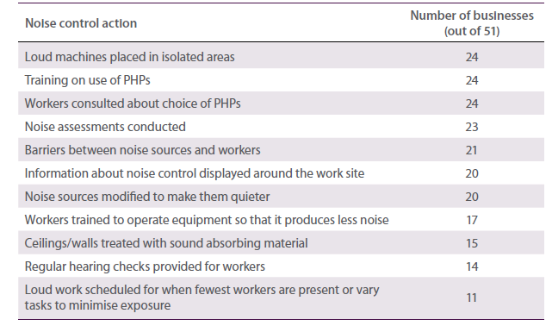
In general, workers were given a choice between ear plugs and ear muffs, although for some tasks only one or the other was practical. The cost of hearing protection was found to be inconsequential for employers, so asking for a different type or brand was not frowned upon. Importance was given to selecting the right type of hearing protectors that is, the one that allows the appropriate amount of noise so that people can still hear instructions.
Noise assessments helped identify the areas of excessive noise and allowed respondents to feel more confident about which noise emissions were going to be dangerous to workers’ hearing. Encouragingly, there was some evidence of noise assessment results being used to develop noise control plans. Noise assessments were also seen to be triggers to investing in noise control.
It was found to be more common for employers to put barriers between noise sources and workers than to modify the noise source itself. The interviews from Hospitality and Entertainment showed some evidence of installing barriers around noisy areas, with poker machines often in their own room and nightclub areas zoned off. However, some businesses, especially in Construction and Manufacturing, felt that it was impractical to erect barriers in certain situations. For instance, construction sites were not thought to be suitable for barriers since they were only a temporary work site. Barricades were generally put up to protect workers from other hazards such as slips and falls. This is despite the fact that mobile noise barriers can be erected easily and moved from site to site (see Australian Standard AS 2436-2010 Guide to noise and vibration control on construction, demolition and maintenance sites for examples).
The most common form of information about noise control displayed around the work site was that which reminded workers to wear hearing protection, and this applied only to Manufacturing, Construction and Agricultural sectors. Rarely was there any more detailed information about things such as how to operate machines more quietly or using noisy machines out of hours. Enhanced signage was felt by most in these industries to be useful in reminding people around the work site of the need to control noise.
In most cases, modifying noise emissions at the source was not seen as possible or practical. It was felt that it was not the machines that were making the noise but rather the tasks being conducted and the materials used for the job, so there was no way of dampening the sound. While often being invested in for aesthetic value, sound absorbing furniture and acoustic panelling was used in hospitality and entertainment workplaces to absorb sound and therefore control noise levels.
Many of the respondents from Manufacturing stated that they provided hearing tests for workers every two years. Also, it was common for workers to receive a hearing test as part of their pre-start medical on their induction into the organisation. The main role of this was for insurance and workers’ compensation purposes.
Administrative controls on worker exposure to noise, such as varying tasks and limiting loud work to after hours, were not common practice. Resourcing constraints and project management plans tended to mean that administrative measures to protect workers from high levels of exposure were not practical. Work breaks, however, were often seen as a form of task variation.

Benefits of investing in noise control
The potential benefits of investing in noise controls were not readily brought to mind by respondents who did not feel that noise was a problem in their workplace. Part of the reason for this was the fact that PHPs were being implemented and were seen as an appropriate solution. However, when noise controls were used, immediate benefits were seen. Some of these included
- workers are safe/healthy
- the workplace is more pleasant
- happier workers
- increase in productivity
- less fatigue
- licence to operate continues (hospitality)
- easier to do your job
- lack of claims, and
- good for business.
The problem with this scenario was that until noise controls were implemented, respondents had trouble conceiving of the potential benefits the investment could bring.
Overall, there was a distinct lack of drivers for businesses to invest in noise controls. Economic drivers, such as compensation claims and regulatory fines, were said to be extremely rare and not worth spending money on to avoid. While it was claimed by some respondents that the main trigger to investing in noise controls was the wellbeing of workers, the economic implications associated with workers being unable to work were often the overriding reason for the investment. Also, only when machinery or work processes had passed their use-by date, or more efficient processes became available, did the issue of noise control become part of the purchase decision. In these circumstances, a noise rating on machinery was one way respondents felt they could contribute to controlling noise in the workplace. Again, this was generally only considered when there was a need for the new equipment.
Noise assessments and problems showing up in workers’ hearing tests were also triggers to investing in noise control. Of course, this was dependent on the company regularly conducting these types of tests, which was not always occurring.

Barriers to investing in noise controls
Some key barriers to adopting effective noise control were identified. These include loud noise not being seen as a problem to that particular workplace, the costs associated with investing in noise controls, the impracticality of implementing noise controls, lack of knowledge of how to control noise, and lack of time.
For all the reasons already discussed, noise was simply not seen to be an issue among many of the respondents. A lack of claims and fines leaves managers and employers with no compelling reason for addressing noise control. There needed to be an obvious impact before it becomes a workplace issue. The cost of quieter equipment and engineering controls was a definite barrier to investment. Noise control in this sense was not seen as a viable option for employers and managers.
Another barrier to investing in noise control, especially in the manufacturing industry, was the amount of space available to house such processes. Also, it was claimed that quieter technology simply didn’t exist and there would need to be a significant advance in innovation for machinery to make less noise. Often it was not the actual machines making the noise, but the processes undertaken while using the machines.
Many respondents could not think of how to control noise. Some felt that they could be doing better, but were not sure how. Respondents were not aware of any research being conducted into developing more effective methods for reducing noisy processes. Similarly, there was no awareness of where one could go, other than the work health and safety authority, for advice on reducing noisy processes. Moreover, there was generally felt to be no need to take such action. That said, many did have a sense of what they should be doing about noise.
Where employers thought that processes could be improved or that noise sources could be re- engineered, they noted that finding time to identify noise solutions was a barrier to action. When pushed on this issue it was apparent that there was an underlying inertia to action—the need to act was simply not there.
The cultures of many of the industries participating in the research accepted noise as an inevitable part of the job, creating a degree of complacency around acknowledging the problem and solving it. The resistance to change was connected to older workers in particular, for whom things had been how they were for their whole working lives.

Moving noise control up the work health and safety agenda
Several factors were found that would encourage businesses to push noise up the work health and safety agenda. These include
- an increase in the number and cost of claims
- greater enforcement from regulatory bodies
- an increase in complaints from workers or neighbours, and
- provision of guidance on how to implement noise control.

Claims and enforcement
For some businesses it was felt that to gather momentum around noise, there would need to be a significant increase in the cost and number of claims. It was felt that compliance to both PHPs and higher-order controls should be more actively enforced, with greater penalties for offenders. Often this was seen as the only way of getting people to take the issue seriously. However, there was some complacency about the likelihood of actually being fined by the work health and safety regulatory body. Some felt that workers would be more concerned about internal repercussions, such as suspension or termination, rather than external consequences such as fines.

Complaints
The hospitality and transport industries in particular would respond to an increase in complaints from neighbours or patrons. This was mentioned more often as a key driver to action than complaints from staff. The consequences of a neighbour complaint is potentially damaging to the business. It was found that where there was a business reason to invest in controlling noise it was far more likely to happen.

Guidance
Many respondents couldn’t think of how to further control noise. Some felt that they could be doing better, but weren’t sure how. Many positively responded to the suggestion of research being done in their industry to identify ways to reduce noise, such as strategies to reduce the need for grinding, and for this information to be disseminated through their industry. Another key source of this information would be machine manufacturers.

Engaging with workers about loud noise and hearing loss
How to effectively communicate information about the dangers of loud noise and hearing loss to workers was felt to be the ‘million dollar question’. The main barrier to engaging with workers on the issue was thought to be the invisible nature of hearing loss as a workplace injury. The fact that hearing loss was not a physical injury meant that the consequences associated with prolonged exposure to loud noise were rarely accepted among workers and were not prevalent in their minds. The key challenge was thought to be in making the issue relevant to people early in their working lives rather than later, when it was too late.
For some respondents, having a representative from a union or a hearing specialist visit the workplace and speak to workers in person was seen as the only way of connecting with people. In Construction and Manufacturing, small group meetings, tool box talks and similar mechanisms were identified as the most effective forums for getting the message across. They provide an open and trusted environment in which workers are encouraged to raise any work health and safety issues requiring attention. It was felt that if workers understood the risks to their ears in a physical sense, they would be more likely to take the issue seriously.
The perceived value of visits from the work health and safety regulatory authorities to conduct a noise audit was mixed. For some, regulators were great resources they often used for advice on improving workplace safety. The majority of respondents had a good relationship with the regulator. However, there were some businesses, albeit the minority, in which there was a lack of trust in regulatory bodies. This would serve to create a barrier to gaining the respect required to engage with people and for the message to be effective. It was suggested that a hearing or ear specialist would be more appropriate to talk to these businesses about such matters.
Few respondents saw any value in brochures, leaflets and similar material because it was thought to lack impact given the amount of material already circulated. Also, some thought that only about half of workers actually read the information that is given to them. However, it was suggested by others that letters were often opened by the partner in the household, so simple communication in mail-out form had the potential to be effective. It was also suggested that if the information were concise and limited to a single page it would be better understood and utilised.
Supervisors were seen by some to be the ultimate source of messages about hearing protection. With a level of trust already established between them and workers, the message was thought to have the potential to be more authentic. In some companies apprentice mentoring systems help instil good habits in workers early on, so that safety-friendly behaviour becomes almost automatic.
Peer influence was seen to be a major factor in encouraging people to take responsibility for their own health and safety in the workplace and peer-led discussions were raised as a potentially effective way of getting through. This could include talks by people affected by hearing loss, especially young people affected by hearing loss to convey the message that it does not just occur in older workers. In addition, many of the respondents noted that workplace role models such as older supervisors were essential to creating a culture where noise would be controlled at work. This type of influence was valued more than that coming from the foremen because foremen are seen as enforcers with agendas whereas peer support was seen as genuine and worth valuing.

Remaining Questions
- What is the incidence of ONIHL in Australia, and what are the recent trends?
- What proportion of Australian workers are still exposed to excessive levels of noise?
- What are the important gaps in workers’ and managers’ knowledge about occupational noise, hearing loss, and noise control?
- Will better awareness and consideration of the potential benefits of noise control enable greater noise control adoption?

Chapter 5 Overcoming barriers and enhancing enablers
Findings from the studies described in the previous chapter highlighted several important barriers to the adoption of effective noise control. These findings complemented the literature on barriers and enablers reviewed in earlier chapters. The semi-structured face-to-face interviews were particularly illustrative as the in-depth discussions not only revealed barriers but also suggestions for possible interventions. Possible interventions include displaying noise rating information on machinery at the point of sale so that it might influence purchase decisions. Other intervention options are aimed at changing the awareness and behaviour of individuals. Before exploring these options in more detail we need to understand the difficulties involved in changing behaviour and what insights are needed to make behaviour change more likely to succeed.
In this chapter we review some of the behaviour change models that may maximise the likelihood of adopting effective noise control. We then outline some of the potential intervention strategies arising from our empirical work and literature reviews. We close the chapter by revisiting some of the economic factors described in Chapter 3 and propose a cost-benefit analysis model that, with further development, may be used as a decision-making aid that indicates the potential cost-effectiveness of effective noise control.

Chapter 5 Highlights
- Social marketing and behaviour change models can be used to raise the prominence of ONIHL as a work health and safety issue and to raise knowledge and self-efficacy concerning noise control.
- Opinion leaders and role-models are useful in effecting and maintaining positive work health and safety and noise control actions.
- Key noise control and ONIHL prevention interventions include education about noise control options and promotion of a buy-quiet policy.
- With sufficient research and development, accurate, simple to use and easily accessible cost-benefit models and templates can be used to aid noise control decisions.

5.1 Work health and safety and behaviour change models
The existing literature contains few reports of successful work health and safety interventions. Available studies tend to lack scientific rigor (Goldenhar & Schulte 1996 Zwerling et al. 1997). Public health literature offers some guidance that may be adapted for use by work health and safety researchers and practitioners. In an evaluation of public health promotion programs, Valente (2002) highlighted the following eight intervention strategies
- Provider training designed to improve the way providers (physicians, counsellors, nurses, etc.) communicate with clients and patients and usually conducted within health care facilities. From the health care perspective there is little direct relevance to work health and safety interventions. However, within the work health and safety or noise context, relevant providers might include occupational hygienists, work health and safety consultants, acoustical consultants, noise assessors and audiologists.
- Community-based distribution or outreach outreach workers convey information at targets’ homes or in public locations. While the personal contact is very useful it is a costly strategy where target numbers are large and widely spread and is popular in developing countries where labour costs are low.
- Community mobilisation community leaders identify the community’s needs and create programs to address them. Events such as fairs, street theatre and advocacy events may be used and are usually limited geographically and serve as pilot programs.
- Entertainment-education entertainment is used to educate audiences about health issues. Programs may include drama, film, radio and television soap operas, music and variety shows, and talk shows with audience participation.
- Interactive health communication computer and other telecommunication technologies are used to deliver health information.
- Multimedia or community-wide programs comprehensive programs using a variety of media, enlistment of community support through opinion leaders, and provider personnel training to change community norms about health and the system that provides it. It is assumed that the best approach to behaviour change is a multimedia approach that reaches the largest possible audience through as many different channels as possible.
- Mass media advertising television, radio and print are used to disseminate information through advertisements.
- Social marketing a term used to describe any promotion of health and social behaviours.
Mass media advertising has been widely used by work health and safety authorities in Australia and elsewhere to raise awareness of relevant legislation, legislative change, company and personal obligations and, in a limited number of cases, to increase the adoption of specific work health and safety risk control measures (Larsson et al. 1997). However, both in Australia and overseas, awareness of work health and safety legislation and obligations has traditionally been low and adoption of work health and safety risk controls may not be as widespread as desired (Briggs & Crumbie 2000 Holmes 1993 Howell et al. 1998 Lamm 1999).
Some of the inadequacies of mass media campaigns can be overcome by applying the principles of behaviour change models. Various behaviour change models have been proposed that can explain and predict behaviour change within a target population. They help us understand the decisions and actions of key players, thereby making interventions better focussed and more likely to succeed. Behaviour change models may be used to improve work health and safety in small business by, for example, increasing use of buy-quiet procedures.
Behaviour change models have been used extensively in public health and also to a limited degree in the workplace in regard to the adoption of personal protective clothing, sunscreen, and so forth. However, the models focus on self-protective behaviour rather than on the behaviour of individuals who make decisions regarding the adoption of risk controls (Cowley & Else 2003 Cowley et al. 2004). Nevertheless, they have potential to influence workplace decision-makers’ adoption of innovations and controls and are therefore of interest in relation to occupational noise control. That is, they can target employer behaviour to make better-informed noise control investment decisions.
The best known behaviour change models include the health belief model, protection motivation theory, social learning theory, the theory of reasoned action, the theory of planned behaviour, the theory of trying, precaution adoption process, and the transtheoretical model (see Donovan & Henley (2003) for a detailed review of each of these models). These models are also regarded as ‘knowledge-attitude- behaviour models’ as they are based on an assumption that an individual’s beliefs about a desired behaviour will determine that individual’s attitude and intentions regarding the behaviour (Donovan & Henley 2003). The models of interest to noise control adoption are those that deal with noise control adoption barriers such as low knowledge, prominence, and self-efficacy.

The Transtheoretical Model
To simplify and refine many of the principles within other models, Prochaska and colleagues proposed a transtheoretical model (TTM) of health behaviour change (Prochaska & DiClemente 1986 Prochaska & Velicer 1997a). The model aims to integrate processes and principles of change from different theories of intervention, hence the name ‘transtheoretical’. The model construes change as a process involving a series of six stages
- Precontemplation people are not intending to take action in the foreseeable future, usually measured as the next six months. People may at this stage be uninformed or under-informed about the consequences of their behaviour and will avoid reading, thinking or talking about their behaviours.
- Contemplation people are intending to change in the next six months. They are more aware of the pros of changing but are also acutely aware of the cons. The balance between the pros and cons can lead to ambivalence.
- Preparation people are intending to take action in the immediate future, usually measured as the next month.
- Action people have made specific and overt modifications in their lifestyles within the past six months. Action is an observable behavioural change.
- Maintenance people are working to prevent relapse.
- Termination people have zero temptation for the undesired behaviour and 100% self-efficacy for the desired behaviour (Prochaska & Velicer 1997a).

Synthesising the models
Many of the behaviour change models have much in common, specifically the common element of self-efficacy, perceived risk and readiness to adopt behaviour change (Rimer 2002). Weinstein (1988) reviewed various behaviour and stages of change models and pointed out that each is dominated by a cost-benefit decision-making perspective. The theories assume that people weigh the expected benefits of a precaution against its costs and adopt the precaution if the balance appears favourable. The various theories differ mainly in the range of costs and benefits that are considered.
When communication does not provide certainty, optimistic bias can occur and become a barrier to the adoption of precautions (Weinstein 1988). Optimistic bias is defined by Weinstein as a mistaken belief that others face a higher risk of harm than oneself. According to Weinstein, hazards that are most likely to evoke optimistic bias are those we seldom encounter, that we think are preventable and that we encounter early in life. As discussed above, fatalism is quite widespread in regard to noise exposure in the workplace and the true cost of the damage is not generally understood. Weinstein suggests that both personal experience and information about the factors that determine susceptibility help reduce optimistic biases, as will information about the precautions that peers are taking.
Also important in determining preventive behaviour is the perceived cost. Cost, as used in behaviour change models, includes the time and effort required to carry out the precaution, the expense, any undesirable side effects, the loss of pleasure from the behaviour that must change, the possibility that the precaution is unavailable to the individual, and similar obstacles (Weinstein 1988). Because cost encompasses difficulty, it is possible that an individual may doubt their ability and therefore self-efficacy becomes a factor. The decision to act (i.e. adopt a hazard precaution or a risk reduction measure), therefore, requires an individual to believe that they are susceptible, that the hazard would have personally negative consequences and that the precaution would be personally effective.
Weinstein (1988) discusses a number of influences on the decision process. These include salience or prominence (the extent to which different aspects of the hazard hold our attention) and time dependency of costs and benefits. The latter is of particular interest to the present discussion given the long term and sometimes delayed effect of noise exposure in the workplace. Weinstein suggests that even if people sometimes consider long-term effects, there is evidence that they weigh short-term consequences more heavily in making decisions.
Emotions will also influence the decision to act. Worry and fear can be used to focus an individual’s attention and maintain awareness of a hazard. However, there are a limited number of reports of intervention studies and among those the evidence suggest that fear campaigns raise awareness and change attitudes but do not change behaviour (Hastings et al. 2004). Because the threat to the individual is often not immediate, it has limited use in the decision process (Weinstein 1988). The commercial marketing literature also dismisses fear as a useful lever (Kotler et al. 2001).
Diffusion theory is another model that can be used to explain why some innovations are adopted more rapidly than others (Rogers 1995). Specifically, innovations that are perceived as having greater relative advantage, compatibility, testability, observability and less complexity will be adopted more rapidly than other innovations.

Social marketing
Williams and colleagues (2007) examined the intervention effects of a simple one-hour training session designed to raise awareness of noise as a workplace hazard. They conclude that to bring about significant changes in the prevention of noise exposure, training programs must address not only attitudes and perceptions, but also the requirements of the stages of change as described by Prochaska and colleagues (Prochaska & DiClemente 1986 Prochaska & Velicer 1997b Prochaska et al. 2002 Velicer & Prochaska 1997). These stages of change could be achieved through the application of social marketing processes to occupational situations and their associated hazards.
Social marketing promotes the adoption of beneficial behaviours by using commercial marketing principles and techniques (Kotler et al. 2002 Weinreich 1999a). As in commercial sector marketing, social marketing uses a combination of influence factors to bring about change. These factors are analogous to the four Ps of the commercial sector that is, the ‘marketing mix’ that refers to the conception of the Product, its Price, its distribution (Place) and its Promotion (Kotler et al. 2001). Weinreich (1999b) applies the four Ps to social marketing as follows
- Product may be physical, such as noise control fittings, or a practice, such as eating a healthy diet, or intangible, such as environmental protection.
- Price refers to what the customer must do in order to obtain the social marketing product. This could be monetary, time, effort or even embarrassment or disapproval. Obviously, the perceived benefits must outweigh the price.
- Place describes the way the product reaches the consumer. The place could be tangible in terms of a retail outlet or intangible in terms of information delivered through a communication channel.
- Promotion creates and sustains demand and may use a combination of advertising, public relations, promotions, media advocacy, personal selling, and so forth.
Applied to the control of noise, the product might be the adoption of engineering controls. Therefore, the product is a tangible item that the user will need to perceive as a solution to a problem. The price or cost of adoption will be the purchase cost, the disruption to production during installation and use, and on-going maintenance costs. The perceived benefits of the product must be greater than the price and include avoidance of workers’ compensation claims, litigation and prosecution reduced absenteeism, staff turnover and risk of injury due to communication interference greater employee morale and a sense of satisfaction resulting from the fulfilment of a moral obligation. The promotion is likely to rely on personal communication through the supply chain. Promotion could be at trade shows, through employers groups and personal contacts, as well as suppliers.
As in commercial sector marketing, social marketing requires demand for the product. This can range from full demand to irregular demand, declining demand, latent demand, no demand, and negative demand (Kotler et al. 2001). In work health and safety, business often demonstrates no demand and negative demand. The former occurs when the consumer does not perceive there to be need for the product and is therefore uninterested or indifferent (this is described as precontemplation in the TTM).
Decisions about behaviour always have alternatives. In the commercial sector the alternatives (i.e. competition) come from other brands. In social marketing, competition often comes from past habits or inertia (Andreasen 1995). Therefore, marketing of a new behaviour involves ‘demarketing’ of an old one. These marketing processes must address the positive and negative consequences that are perceived by the target. For behaviour change to occur the target needs to perceive that the benefits outweigh the costs of the new behaviour.
Social marketing emphasises the role of ‘significant others’ in exerting social pressure on individuals to move from contemplation to action (Andreasen 1995). In other words, community norms will play an important role in influencing a target to adopt a behaviour. Further insight is provided by the Theory of Reasoned Action (Ajzen & Fishbein 1980 Fishbein & Ajzen 1975) and the Precaution Adoption Process (Weinstein 1988) each of which are incorporated in Andreasen’s social marketing model and enable the understanding of the psychological processes engaged in moving through the model.
Moving from the belief that a behaviour is a good idea (contemplation) to action requires the target to have ‘perceived self-efficacy’ (Bandura 1977) or ‘perceived behavioural control’ (Ajzen 1991). Andreasen (1995) suggests that there are two parts to behavioural control ‘internal efficacy’ and ‘external efficacy’. Internal efficacy refers to the individual’s perception that they have the knowledge and skills to carry out the behaviour. External efficacy refers to the individual’s perception that environmental factors will permit the behaviour to occur. Environmental factors that might interfere with behaviour might be related to the availability of necessary equipment or services or the willingness of another party to cooperate. Andreasen (1995) subsequently introduces the notion of action efficacy, which is related to the target’s estimate of whether the action will achieve the individual’s behavioural goal. Action efficacy is therefore related to the perception of positive consequences of adopting the desired behaviour. The social marketer’s task is therefore to increase the target’s internal, external and action efficacy.
Commercial marketers often use opinion leadership to persuade people to buy their goods or services. However, Summers and colleagues (2003) suggest that opinion leadership is a casual, face to face phenomenon and is usually inconspicuous. Thus, location of opinion leaders can be challenging. The opinion leaders must be not only willing to participate but also believe in the innovation (Valente & Davis 1999). Andreasen (1995) differentiates between opinion leaders and role models in that in addition to showing what should and can be done role models show how to do it. This helps the target develop self-efficacy.

Summary
Numerous models have been proposed to explain and predict health-related behaviour change within a target population. These models, and their underpinning theories, are applied widely in public health. However, there has been limited testing of these models in work health and safety settings. In the context of the present project the interest lies in changing the behaviour of the person in a business that makes the decision whether or not to adopt a noise control measure.
The TTM construes behaviour change as a process involving a series of stages. It emphasises the importance of self-efficacy and the individual’s assessment of pros and cons of adopting the desired behaviour change. The TTM is closely allied with social marketing processes.
Social marketing draws together various behaviour change and intervention evaluation theories, including the TTM and Rogers’ diffusion theory. The objectives of social marketing set it apart from commercial marketing. The aim of the marketing process is to unfreeze behaviour and move the target individuals from their current respective positions in the model to the next stage. Social marketing and its incorporated behaviour change models has been proposed as an approach that will increase the adoption of risk controls in workplaces (Cowley & Else 2003 Cowley et al. 2004 Williams et al. 2007).
Opinion leaders are central to the success of the social marketing approach. Opinion leaders are people whose conversations make innovations contagious for the people with whom they speak. They are important in determining the rate of adoption of innovations such as work health and safety interventions. Opinion leaders trigger contagion across social boundaries between groups. It is suggested that opinion leaders be employed within a social marketing approach to diffuse information and increase the effort of those wishing to adopt an innovation. Thus, engagement of opinion leaders in work health and safety interventions for the communication of risk control messages, such as effective noise control, may be more cost-effective than attempting to visit every workplace within an industry group.

5.2 Noise control interventions
Knowledge and awareness underpin most of the noise control barriers identified in the literature and by the studies conducted for the present project. These include the low prominence of the issue, low self- efficacy regarding implementing effective controls and high optimism regarding the risk. However, as discussed above, mass media campaigns often fall considerably short in achieving meaningful awareness and behaviour change. For example, they may convey the risk adequately (increase prominence) but may not explain adequately the procedures for and potential benefits of effective control, thereby not addressing issues of self-efficacy and perceived costs and practicality. More innovative strategies, such as using a social marketing approach, are needed to make a significant and lasting impact (Table 5.1).

Education and promotion
Lack of knowledge of the effects of noise on hearing has been indentified in the present project and other research as an important barrier to effective noise control and ONIHL prevention. However, it would be impractical to attempt to teach all managers and workers the basics of acoustics and audiology. Rather, a more realistic and efficient alternative is to provide clear, concise, and simple information about the consequences of noise exposure and poor noise control in various workplace scenarios. Such information might be conveyed by leaflets, signs, or seminars and might include the dangers associated with removing PHPs for even short periods, leaving open doors to machine enclosures, failing to properly maintain noise controls, and so forth. Information media may also convey the following points
- Noise is a common but preventable cause of permanent hearing loss (deafness).
- Damage caused by exposure to loud noise is cumulative so every little bit is doing harm.
- Hearing loss can take many years before it becomes noticeable.
- Even brief periods of exposure to very loud noise can cause irreversible hearing loss.
- Exposure to loud noise can cause tinnitus, which is an annoying and sometimes disabling ringing or buzzing in the ears or head.
- Exposure to loud noise can contribute to stress, heart disease and accidents.
- The workplace is only one potential source of loud noise noise encountered outside of work may be equally as harmful.

Table 5.1 ONIHL prevention strategies arising from studies reported in Chapter 4 Education
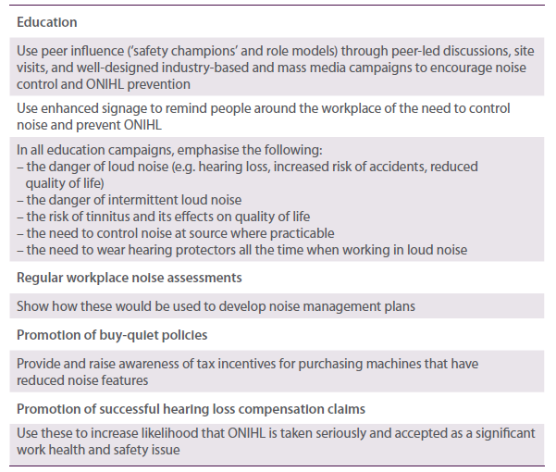
From the findings of the studies of the current project, the basic message appears to have registered with many of the interview respondents—the challenge seems to be reinforcing the message in a systematic fashion. Campaigns to promote having noise controls plans would serve to consolidate the readiness workplaces have to support noise control. The general problem was that they were not really aware
that they were implementing noise controls, and with more awareness could be doing it a lot more systematically and effectively. To this end, an easily accessible online version of the noise management guide, and any subsequent guidance material, supplemented with an industry-led education campaign would be a positive step. The internet was also thought to be a good tool for communicating information about workplace hearing loss however, not all workers had access to the internet, be it at home or work.
There were positive reactions among the interview respondents to getting industries to focus on a different work health and safety risk each month, much like the ‘Manual Handling Month’. Hence, there could be a ‘Noise Exposure Month’ in which workers and employers could be made aware of techniques for preventing noise-induced hearing loss. This could coincide with Hearing Awareness Week held every August. Potentially effective ways of communicating the noise control message include small group meetings, tool box talks, and workplace visits from a union representative or a hearing specialist to speak to workers in person.
Incorporating information on noise exposure and hearing loss as a compulsory part of staff induction processes was also raised in the interviews as a suggestion, as this would reach the vast majority of workers changing jobs. However, this did not provide a solution for targeting workers who remain with a company for several years or their entire working life. Other key channels for this type of information included weekly staff notices, on the job training and health and safety committee meetings. Recent mass media campaigns with the tagline ‘your reason for going home safely’ were considered highly effective by a few respondents. The television commercials were something that got people talking about workplace safety.

Safety champions and role models
Safety champions (including young people, older workers affected by noise, and whole companies) were regarded by many interview respondents as a possible tool for promoting and progressing noise control. It was suggested that the local work health and safety authority could identify influential individuals or exemplary businesses doing the right thing in terms of noise prevention and use them as role models for the rest of the industry to follow. In this way proactive behaviour would be rewarded and could be potentially more effective than penalties for negligent behaviour. As an example, a company participating in the face-to-face interviews claimed to have a sophisticated model for controlling
noise and other work health and safety issues. The company maintained a risk database containing all the hazards on the work site that may pose risks to workers’ health and safety. Each risk was classed according to its potential impact, the probability that the risk will occur, the level of exposure, the consequence of the exposure, an overall risk score, legal requirements associated with the risk and the relevant legislation. The database entry associated with exposure to loud noise is similar to the following
- risk – operator exposed to high noise levels
- impact – operator hearing loss
- probability – almost certain
- exposure – continuous
- consequence – serious
- risk score – high (calculated by an exposure/consequence matrix)
- legal requirement – employees must not be exposed to more than 85 dB over an 8 hour average or an impact noise of more than 140 dB
- legislation – OHS Regulations 2007.
The interview respondent reported that at this work site noise was a well recognised, documented and understood workplace hazard.

International solutions
Some of the suggestions arising from the interviews regarding education and role models are in place in other countries. For example, the United States Construction Noise Control Partnership developed a ‘one-stop shop’ information source in an effort to increase the acceptability of noise controls to that industry (Neitzel 2002). The partnership includes industry, union and government stakeholders, academic institutions, insurance companies, equipment manufacturers, trade organisations, consulting firms and professional organisations. The use of noise controls is promoted through an equipment-specific on-line noise database known as the Washington State noise reduction ideas bank (www.lni.wa.gov/ safety/topics/ReduceHazards/NoiseBank/default.asp). The database contains information on a range of engineering controls to help workplaces reduce noise at its source.
In response to the little, if any, attention given to controlling noise through engineering in the construction industry, the National Institute for Occupational Safety and Health (NIOSH) in the United States of America developed a database on the sound levels of powered hand tools (www.cdc.gov/niosh/ topics/noise/solutions/toolsdatabase.html ). In order to assist with buy-quiet decisions, construction workers also have access to information about quieter tools and machines.
Each year the European Agency for Safety and Health at Work (EASHW) conducts good practice competitions and publishes the entries to support the dissemination of good practice. Noise was the hazard in focus in 2005. The EASHW publications aim to promote the application of ‘practical solutions’ in workplaces in the 25 member states. The examples are not intended to be definitive or to provide detailed technical guidance, and some were unsuccessful (EASHW 2005). The format of the solution information is similar to that published in the United Kingdom in the Health and Safety Executive 100 Practical Solutions to Noise Control, now replaced by an on-line database of examples of noise control, and the 2001 Singapore Ministry of Manpower book of 33 examples of successful noise control (MOM 2001).
The ultimate aim of improving awareness of ONIHL and noise control is that businesses will adopt and maintain a buy-quiet policy, which itself can benefit from a ‘quiet by design’ policy among manufacturers and suppliers. For example, the Blue Angel program in Germany allows manufacturers to submit specific equipment for analysis. Those that meet specified criteria, including sound power levels, are designated as environmentally friendly and allowed to be marketed with the Blue Angel symbol. The program began certifying construction equipment in 1988 and covers nearly all types of heavy mobile equipment. The Blue Angel program is operated by the Environmental Label Jury which is an independent decision making body comprised of representatives from environmental and consumer associations, trade unions, industry, trade, crafts, local authorities, science, media, churches and federal states (Environmental Jury 2009 Neitzel 2002).
NIOSH in the USA has applied its quiet by design, or Prevention through Design (PtD), approach to overcome barriers to reduce ONIHL in the mining industry (Kovalchik et al. 2008 Matetic 2005). PtD has four functional areas Practice, Policy, Research and Education. It relies heavily upon the involvement of partnerships with industry and unions. It also provides opportunities for collaborative work with machinery manufacturers. The barriers that have been identified include the misapplication of technologies, lack of maintenance of noise controls and the treating of noise sources that are insignificant to worker exposure. In addition there has been a failure to develop noise controls due to a lack of understanding of the mechanisms of noise generation and the inability to develop controls that are suitable for the mining environment (Kovalchik et al. 2008 Matetic 2005).
NIOSH noise control guides emphasise the longer term benefits of the implementation of a buy-quiet policy (Franks et al. 1996). The success of this policy has been demonstrated in several case studies. For example, although retrofitting of engineered controls is a key element of the NASA noise control program (Cooper & Nelson 1997), NASA has implemented a buy-quiet program with the goal of achieving long-term reduction of employee noise exposures through the purchase of equipment that conforms to hearing conservation goals. Project designers and engineers are required to consider noise emissions along with other performance criteria and are provided with a Guide to Specifying Equipment Noise Emission Levels.

5.3 Noise control and ONIHL prevention cost-benefit analysis
In Chapter 3 we provided examples of business case studies that showed benefits from effective occupational noise control in addition to reduced noise levels or noise exposure. The importance of some of these benefits was confirmed by the findings of the studies described in the previous chapter. Apparent from both previous chapters is the lack of quantification of these benefits, particularly in monetary terms. Part of the reason for this is that some of the reported benefits are intangible in that it is difficult if not impossible to put them in monetary terms. Other benefits are not considered at the time of making the noise control investment decision or are difficult to attribute in whole or part to the noise control. In order for businesses to be convinced of the economic value of effective noise control, quantification of the benefits is required so that reliable and valid cost-benefit analyses can be undertaken. Such information is not readily available. However, in this section we provide a cost-benefit analysis model to be used as the basis for further research and development.
A typical cost-benefit analysis for noise control (based on Berglund et al. 1999) might follow the following stages
- Assess the noise levels to which workers are exposed.
- Identify and place a monetary value on noise control options.
- Identify the likely benefits, including those that have a monetary value and those that do not.
- Determine pre-control baselines for the benefits, including intangible benefits such as absenteeism rates and morale levels if possible.
- Compare the costs of noise control with the known and estimated benefits.
- Conduct sensitivity analysis to account for uncertain levels of the benefits.
The cost of noise control would include the initial investment (including training if required) and ongoing operation and maintenance costs (Berglund et al. 1999). The initial investment would be a one-off cost, although in subsequent years it may involve annual depreciation estimates. The operation and maintenance costs would be assessed on an annual basis for the operating life of the noise control. Sensitivity analysis involves repeating the cost-benefit analysis with different plausible cost and benefit scenarios. The result is a range of possible outcomes rather than a single forecast.
Table 5.2 contains the most likely components of a noise control investment cost-benefit analysis. Some of the components in Table 5.2 can be expressed as absolute values, others as rates. ‘Intangible’ refers to variables for which it is difficult to assign monetary value however, most are measurable in some way. For example, some of these variables may be measured by psychometric surveys. Therefore, benefits such as morale and communication can be scored from annual staff surveys and correlated with key outcome variables such as work efficiency and productivity. Other potential costs include extra overtime, over- employment of staff, product wastage and loss of corporate image or reputation, while other potential benefits include payroll savings (Oxenburgh & Marlow 2005).

Table 5.2 Possible components of a noise control cost-benefit analysis
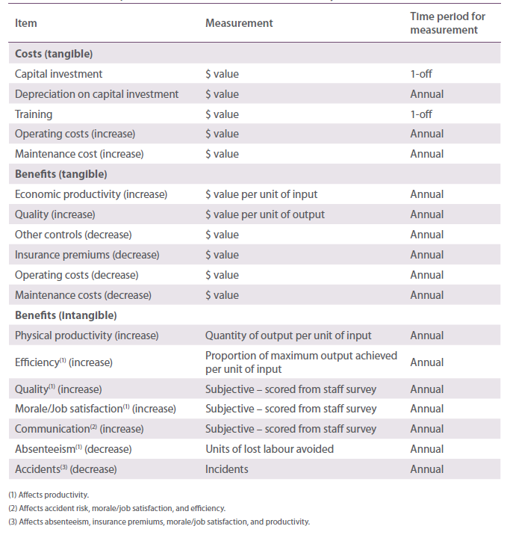Typically, costs are more readily assessed than benefits as they have a more immediate impact on business. Therefore, costs are often overestimated while benefits are usually underestimated (Berglund et al. 1999). Another qualification is that control of one hazard or feature of the workplace may affect the influence of another (Berglund et al. 1999). For example, a common reason for not wearing PHPs is the belief that they interfere with hearing warning signals. Berglund and colleagues also caution that, while cost-benefit analysis can be a useful decision-making aid, it should not serve as the only basis on which noise control decisions are made.
Whereas the discussion in Chapter 3 included ‘direct’ and ‘indirect’ costs and benefits, the focus here is on costs and benefits that can be measured in monetary terms (‘tangible’) and those that are difficult to measure in monetary terms (‘intangible’). For a cost-benefit model to be useful it should be as comprehensive as possible while remaining simple to understand, use and interpret. Ideally it should refer to the benefits of doing something rather than the costs of doing nothing. A simple cost-benefit analysis model may involve the following equation
- Net present value = Present Value (Benefits) – Present Value (Costs)
A more complex model may include productivity changes separately from present cost and benefits. Such a model is presented in equation 2
- DProfit = ΣBenefit + ΣDEP – ΣCost
In this model ‘DProfit’ is the change in profit (in dollars) associated with the investment (i.e. salaries and other non-related operating costs are held constant) ‘ΣBenefit’ is the total savings and gains (in dollars) following the investment ‘ΣCost’ is the total cost (in dollars) of the noise control investment, including capital investment and additional training, maintenance and operating costs, if applicable and ΣDEP is the difference (in dollars) in the combined employee productivity measured before the investment and estimated after the investment. Based on Tarantino (Tarantino 2005) and considering output value, physical productivity, and the impact of absenteeism, EP can be expressed as
EP = [value per unit output] x [output per employee per week] x [weeks worked per employee per year].
Post-investment productivity effects may be estimated from past experience within the company, available research, or expert/peer advice. An alternative way of expressing the result of the cost-benefit analysis is the time required for the investment to be paid back by the resulting benefits. Through development of the input/output measures and the establishment of the correlations between variables, the resulting weights can be used to form an algorithm for a cost-benefit analysis template. Such a template would allow variables to be omitted where sufficient information is lacking.
Box 4 contains a fictitious business case study based on the cost-benefit analysis model from equation 2. If the cost-benefit analysis only included the cost of the noise control, ‘Company X’ would have faced a decrease in profit and the investment may not have been made. If the tangible benefits were considered along with the noise control costs, the decrease in profit would have been slightly less. However, if all the benefits were considered, including expected gains in efficiency and absenteeism, the cost-benefit analysis would have shown an expected increase in profits.

Box 4 Illustrative noise control business case study based on proposed cost- benefit analysis model
Before the noise control investment ‘Company X’ made widgets that each sold for $50. Five employees each made on average 10 widgets per week and worked for 40 weeks per year. The widget making machine operated at 87 dB(A), requiring each of the workers to wear PHPs throughout their 8-hour shifts.
Noise control investment A new, 8 dB(A) quieter widget-making machine was purchased for $10000. The new machine required training for each of the five employees at $1000 per employee.
One year after the noise control investment The new machine is less expensive to run resulting in a saving of $100 per employee. In addition, there was a $100 per employee saving on PHPs and a $100 saving on insurance premiums. After the first year of operation with the new machine there were 10% more widgets made per employee per week and each employee worked 10% more weeks per year. A staff survey showed increases in employee morale and communication. With all widgets sold and all salaries and other employee costs remaining unchanged, the noise control investment increased the company’s profits by $7100.
Factors such as improved staff safety and morale should always be considered as possible outcomes of a cost-benefit analysis regardless of their quantifiable effect on productivity. However, if flow-on effects on productivity can be quantified, the analysis would be much more powerful. Different scenarios, such as higher morale by itself and higher morale linked to higher productivity, could be built into a template provided there is sufficient empirical data and a desire to include intangible outcomes in their own right. For example, an increase in morale was noted in the fictitious business case study described in Box 4 without making an explicit link to higher productivity or lower absenteeism. In other words, the cost- benefit analysis template could have several layers of input and output variables depending on (a) the available data and (b) the personal values of the decision maker. For example, staff morale may be an important consideration regardless of its flow-on effects and tangible outcomes. In any event, it must be stressed again that cost-benefit analysis should only be used as a decision making aid and not as a profit- loss forecasting tool. That is, it should be used for its heuristic value rather than as an accounting algorithm.

Remaining Questions
- Is social marketing the best behaviour change strategy to achieve the adoption of effective noise control?
- How does business size affect susceptibility to social marketing strategies?
- How does business size affect ability to adopt a buy-quiet policy?
- To what extent can fulfilment of a moral obligation be used as a noise control adoption enabler?

Chapter 6 Conclusions and implications for policy
ONIHL is a significant global problem affecting individuals, families, businesses and communities. Despite abundant evidence that eliminating the noise source or implementing engineering noise controls is the most appropriate way to reduce the risk of ONIHL, providing personal protective equipment (i.e. PHPs) appears to be the preferred risk reduction measure. Several factors may account for this situation. First, occupational diseases such as ONIHL often seem to have low prominence or urgency as work health and safety issues. Secondly, a lack of understanding of noise control techniques and a perception that noise control is complex and costly further emphasises PHPs as the protective measure of choice. These factors, among others, constitute barriers to the adoption of effective noise controls. The studies undertaken for the present project revealed several noise control barriers (Table 6.1). Many of these barriers, such as low prominence and high fatalism, point to a general lack of knowledge and appreciation of the effects of excessive exposure to loud noise.

Table 6.1 Barriers to effective noise control and ONIHL prevention
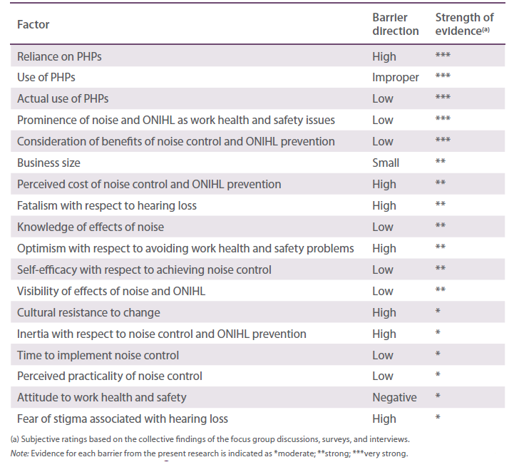
Literature on the topic of occupational noise emerges from many countries and is indicative of the significant amount of work that has been undertaken in relation to noise over many decades. However, there is limited information on the barriers and enablers associated with the adoption of noise controls and ONIHL prevention measures other than providing personal hearing protection. Relatively few studies have looked at the factors that motivate employers and managers to implement higher-order noise controls. Nevertheless, the available literature (as reviewed in Chapter 2) supports all of the barriers in Table 6.1 as well as others revealed to some degree in the present project. For example, a recent Canadian study of eight worksites in the food and beverage industry found the following barriers to adopting engineering noise controls
- expectation and acceptance of noise in the workplace
- low perception of risk from noise exposure
- low priority of noise as a health hazard
- over-reliance on PHPs
- emphasis on workers to identify and report noise problems
- reluctance of workers to complain about noise
- low understanding of engineering options
- assumption that engineering controls are impractical, and
- poor knowledge of noise regulations (Davies et al. 2009).
The real and perceived costs and difficulty of implementing engineering noise controls are among the major barriers to their adoption. Consequently, noise control is often considered a low priority, especially in companies that are struggling to survive in difficult economic times. A factor that influences expenditure on noise controls is the lack of recognition of the hidden costs associated with noise exposure. Noise control investment is also less likely unless productivity gains and other benefits are made as a result. Published business case studies illustrate that correctly implemented at-source noise controls not only reduce hearing loss but also reduce machine wear and increase tool life, work efficiency, production, and profits.
Relying mainly or solely on personal hearing protection can place the onus for ONIHL prevention upon the employee and their self-protective behaviours. However, responsibility for the management of noise remains the legal responsibility of the employer. It is important for both managers and workers to realise that PHPs do not control noise, nor in the strictest sense do they reduce exposure. Rather, if appropriately provided and properly used, they reduce the amount of sound energy absorbed by the individual. Therefore, if PHPs are provided it must be as the last resort and after consideration of noise elimination and other control measures.
Workers are typically not motivated to do much about noise because ONIHL occurs gradually, is not visible, and there is a lack of knowledge about the full nature of the disability associated with the condition. Hearing loss is neither shocking nor life-threatening and is therefore not perceived to be serious. The slow progression of ONIHL and its manifestation at a time of life when many people are experiencing age-related hearing loss (presbycusis) leads to the problem being further under-recognised. In many occupations hearing loss is still accepted as inevitable. Such fatalism is a barrier to achieving risk control, as is the fear that one will be stigmatised if admitting the presence of a hearing problem. The most straightforward solution to these barriers includes thoughtful and innovative education and greater involvement of regulators as both rule enforcers and solution educators. The latter suggestion, however, posses the question of who will educate the regulators?
Access to databases of noise control solutions may aid business owners and managers in their noise control investment decisions. The Victorian SHARE solutions database contained numerous examples of noise controls that illustrated the simplicity and cost effectiveness of engineering controls (Mitchell 1992 Mitchell & Else 1993 Swuste et al. 2003). This database was subsequently incorporated into the National Solutions Database hosted by the National Occupational Health and Safety Commission. However, in the absence of maintained support, the database has ceased to be available.
Evidence from the literature suggests that management commitment may be the most important factor in ONIHL prevention as it underpins many of the individual barriers found in the present and other research. That is, there needs to be leadership from senior management, clear allocation of relevant operational responsibilities among middle managers in noise hazard areas, and technical competence in noise management and control. Also, a noise control effort may seem to be overwhelming and this may result in a decision that control is not feasible hence, the widespread reliance on personal hearing protection.
A significant indication of management commitment to effective noise control is a written hearing conservation or noise control program and a buy-quiet purchasing policy. Unfortunately, there appears to be a commonly held perception that the term ‘hearing conservation program’ describes activities focused exclusively on personal hearing protection and audiometry rather than a comprehensive package of activities that include and focus primarily on engineering controls. One suggestion from the literature worthy of consideration comes from Thorne (2006) who suggests that noise-induced hearing loss should be referred to as something like ‘sound injury deafness’. This, suggests Thorne, would help avoid the common impression that noise is bad while sound is good. A change in terminology such as this may also lead to ONIHL being considered as a series of occupational incidents, including every occasion of noise-induced temporary threshold shift, rather than as a long-latency occupational disease.
Ultimately, solving the ONIHL problem requires behaviour change among managers and others who make decisions about the adoption of noise controls. Numerous behaviour change models have been applied within the public health domain and some may have the potential for application within work health and safety. These models have the potential to inform the design of interventions that aim to influence decision makers in regard to the adoption of noise control. Social marketing is an approach that has merit for applying these models. It draws together various behaviour change and intervention evaluation theories. For example, the transtheoretical model is a useful simplification and refinement of several principles from other behaviour change models and lends itself well to the social marketing process. In particular, opinion leaders and role models can be used within a social marketing process to spread information about the need for and benefits of adopting effective noise controls.

Role of regulators and designers
The research and discussion undertaken for the present project has focussed on workers/employees and business owners/employers/managers. The former are those most likely to experience the most serious consequences of excessive exposure to loud noise the latter are those most directly responsible for providing a workplace free of risks to health and safety. Other important stakeholder groups are regulators and plant designers and suppliers.
One of the key principles of the work health and safety and workers’ compensation system is that pressure is placed on unsafe workplaces to comply with work health and safety legislation through the consequences of higher insurance premiums. Changes to workers’ compensation eligibility criteria in the 1990s meant that only people with quite advanced hearing loss were eligible to lodge a claim. As such, an unintended policy consequence of trying to contain the cost of claims was to undermine the primary business driver for complying with work health and safety regulations. Employers and managers interviewed for the present project were not concerned about the possibility of being fined by the work health and safety inspector for having loud noise, not having assessed their noise, not having a noise management program, or for not implementing it. Rather, they see the role of the inspector as being to fine employees for not wearing PHPs. By contrast, it can be seen in hospitality and entertainment businesses that very powerful economic drivers underpin compliance to environmental noise regulations as they relate to liquor licensing.
Findings from the present project suggest that for effective noise controls to be adopted noncompliance with noise-related regulations should carry meaningful sanctions. This could be in the form of higher fines, higher insurance premiums, and lower criteria for workers’ compensation claims. Also evident is the need for the greater likelihood of the enforcement of these regulations. Therefore, making regulatory enforcement more likely and publicly visible may be part of the answer. However, in many instances it would be necessary to deem that the employer was not doing all that was reasonably practicable. A preferable situation would be that instead of doing nothing or simply relying on PHPs business owners and managers were aware of a wider variety of options that were not only practicable but also had potential benefits for their businesses.
The present project’s findings also suggest that there is a strong desire for regulators to provide a carrot along with the stick. That is, in addition to mandating what preventative actions are to be taken, many managers want regulators to explain more clearly why the actions should be taken and how they are taken. The ‘why’ question represents the motivational aspect of behaviour change whereas the ‘how’ question represents the actual process of behaviour change. As discussed in earlier chapters, motivation and process relate directly to low prominence and self-efficacy—two key noise control barriers.
Plant designers and suppliers are obliged under work health and safety legislation to provide adequate information for their products to be operated safely. Comments from participants of the present project suggest that more information about the noise-emitting properties of products would be useful. Engineering considerations may limit the degree to which noise can be reduced, but more information at the point of sale (perhaps similar to the star energy rating on refrigerators and other white goods) may facilitate a buy-quiet policy. In any event, cost-benefit analyses and market forces will influence the actions of business owners, designers and suppliers. With good understanding and evidence these considerations can be enablers rather than barriers.
Clearly, further research exploring the beliefs, attitudes and motivations of regulators, designers and providers is needed to gain a more comprehensive understanding of noise control barriers and enablers. Future research should aim to elicit their views on issues and suggestions arising from the present project, such as the need for greater education and regulatory enforcement. Industry and worker associations and work health and safety advisors are also influential stakeholders whose views should be sought as they are important sources of information and support.

Role of further research
Research and commentary on occupational noise and ONIHL has focused on a long list of factors and constructs, including the following
- prevalence of ONIHL in different industries
- noise levels in various work environments
- methods for diagnosing ONIHL
- links between ONIHL and factors such as shift work and smoking
- links between noise and nonauditory effects such as stress and heart disease
- effects of noise on pregnancy
- effects of hearing loss on the families of affected workers
- characteristics and use of personal hearing protectors, and
- contribution of non-occupational activities on total noise exposures.
The main aim of the present project was to add to the body of knowledge on the barriers and enablers to the adoption of effective occupational noise control. Each of the studies undertaken for the present project was essentially qualitative in nature and contained some degree of bias. Therefore, the findings should be used to focus the aims and scope of further investigations of occupational noise control barriers and enablers. Depending on the exact purpose, future studies should involve a population- based survey with a representative sample and a well-validated instrument, and/or a well-designed case- control study comparing business with poor noise control to those with successful control. Only then will we have a clear picture of the extent of the need for greater education and regulatory enforcement and the best strategies for achieving this need.
The cost-benefit analysis model proposed in Chapter 5, or a similar model, could be the basis of a template that could be made available to business owners and managers on a compact disc or on the internet. There could also be a built-in option to include subjective weights for some variables representing additional benefits such as staff morale. However, it must be noted that the model is of limited practical use until sufficient data are collected and the model fully developed and tested.
Similarly, although the present report contains suggestions for noise control and ONIHL prevention interventions based on the literature and research findings, assigning costs to such interventions requires proper scoping and feasibility studies.
The present project raised several questions, as highlighted at the end of each previous chapter, which were beyond its scope. For example, without good exposure and outcome data we really do not know the extent to which current controls and initiatives have an effect nor can we be sure of how much improvement, if any, is occurring as technology and Australia’s industrial profile evolves. This lack of data has direct implications for policy aiming to prevent ONIHL. From the present project we may be able to say that there appears to be too many employers, managers and workers who believe that noise control is too expensive, too difficult, easily fixed with PHPs, or simply not worth worrying about. The other major policy implication from the findings of the present project is that an increased recognition of the seriousness of ONIHL, and the ways it can be prevented, is fundamental if this situation is to change.

Appendix A Review of the literature on selected nonauditory effects of noise exposure
Exposure to noise can have adverse effects that can be independent of hearing loss or arise as a secondary consequence of hearing loss. Among the most studied of these ‘nonauditory’ effects are workplace accidents, psychological effects, and impact on productivity and performance.

Risk of accidents
Exposure to noise can increase the risk of accidents by causing a lack of attention and by masking danger signals (Wilkins & Acton 1982). Noise has also been implicated in causing increased rates of stress which can act as a contributing factor to accidents. Moreover, noise-induced hearing loss and the wearing of personal hearing protection can interact with excessive noise to hinder auditory communications and therefore increase the risk of accidents (Wilkins & Acton 1982).
Numerous studies have found a positive correlation between noise exposure and accident rates (see for example Cohen 1973 1976 Deshaies et al. 2008 Dias & Cordeiro 2007 Melamed et al. 1992 Melamed et al. 2004 Moll van Charante & Mulder 1990 Picard et al. 2008). In one of the first major studies to be carried out in this area, Cohen (1973) examined the medical, attendance and accident files of over 500 workers from two manufacturing firms in the United States for the period 1966–1970. Fewer than 5% of workers in the quieter areas had 15 or more accidents for the five year period of the study. However, 35% of workers in the noisier environments had 15 or more accidents in the same period and 10% had up to 40 (Cohen 1973).
A similarly strong association between noise exposure and accidents was found in a more recent study (Melamed et al. 1992). In this study of 2368 subjects who were participants in the Cardiovascular Occupational Risk Factors Determination in Israel Study (CORDIS), the relation between accident rates and absentee rates and noise exposure levels was examined. It was found that the percentage of accidents among males increased from 14.8% at low levels of noise exposure (< 75 dB(A)) to 22% at high levels of noise exposure (≥ 85 dB(A)) (Melamed et al. 1992). The results for females were less significant but still showed an increase in the percentage of accidents from 10.1% to 14.7% (Melamed et al. 1992).
More recently, a study of 52,982 male workers also points to a link between noise exposure, hearing loss and accidents (Picard et al. 2008). The authors concluded that 12.2% of accidents are attributable to a combination of noise exposure and noise-induced hearing loss. While the sample size of this study gives this finding statistical power, age was the only confounding factor controlled.
By far the highest estimate of the influence of noise on accidents can be found in a study by Moll van Charante and Mulder (1990) which explored the risks of injury to shipyard workers in the Netherlands. The study was carried out in 1986-87 and involved 300 workers who had at least one injury in the previous 3.5 year period. The main finding was that hearing loss greater than 20 dBHL, and loud noise greater than 82 dB(A) were hazardous to safety (Moll van Charante & Mulder 1990). Altogether, 43% of the injuries were attributable to noise and hearing loss (Moll van Charante & Mulder 1990).
On the other hand, other studies have found little evidence supporting the link between noise and accidents (Noweir 1984 Viljoen et al. 2006). Noweir’s often-cited study of the effects of noise on textile workers (1984) found that there was little evidence that noise was a causative factor in accidents. Even though the incidence of accidents among workers in the high-noise groups was higher than those in the low-noise group in the total sample, these differences were statistically insignificant (Noweir 1984). Moreover, the effect was inconsistent because it was observed in only one of the three plants studied (Noweir 1984). Viljoen and colleagues (2006) also found little overall association between hearing loss and accidents in the New South Wales underground coal-mining industry. Workers who had lost up to 54% binaural high tone hearing and were older than 29 years old did not appear to have an increased risk of accidents when compared with workers who did not have hearing loss. However, workers younger than 29 years who had high tone hearing loss were found to be at an increased risk of accident. Thus, the study found that age and job experience may act as stronger predictors of accidents than hearing loss.
A significant criticism that has been levelled against all of the studies discussed above is that they fail to adequately control for confounding variables, the most significant of which is safety hazards (Kjellberg 1990 Noweir 1984 Smith 1990). In response to this problem, some studies have sought to control for confounding by studying the effects of noise reduction (Cohen 1976 Schmidt et al. 1980). Cohen’s follow-up to his 1973 study, (discussed earlier), was the first to test this strategy (Cohen 1976). The follow-up study examined the records of 400 boiler workers, representing 90% of the workers examined in the original study. The study found that after the introduction of a hearing conservation program which involved the introduction of personal hearing protectors, the median frequency of job injuries from workers in high noise areas fell from 3.8 to 2.3 median injuries, equivalent to a fall of 25 per cent in the number of injuries (Cohen 1976). Importantly, although the number of injuries for workers in the low noise group were slightly lower than in the period of the first study, the difference was virtually insignificant compared to the reduction in injuries found in the high noise group (Cohen 1976). However, significant reductions in the number of accidents were also found in those who did not wear hearing protection (Cohen 1976). This inconsistency suggests that other factors besides the reduction in noise exposure may have influenced the results.
Aside from this work by Cohen, a study by Melamed and colleagues in 2004 also controlled for safety hazards and other confounding factors such as age, job experience, body mass index, educational level and managerial status. Interestingly, the authors discovered a threshold effect in injury rate and thus a cut-off point of 80 dB(A) was used to dichotomise noise exposure levels into high and low rather than treating noise as a continuous variable. The study examined 6014 workers and considered the joint effect of noise exposure and job complexity on the rate of accident occurrence. Both men and women in jobs with high noise levels had a higher percentage of injuries compared with those in jobs with low-noise levels (Melamed et al. 2004).
Essentially, while it is possible to identify noise as a contributing factor to accidents, it is much more difficult to establish it as a direct cause. This is predominantly due to the difficulty of controlling for other factors that may influence the rate of accidents, such as safety hazards, age and job experience. Due largely to these difficulties, estimates of the percentage of accidents that can be attributed to the effects of hazardous noise levels vary significantly. There are also inherent difficulties in determining the extent to which the combined effects of noise and hearing loss contribute to accidents.
Despite these caveats, and some negative findings, evidence supporting a link between noise and accidents is growing, and such studies lend support to the argument that reducing noise levels may result in a reduction in the number of workplace accidents.

Psychological effects
The numerous psychological effects of noise exposure, such as increased stress and annoyance and decreased job satisfaction and motivation, are often under-acknowledged. In recent years, research has shown that these effects are evident even at moderate noise levels, particularly among workers who are sensitive to noise (Evans & Johnson 1998 Loewen & Suedfeld 1992 Sundstrom et al. 1994). Studies have also found that in many cases the decibel level of noise is not actually the determining factor in the extent to which noise can cause annoyance or stress. Instead, research has highlighted a number of other factors which can determine the psychological effect of noise. These include the frequency, type and controllability of noise, the nature of the tasks being performed in noisy conditions, and individual sensitivity to noise. In addition to occupational studies, knowledge about the nonauditory effects of noise can also be drawn from research on the effects of community noise, traffic noise and air traffic noise. This review focuses on major studies of the psychological effects of occupational noise.
Although there has been some work done on the psychological effects of industrial noise exposures, there is a large number of laboratory and field studies which have examined the effects of noise in office environments (see for example Evans & Johnson 1998 Kjellberg & Landstrom 1994 Mital et al. 1992). As office noise is usually not severe enough to cause hearing loss, these studies have produced substantial evidence that office noise can have negative effects on levels of stress, annoyance, concentration, job satisfaction and motivation, even at low levels of noise. For example, Sundstrom and colleagues (1994) tested the hypothesis that dissatisfaction with the work environment caused by unwanted noise may contribute to job dissatisfaction. Participants were asked to complete a questionnaire before and after moving to a new office which asked them to rate their annoyance by sources of noise such as people talking, telephones and typewriters. Fifty-four percent of 2391 office employees who participated in the study reported that they were ‘often’ bothered by one or more sources of noise. The authors also noted that there was a significant association between disturbance by office noise and job satisfaction.
To test the effects of office noise on stress levels, cognitive performance and arousal, 15 student volunteers were observed while undertaking a series of tasks in office noise (54 dB(A) with bursts ranging from 60 to 66 dB(A)), masked office noise (the same noise masked by white noise at 59 dB(A)) and no extraneous noise (Loewen & Suedfeld 1992). The authors found that stress was reported highest in the unmasked noise condition, where sound intensity was actually lower than with the white-noise masking. Thus, it seems that the actual level of noise may contribute less to stress than the presence of distracting, intermittent noise. Similarly, another study found that office noise at a level of 55 dB(A) heightened levels of epinephrine, a reliable index of stress (Evans & Johnson 1998). Interestingly, however, participants did not perceive the noisy working conditions as more stressful than those working under quiet conditions (Evans & Johnson 1998).
In comparison with the literature on the effects of office noise, there have been relatively few studies that have examined the nonauditory effects of hazardous noise exposures in industrial work settings. However, the work that has been done has found a positive relationship between noise exposure and nonauditory effects such as increased rates of stress and annoyance. In a study of 2458 textile mill workers, Noweir (1984) showed that exposure to high levels of noise may negatively affect workers’ well- being and satisfaction, as well as reduce productivity and increase accident rates.
One criticism of work in this area has been that many of the field studies that have reported the effect of noise exposure in industrial environments do not adequately control for confounding variables such as toxic substances, heat, other hazards present in the workplace, or the type of work performed. One possible exception is a well-controlled experiment to test the effect of noise reduction on rates of job satisfaction, stress and company attachment (Raffaello & Maass 2002). The study is a unique example because it examined the employees of one manufacturing company before and after they moved to a new site with significantly reduced levels of noise. Importantly, the control group worked under similar environmental conditions and had almost identical noise levels to those of the experimental group before the move. The results confirmed the authors’ hypothesis that reduced noise exposure would reduce the levels of stress, increase job satisfaction and would increase feelings of attachment towards the company in the experimental group, whereas the levels of the control group stayed the same.
Melamed and Bruhis (1996) devised another approach to overcome confounding factors in a study which examined cortisol levels, fatigue and post-work irritability. By using the same group of workers performing the same tasks in two experimental conditions (i.e. high ambient noise and attenuated noise achieved with the use of ear protectors) and making the level of noise the only variable, the study eliminated many of the confounding factors cited in other studies. The main finding was that wearing ear protectors reduced cortisol levels compared to that observed under the chronic noise exposure condition. Fatigue and post-work irritability reported by the workers was also significantly reduced during the period of attenuated exposure. In a later study, Melamed and colleagues (2001) showed that exposure to high noise levels has a negative impact on job satisfaction in those performing complex jobs. The study controlled for confounding variables including age, sex, body mass index and differences in job complexity between blue-collar and white-collar workers.
A number of studies have shown that the nature of the noise as well as the type of activity that is being performed at the time of noise exposure has a large role in determining the response. For example it has been found that intermittent noise is more distracting and can cause more annoyance than constant noise (Loewen & Suedfeld 1992). In addition, research has also suggested that the predictability and controllability of noise is a factor in how annoying or stressful an effect it will have (Kjellberg & Landstrom 1994). Other research has found that the effects of noise are dependent on the type of activity that the person is engaged in (Rentzsch et al. 1991). Kjellberg and colleagues (1996) found that there was a significant relationship between annoyance and the self-rated ‘necessity’ of the noise. Outside the laboratory it can be expected that a person’s response to noise will be shaped by a combination of these factors.
Due to the fact that stress and annoyance are subjective effects, the extent to which individuals are affected is influenced by individual sensitivity to noise (Belojevic et al. 1992 Bhatia et al. 1991). In addition, it seems that those with hearing impairment are more likely to be annoyed by noise than others because lower noise levels have been found to interfere with speech intelligibility. A study on traffic noise by Aniansson and colleagues (1983) is often cited as evidence for this effect. The study examined the effects of 45 dB(A) and 55 dB(A) traffic noise on normal and hearing impaired groups, and found that the rates of annoyance were much higher for hearing impaired people in situations where the noise interfered with speech than for people with normal hearing.
The research reviewed above shows that even noise at levels as low as 55 dB(A) can negatively affect workers’ psychological well-being. Research has also highlighted, however, that the particular subjective effects of noise are dependent upon a range of factors including individual noise sensitivity as well as the type, level and frequency of noise exposure.

Productivity and performance
Noise has been found to negatively affect worker performance and productivity by causing distraction, interfering with speech and concentration or by changing arousal levels. In a review of the literature on performance and noise Broadbent (1979) found no clear evidence that noise below 95 dB(A) affected performance. However, more recent research provides abundant evidence that noise affects workers’ performance and productivity at levels of noise well below those considered hazardous to hearing (Banbury & Berry 1998 Belojevic et al. 1992 Bhatia et al. 1991 Loewen & Suedfeld 1992 Smith 1988 Sundstrom et al. 1994). Kjellberg and Landstrom (1994) argue that one reason for this change has been the shift in interest for sensorimotor tasks, such as reaction time and vigilance tasks, to verbal tasks. Recent research has sought to determine the extent to which factors such as the task being performed, the nature of the noise and individual sensitivity to noise can influence the effect of noise on productivity and efficiency.
A number of studies on the effects of office noise have found evidence for decreased mental performance as a result of low intensity noise (Banbury & Berry 1998 Loewen & Suedfeld 1992 Smith 1988 Sundstrom et al. 1994). For example, Banbury and Berry (1998) found that both speech and office noise at a level of 66 dB(A) can significantly disrupt performance of tasks involving recall and arithmetic tasks. In the second experiment it was found that performance in the presence of noise at a mean level of 65 dB(A) was reduced to about one-third of the level of performance in quiet conditions.
Research in this area has also shown that the performance and productivity is more likely to be negatively affected in individuals who are sensitive to noise (Belojevic et al. 1992 Belojevic et al. 2003 Bhatia et al. 1991 Jones et al. 1981). People who are sensitive to noise have to expend greater effort to counteract the potentially distracting effect of noise. For example, in a study of 100 students Bhatia and colleagues (1991) found that efficiency was not much affected under high intensity noise in the case of those subjects with low noise sensitivity, but in the case of subjects with high noise sensitivity it had a negative effect under both high and low intensity noises. This study and others which have achieved similar results show that there are wide individual differences in reactions to noise.
Studies that have found a positive link between low levels of noise exposure and performance and productivity loss are corroborated by studies that have examined the effects of industrial levels of noise (80 dB(A) and above). For example, from a study of over 2000 textile mill workers who were exposed to noise levels ranging from 80 dB(A) to 99 dB(A), mean production efficiency for the high noise group (91.38%) was significantly less than for the low noise group (92.62%) (Noweir 1984). In another study on the effects of high noise exposures, noise impaired tasks involving mental complexity but had little effect on tasks involving manual dexterity (Levy-leboyer & Moser 1988). The authors observed workers assembling a carburettor and an air-conditioner in noisy and quiet conditions. Each of the 94 workers observed were experienced workers of a similar age who had never carried out these particular tasks before. The authors found that for each of the tasks, the faulty behaviour was more frequent in noise and that all faulty behaviour involving a difficulty involving precision was also more frequent in noise. On the other hand, all tasks involving manual dexterity were unaffected by noise. The authors even speculated that noise can facilitate tasks involving physical strength, because the assemblage of the carburettor (the only task which involved physical strength) was achieved more easily in noise. Overall, it was found that assembly of the carburettor, the more complex of the tasks, was slower than assemblage of the air- conditioner in noisy conditions. The authors argue that this result shows that faulty behaviour involving mental load or difficulty in control precision is more frequent in noisy conditions, whereas tasks involving manual dexterity remain unaffected by noise. While this result is certainly interesting, and other research has confirmed that noise may negatively affect performance of tasks involving mental complexity (Belojevic et al. 1992 Loewen & Suedfeld 1992 Smith 1988), the study was carried out in the field and the result may have been confounded by other factors.
The negative effects of moderate intensity noise, such as lost productivity and lowered performance, have often been overlooked due to the focus on preventing noise induced hearing loss. Clearly, the finding that noise as low as 55 dB(A) can negatively affect performance and productivity has far-ranging implications for businesses. Nevertheless, while it is clear from the evidence reviewed above that noise may negatively affect productivity and performance, it is still difficult to predict what effect noise will have because it has been found to be dependent on a variety of factors. While broad patterns can be identified, further research is needed in this area to determine exactly how factors such as the nature of the task and the nature of the noise can influence the effects of noise. The importance of individual sensitivity to noise in assessing the negative effects that it can produce is another often overlooked factor. The effects on the productivity and performance of workers who exhibit high sensitivity to noise may be even greater than these studies suggest because in real occupational settings, as opposed to the laboratory, workers must cope with much longer noise exposure times as well as other stressful factors.

Employee absenteeism
A handful of quite old studies from the United States, Sweden and Egypt have found an association between occupational noise exposure and absenteeism (Cohen 1973 1976 Elvhammar 1981 Noweir 1984). However, confounding factors limit the strength of this evidence. In the United States, the National Institute for Occupational Safety and Health (NIOSH) sponsored the first major study of the impact of excessive occupational noise on absenteeism. The frequency of job injuries, medical problems and absences of 1034 boiler plant workers from two different plant complexes, one large and one small, in high (95 dB(A) or greater) and low (80 dB(A) or less) noise areas were compared. Information extracted from participating companies’ medical and administrative records from 1966–1970, which was just prior to the introduction of a hearing conservation program, showed that absenteeism was higher among workers exposed to high noise levels (Cohen 1973).
However, findings from this study must be treated with caution. This is because job and task type was not accounted for—meaning that jobs or tasks associated with high noise areas could be intrinsically more hazardous and therefore lead to more absences and other effects. As a result, the study was later extended to compare the frequency of accidents, illnesses and absences before and after the implementation of a hearing conservation program involving personal hearing protection equipment (Cohen 1976).
The extended study found that absences for workers in high noise areas fell substantially after the introduction of the hearing conservation program (Cohen 1976). Workers in low noise areas of the same plant showed no substantial changes over the same time periods, suggesting that the observed difference could not be accounted for by plant-wide influences. However, injury rates were reduced not only for workers that regularly wore hearing protectors but also for those that did not (Cohen 1976). The fall in absenteeism could have been influenced by a combination of factors, such as changes in work procedures and staff numbers, in addition to reduced noise exposure. Thus, the author noted that the findings were still only suggestive of the effect of noise on absenteeism. Also, the study involved the use of personal protective equipment but not engineering or administrative controls. It is feasible that absences may be further reduced by engineering and administrative controls, which would eliminate the presumed discomfort and inconveniences associated with hearing protectors (EPA 1976).
Absenteeism rates among white-collar employees in 21 manufacturing plants were examined as part of the CORDIS study (Fried et al. 2002). The study found that absenteeism increased among employees performing cognitively complex tasks under high noise exposure. The highest rates of absenteeism were associated with female employees that were exposed to high levels of noise and had high job complexity (Fried et al. 2002).
A study of textile workers in Egypt in 1975–76 found that workers in areas of noise above 90 dB(A) had 15% more absenteeism than workers in areas low noise below 90 dB(A) (Noweir 1984). In addition to total absenteeism, unauthorized absences and absenteeism due to illness were significantly greater for those workers in the high noise area, both before and after controlling for the effects of socioeconomic and occupational factors. The differences Noweir (1984) found were not as large as those found by Cohen (1973), where workers in noisy jobs (95 dB(A) or above) recorded up to six times more absenteeism than those in quieter jobs (80 dB(A) or below). However, unlike in Cohen’s study, the groups Noweir compared were not separated by a 15 dB(A) range.

Appendix B Survey tables and graphs

Abbreviations
Industry abbreviations have been used in several instances in this appendix
AFF Agriculture, Forestry & Fishing
CN Construction
HE Hospitality & Entertainment
MN Manufacturing
TS Transport & Storage
OT Other.
Other abbreviations used in this appendix
NA not applicable
DK don’t know
CATI computer-assisted telephone interviewing
Int internet
n sample number
cf. compared with
Wkr worker(s) Mgr managers(s).

Workers survey

Exposure to workplace noise
Base sample All (n=1108)
Question Thinking about all the jobs you have had in your life, if ever, how long have you worked. in loud noise?
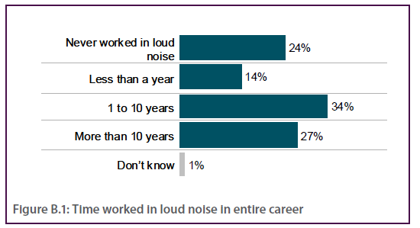

Table B.1 Time worked in loud noise in entire career by industry and survey mode
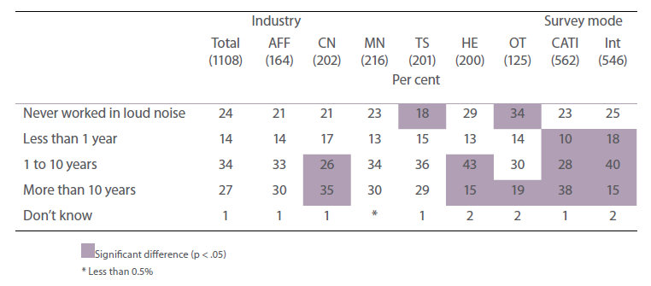

Base sample Exposed to loud noise in last 2 weeks (n=545)
Question On a typical day in the last 2 weeks, how often did you work in loud noise? Was that…?
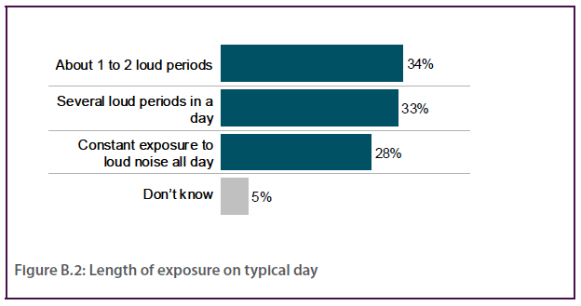

Table B.2 Length of exposure on typical day by industry and survey mode
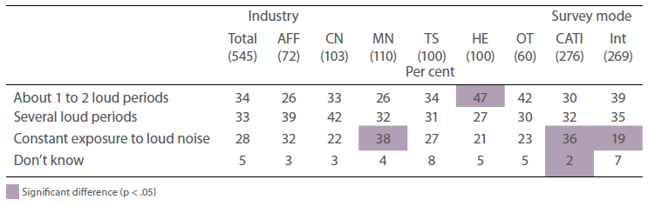

Typical exposure to workplace noise
Base sample Exposed to loud noise in last 2 weeks (excludes DK) (n=543)
Question On a typical day in the last 2 weeks, how much time did you spend working in loud noise? This includes the total time exposed to a loud noise environment, including break periods if relevant.
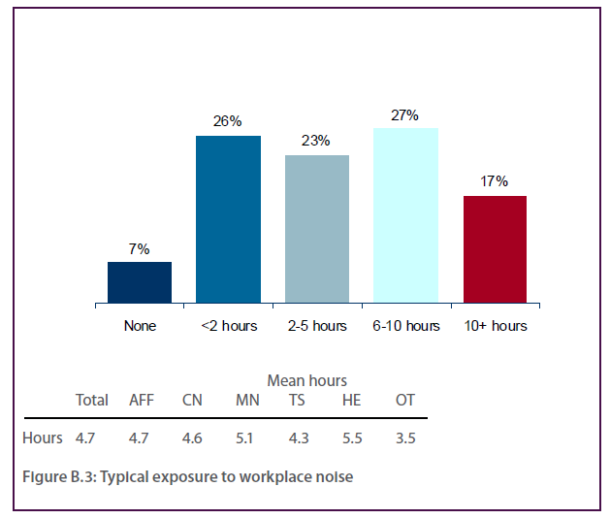

Table B.3 Typical exposure to workplace noise by industry and survey mode
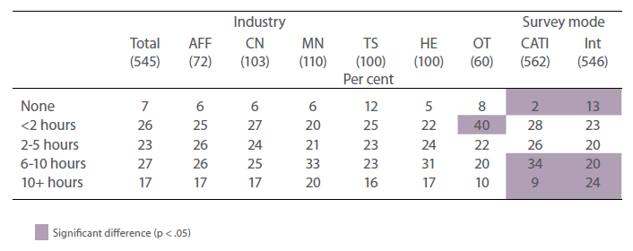
Question In terms of the level of loud noise you worked in the last 2 weeks, was that…?
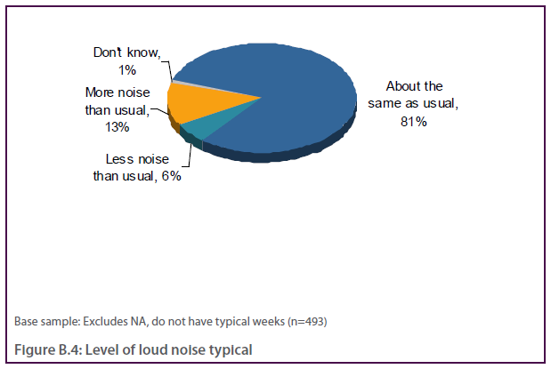

Sources of loud noise at work and feelings about working in loud noise
Base sample Exposed to loud noise in last 2 weeks (n=545)
Question What are the main sources of the loud noise you worked in? For example, these may include machines, tools, vehicles, radios, and loud speakers.
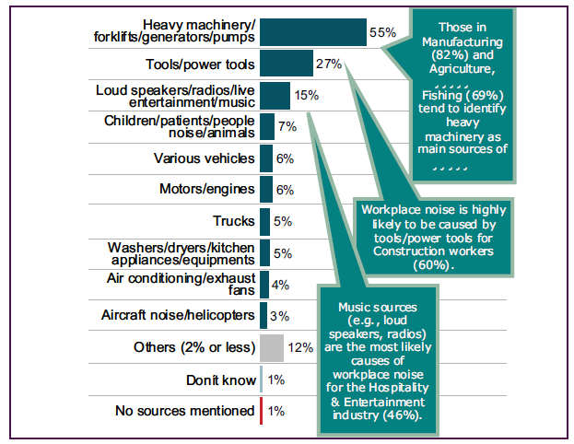
Figure B.5 Sources of loud noise
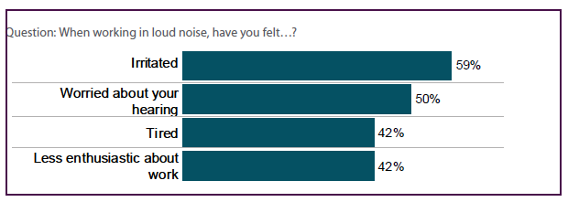
Figure B.6 Feelings experienced while working in loud noise

Table B.4 Feelings experienced while working in loud noise by industry
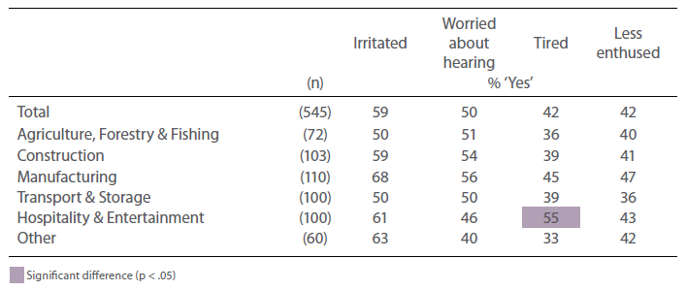

Personal hearing
Base sample All (n=1108)
Question Which of the following best describes your hearing without the use of a hearing aid? Is it…?
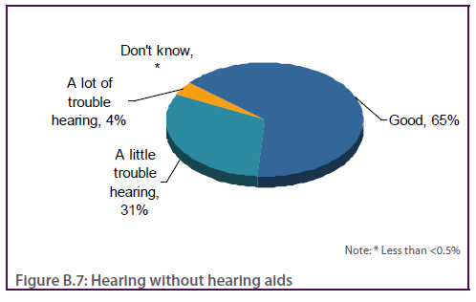
Question Do you experience ringing or buzzing in your ears or head?
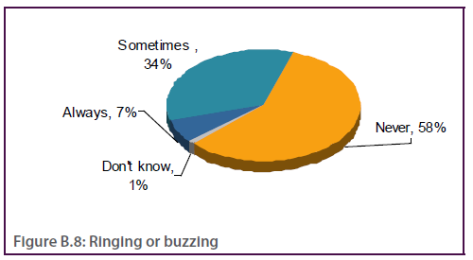

Noise control and reasons for non-exposure to noise
Base sample Exposed to loud noise in last 2 weeks, or typical for workplace noise (n=663)
Question Have you been provided with personal hearing protectors, such as ear muffs or plugs?
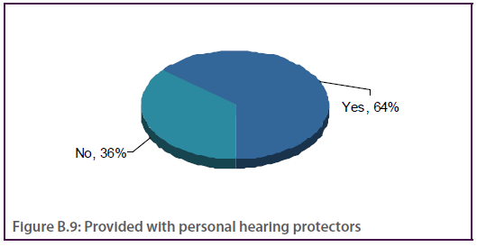

Table B.5 Provided with personal hearing protectors by industry and survey mode
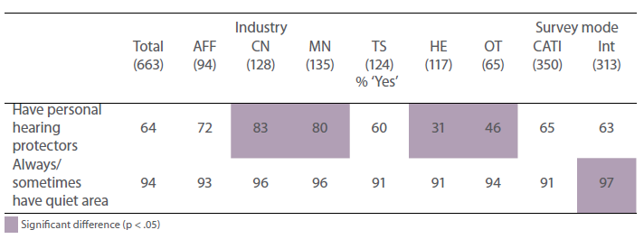

Question Is there a quiet area available for your rest breaks?
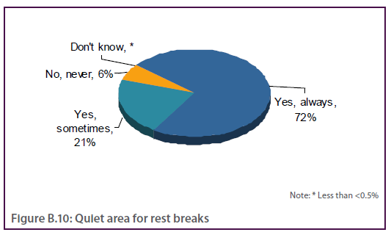
Question You mentioned that you did not spend any time working in loud noise in the last 2 weeks. Was this because…?
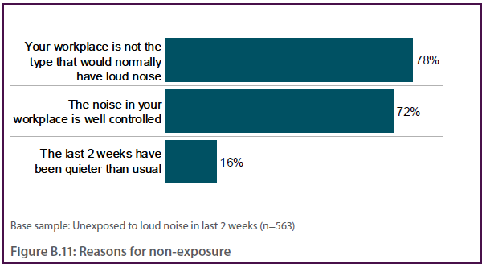

Noise controls used at workplace
Base sample Exposed to loud noise in last 2 weeks, or typical for workplace noise (excluding NA)
Question Thinking about noise control in your workplace, have the following actions been taken?
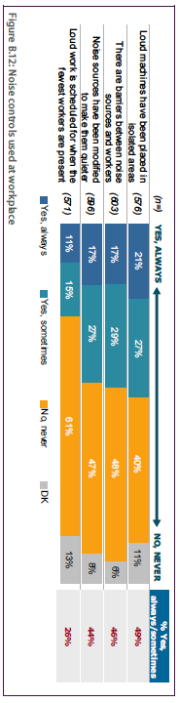

Table B.6 Noise controls used at workplace by exposure, industry and survey mode
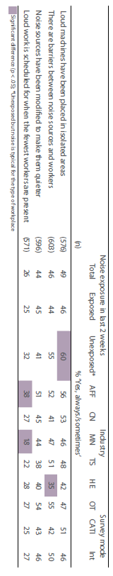

Other noise controls used at workplace
Base sample Exposed to loud noise in last 2 weeks, or typical for workplace noise (n=663)
Question Apart from these noise controls, are there any other noise controls that you can think of that are used in your workplace?
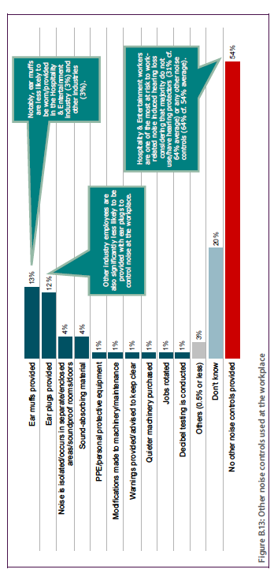

Use of hearing protectors
Base sample Exposed to loud noise in last 2 weeks and excludes NA, do not have personal hearing protectors (n=479)
Question How often did you wear personal hearing protectors while working in loud noise? Was that…?
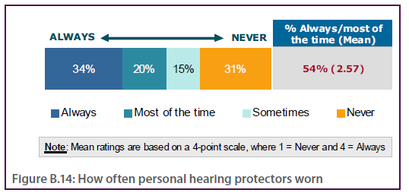

Table B.7 How often personal hearing protectors worn by industry
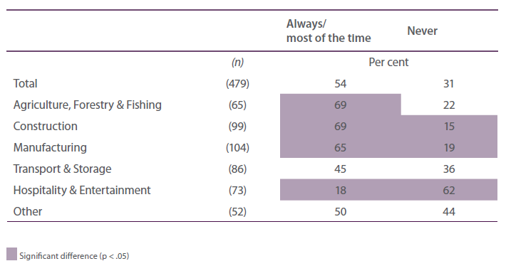

Question If you did not always wear hearing protectors when working in loud noise was this ever because of the following?
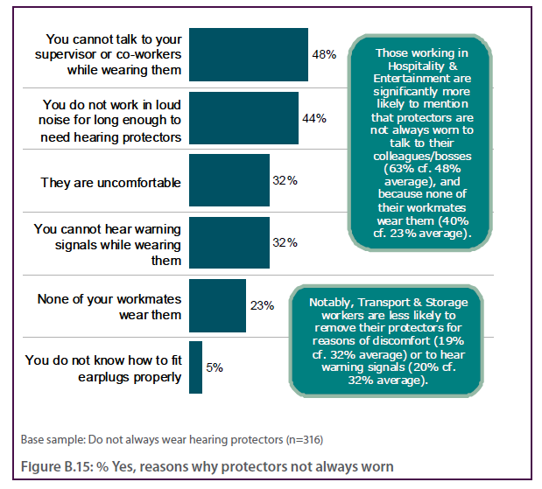c

Fitting of hearing protectors
Base sample Have and wear hearing protectors (n=331)
Question Did you usually fit your hearing protectors before or after experiencing loud noise?
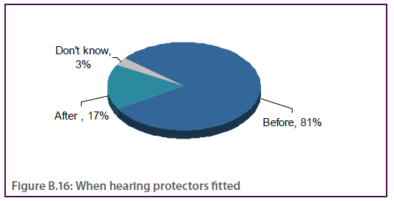

Table B.8 When hearing protectors fitted by industry
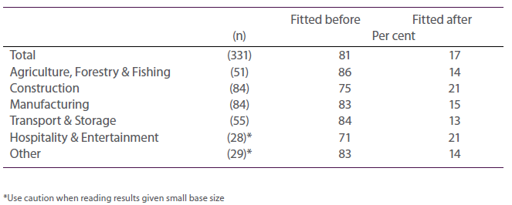

Question What was the main reason for usually fitting your hearing protectors after experiencing loud noise?
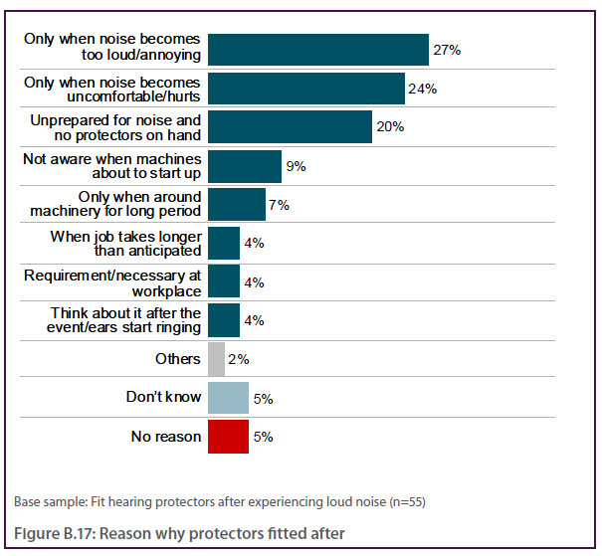

Removal of hearing protectors
Base sample Have and wear hearing protectors (n=329)
Question How often did you remove your hearing protectors while working in loud noise? Was that…?
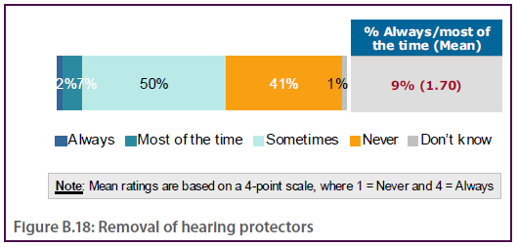%

Table B.9 Removal of hearing protectors by industry
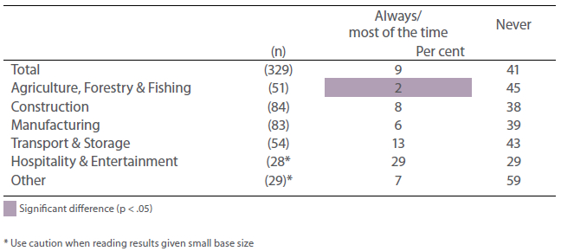

Question What was the main reason for removing your hearing protectors while working in loud noise?
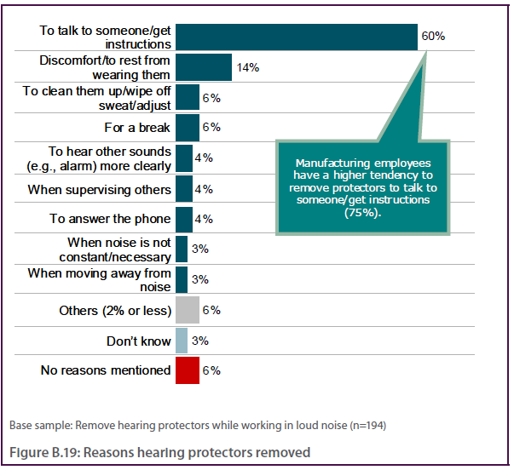

Attitudes on workplace noise
Base sample Exposed to loud noise in last 2 weeks, or typical for workplace noise (excludes NA)
Question To what extent do you agree with the following statements about workplace noise?
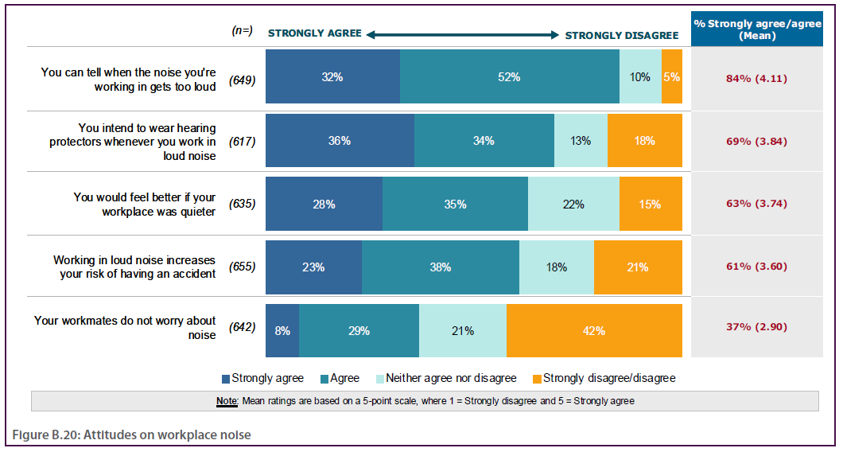%

Attitudes on workplace noise – in detail
Base sample Exposed to loud noise in last 2 weeks, or typical for workplace noise (excludes NA)
Question To what extent do you agree with the following statements about workplace noise?

Table B.10 Attitudes on workplace noise by exposure, industry and survey mode
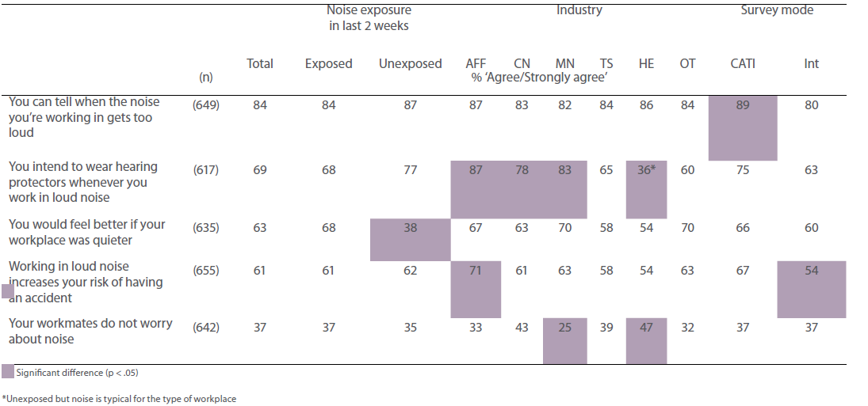

Attitudes on hearing loss
Base sample All (n=1108)

Question The following question asks about your views about hearing loss. Do you think the following statements are true or false?
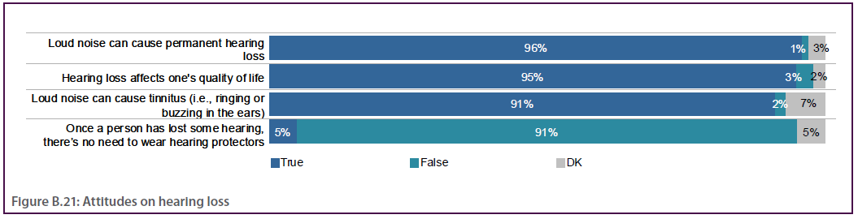

Table B.11 Attitudes on hearing loss by exposure, industry and survey mode
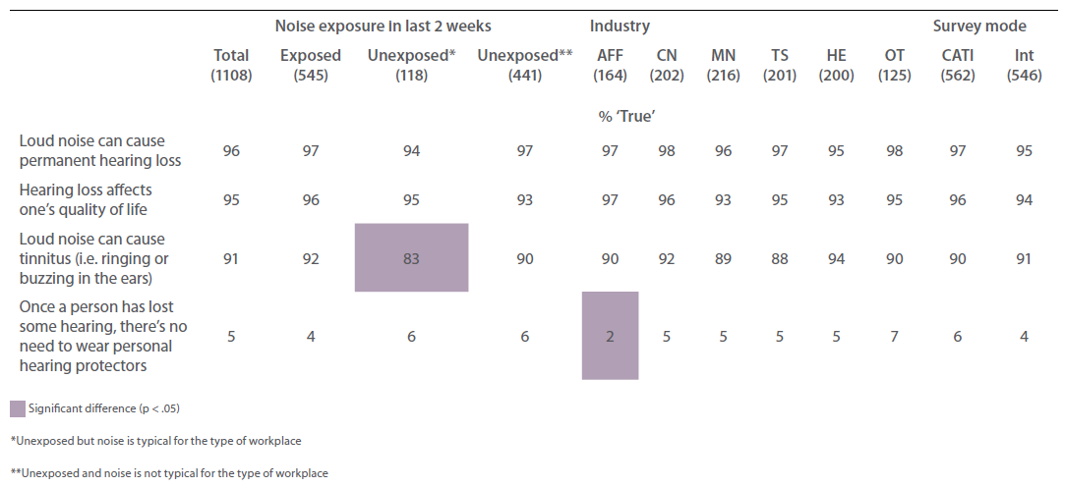

Attitudes on general OHS issues
Base sample All (excludes NA)
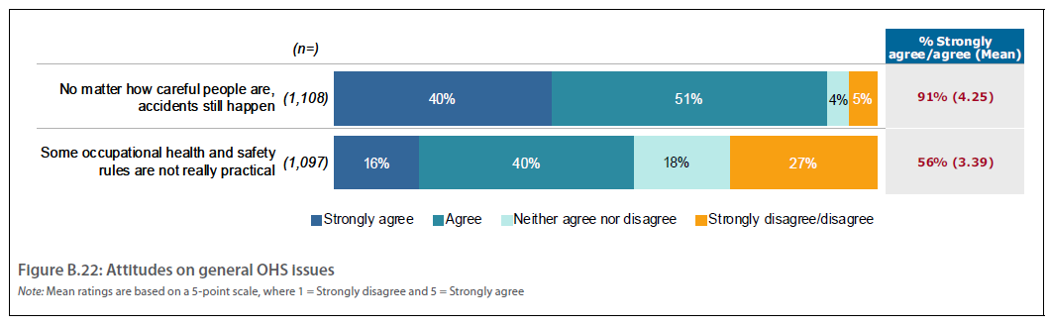

Table B.12 Attitudes on general OHS issues by exposure, industry and survey mode
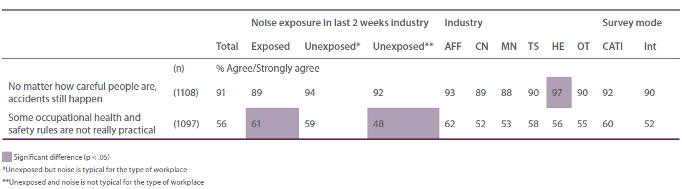

Attitudes on OHS issues at workplace
Base sample All (excludes NA)
Question Now, thinking about occupational health and safety in your workplace, to what extent do you agree with the following statements?
45%
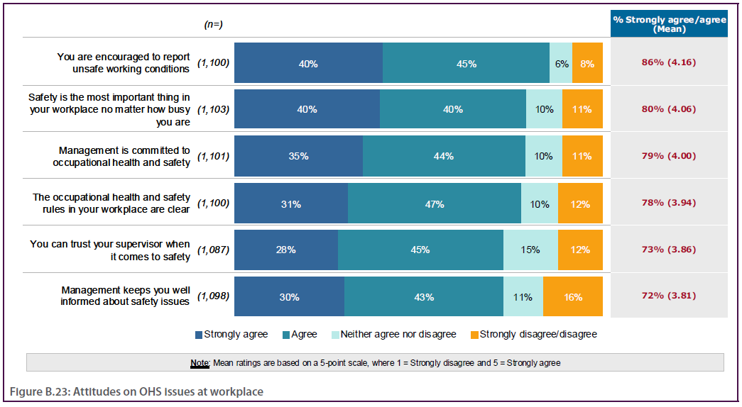

Attitudes on OHS issues at workplace – in detail
Base sample All (excludes NA)
Question Now, thinking about occupational health and safety in your workplace, to what extent do you agree with the following statements?

Table B.13 Attitudes on OHS issues at workplace by exposure, industry and survey mode
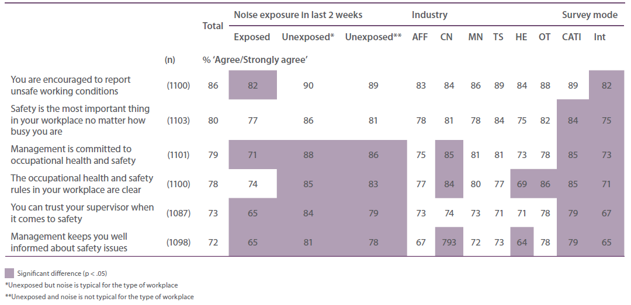

Attitudes on personal OHS issues
Base sample All (excludes NA)
Question Now, thinking about your own occupational health and safety, to what extent do you agree with the following statements?
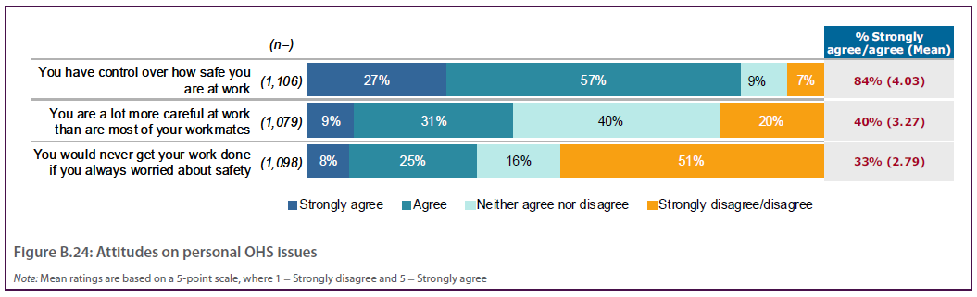

Table B.14 Attitudes on personal OHS issues by exposure, industry and survey mode
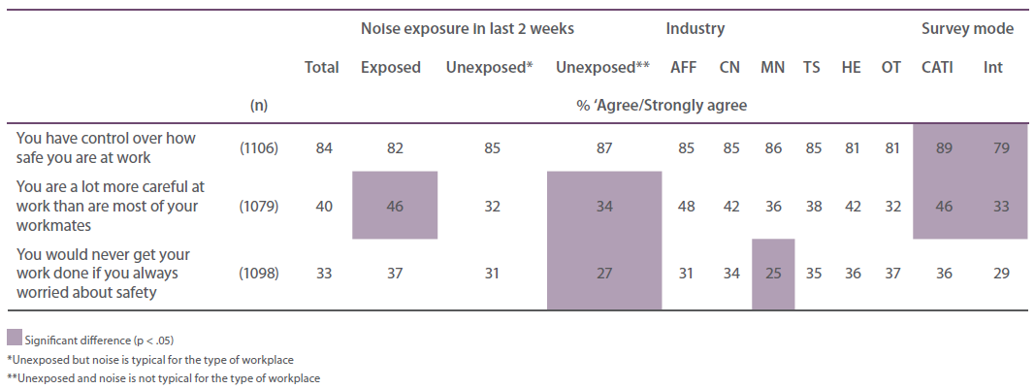

Additional comments about workplace noise or hearing loss
Base sample All (excludes those with no further comments) (n=228)
Question Is there anything you would like to add about workplace noise or hearing loss?
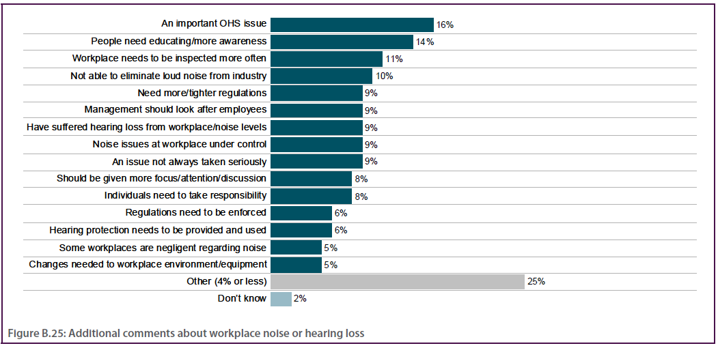

Managers

Exposure to workplace noise
Base sample Currently or used to produce loud noise (n=638)
Question Thinking about all the jobs you have had in your life, if ever, how long have you worked in loud noise?
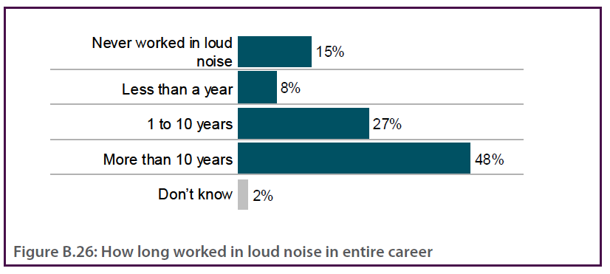
Question Which of the following best describes your hearing without the use of a hearing aid? Is it…?
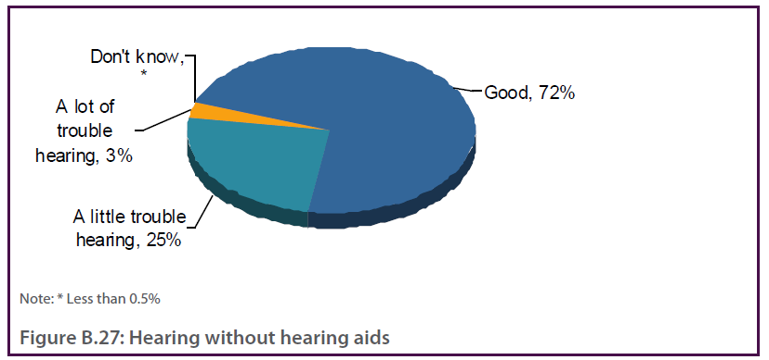

Table B.15 Exposure to workplace noise by business size, industry and survey mode
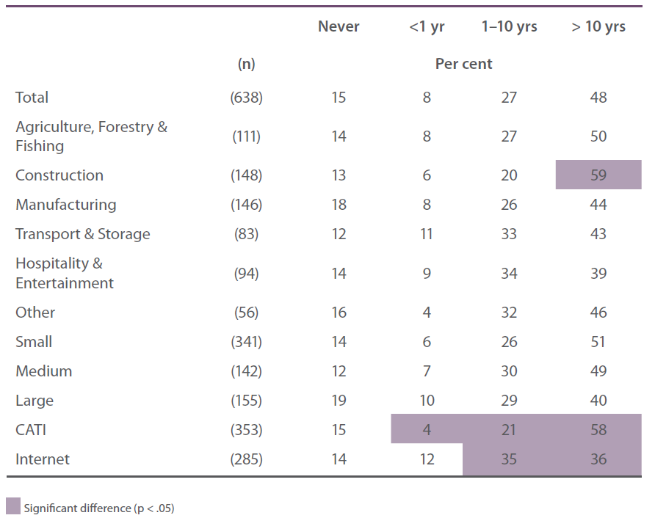

Exposure to workplace noise – managers cf. workers
Base sample All workers (n=1108) and Managers who currently or used to produce loud noise (n=638)
Question Thinking about all the jobs you have had in your life, if ever, how long have you worked in loud noise? (Workers & Managers)
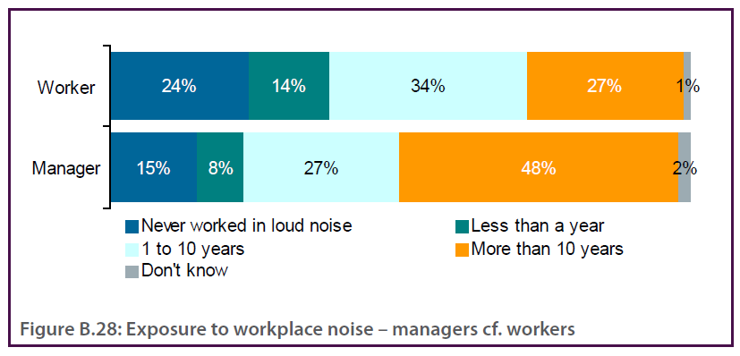

Question Which of the following best describes your hearing without the use of a hearing aid? Is it…? (Workers & Managers)
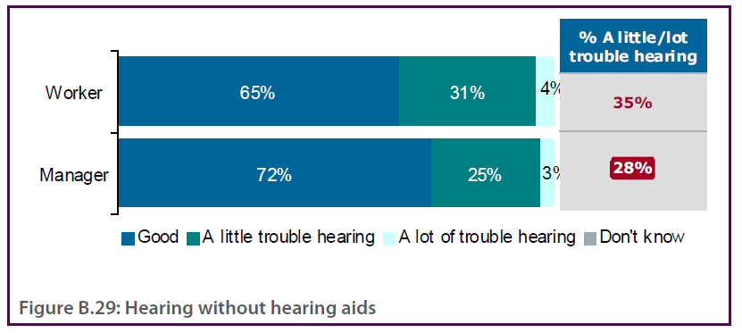

Table B.16 Exposure to workplace noise – managers cf. workers
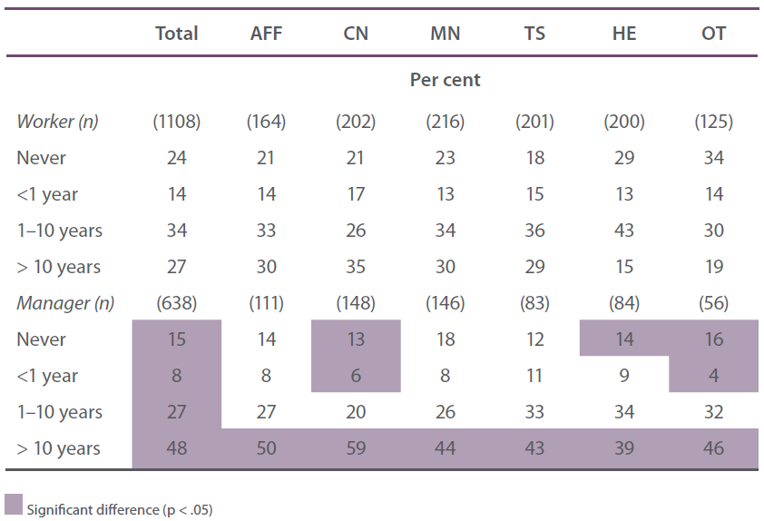

Typical exposure to occupational noise
Base sample All (n=1009)
Question On a typical day at work in the last 2 weeks, how much time did you spend working in loud noise? This includes the total time exposed to a loud noise environment, including break periods if relevant. If you do not have typical days at work, please think about any one day at work in the last 2 weeks. 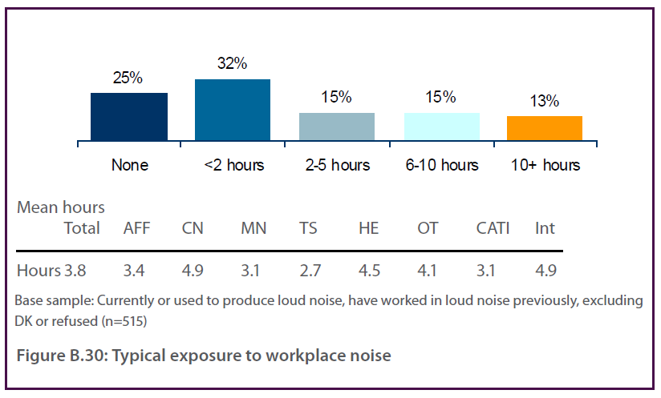
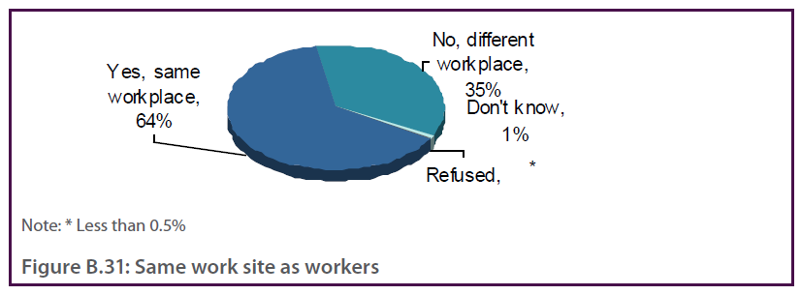

Table B.17 Typical exposure to occupational noise by business size, industry and survey mode
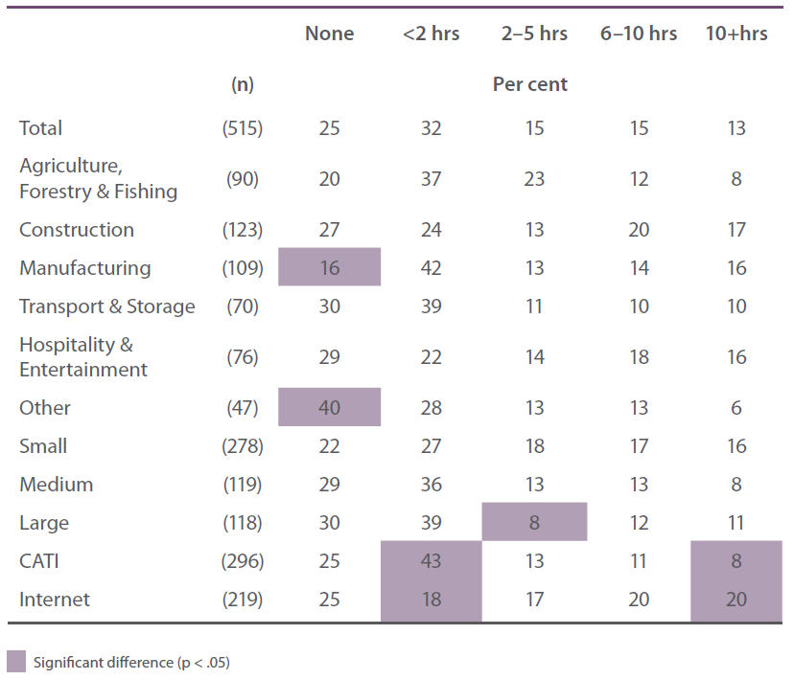

Typical exposure to occupational noise – managers cf. workers
Base sample Workers exposed to loud noise in last 2 weeks (excludes DK) (n=543) and Managers who currently or used to produce loud noise and have worked in loud noise previously (excludes those who never or DK how long they have worked in loud noise) (n=515)
Question On a typical day in the last 2 weeks, how much time did you spend working in loud noise? This includes the total time exposed to a loud noise environment, including break periods if relevant. (Workers & Managers)
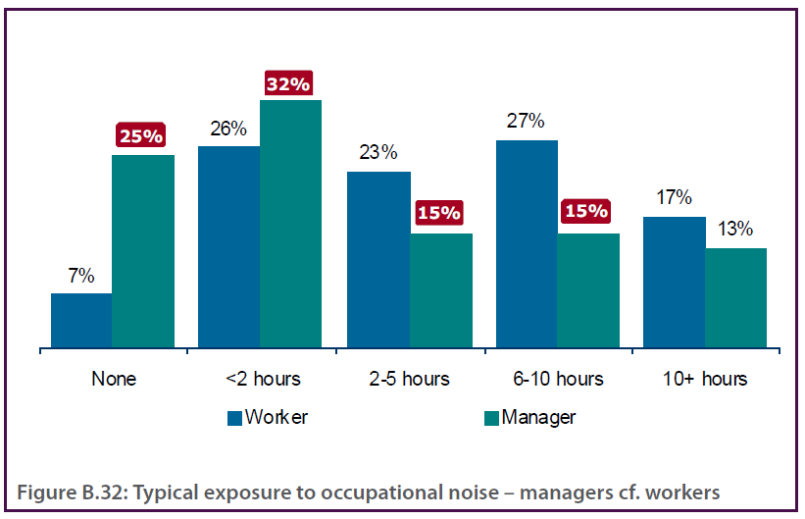

Table B.18 Typical exposure to occupational noise – managers cf. workers
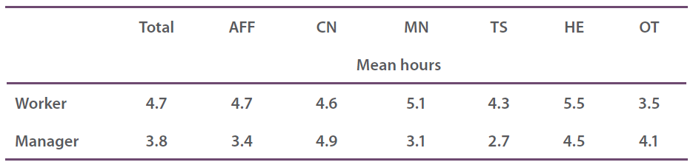

Sources of loud noise in the company
Base sample Currently or used to produce loud noise (n=638)
Question What are/were the sources of noise in your company? Try to think of the plant processes, or activities around. For example, these may include blasting activities, noise produced from reversing vehicles, squealing breaks, live music, the radio etc.
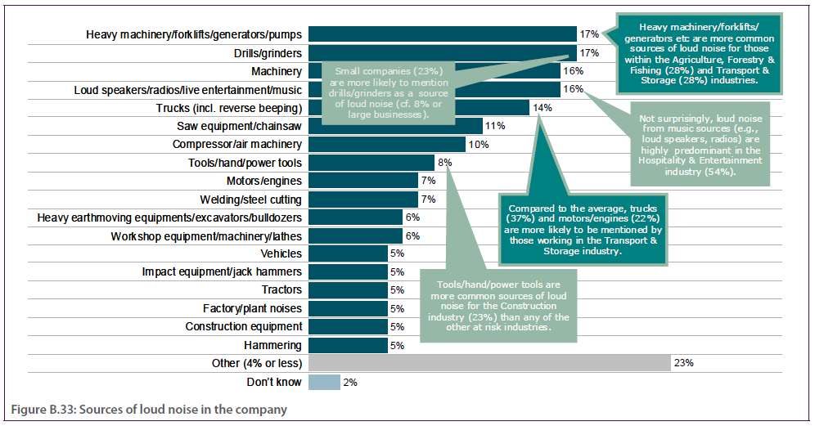
Sources of loud noise in the company – managers cf. workers
Base sample Workers exposed to loud noise in last 2 weeks (n=545) and Managers who currently or used to produce loud noise (n=638)
Question What are the main sources of the loud noise you worked in? For example, these may include machines, tools, vehicles, radios, and loud speakers? (Workers)
Question What are/were the sources of noise in your company? Try to think of the plant processes, or activities around. For example, these may include blasting activities, noise produced from reversing vehicles, squealing breaks, live music, the radio etc. (Managers)

Table B.19 Sources of loud noise in the company – managers cf. workers
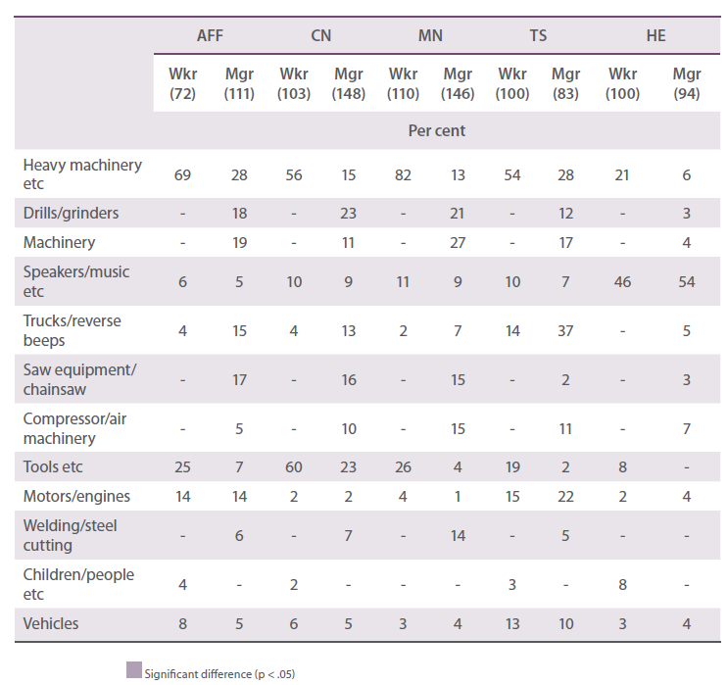
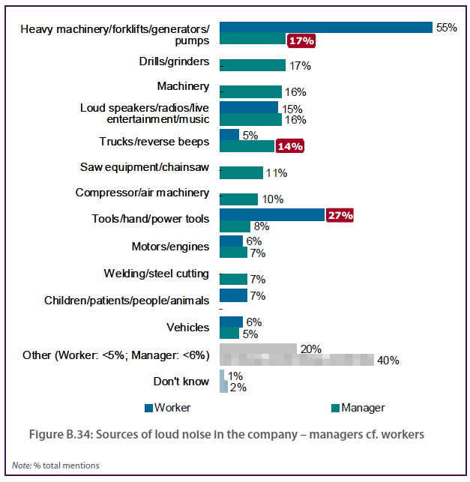

Recent investments in noise controls
Base sample Currently or used to produce loud noise (n=638)
Question Has your company recently invested in noise control that was intentional? That is, you were aware that the specific reason or purpose of the investment was to control noise.
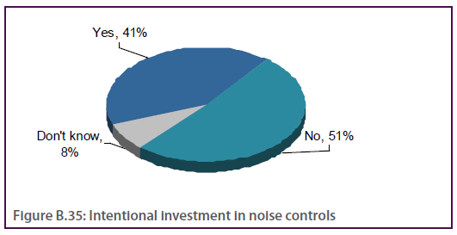

Table B.20 Intentional investment in noise controls by industry
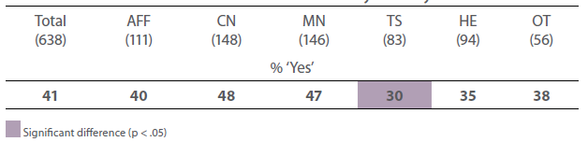

Table B.21 Intentional investment in noise controls by business size and survey mode
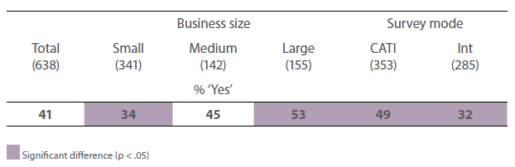

Question Has your company recently made an investment that by coincidence produced better noise control?
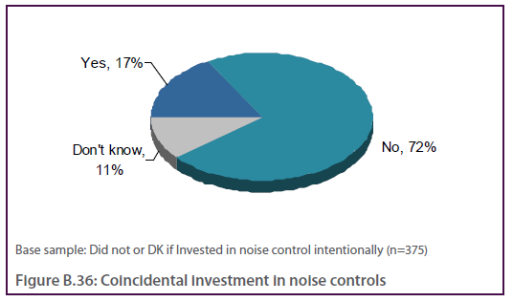

Table B.22 Coincidental investment in noise controls by industry
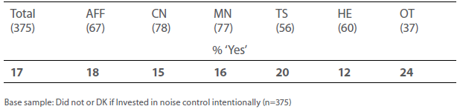

Table B.23 Coincidental investment in noise controls by business size and survey mode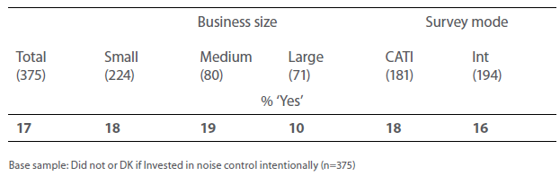

Important considerations behind investment of intentional noise control
Base sample Currently or used to produce loud noise and invested in noise control intentionally (excludes DK and NA)
Question How important was each of the following considerations when making a decision on the noise control investment for your company?
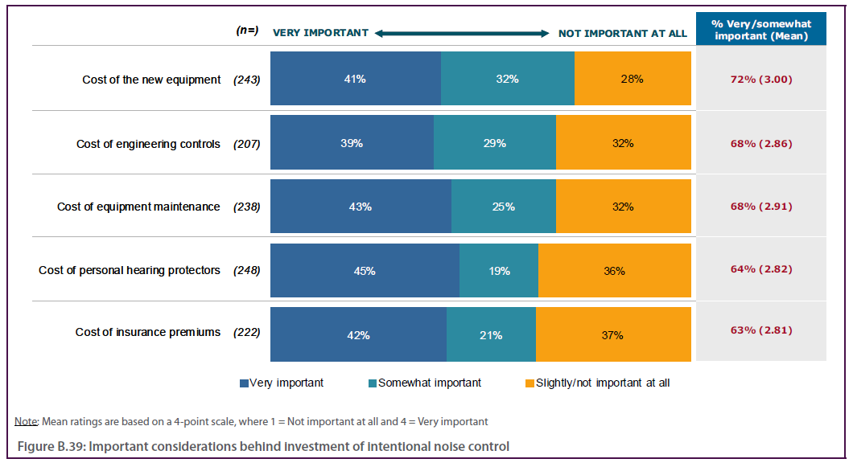

Important considerations behind investment of intentional noise control – in detail
Base sample Currently or used to produce loud noise and invested in noise control intentionally (excludes DK and NA)
Question How important was each of the following considerations when making a decision on the noise control investment for your company?

Table B.24 Important considerations behind investment of intentional noise control by business size, industry and survey mode
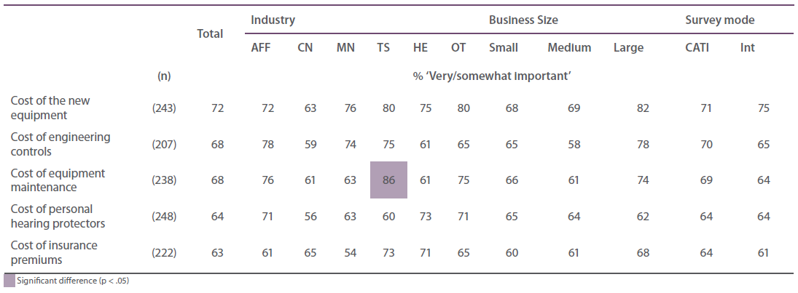

Additional benefits from investments
Base sample Recently invested in noise controls – intentionally or by coincidence (n=328)
Question Besides better noise control, did the investment have any of the following additional benefits?
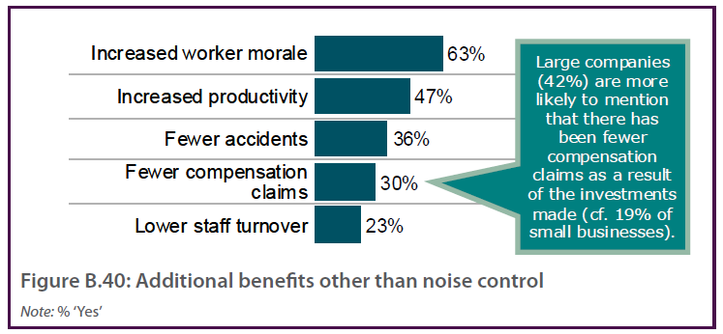

Table B.25 Additional benefits other than noise control by industry
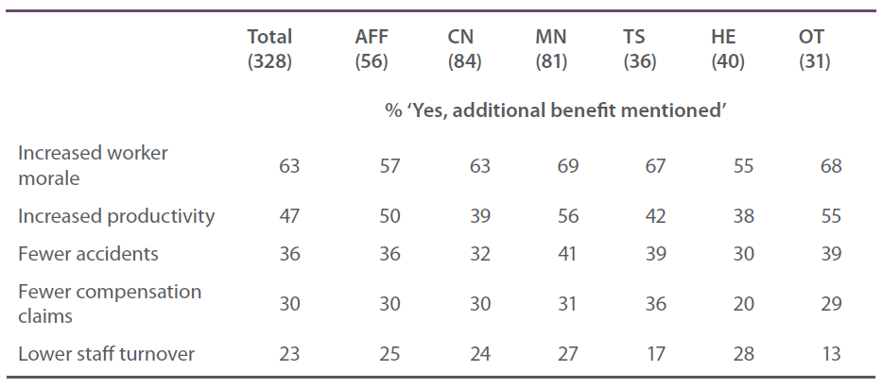

Question Were any of these benefits considered before making the investment? Can you specify which of these benefits were considered?
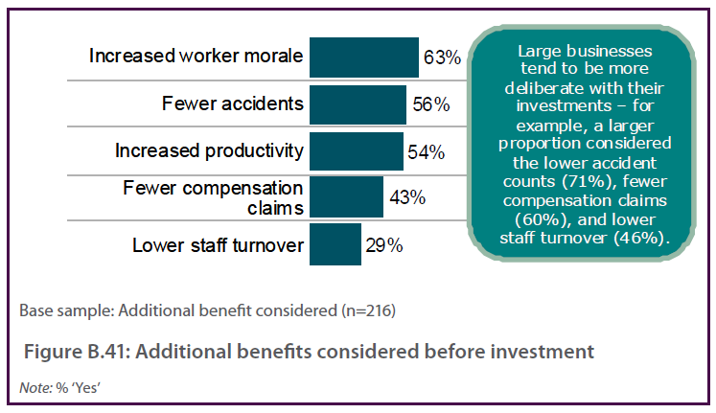

Table B.26 Additional benefits considered before investment by industry
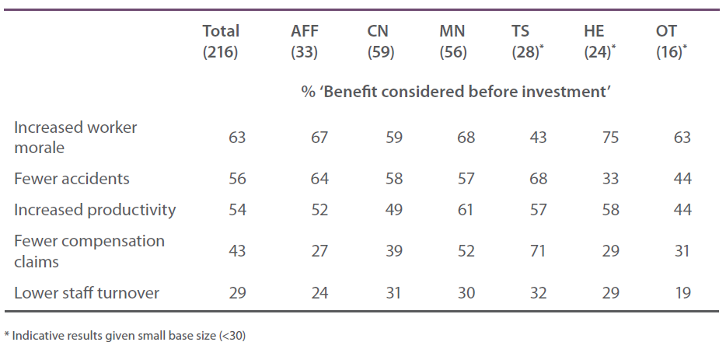

Noise Controls, including Hearing Protectors and Quiet Areas
Base sample Currently or used to produce loud noise (n=638)
Question How effective do you think noise is controlled in your company?
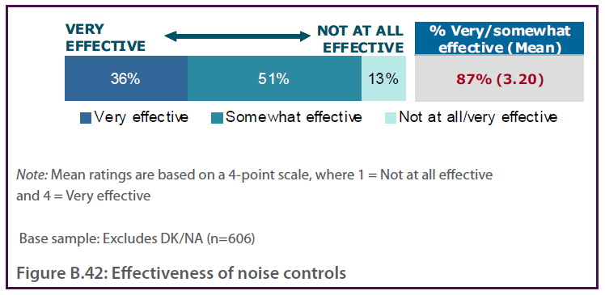
Question Have personal hearing protectors, such as ear muffs or plugs been provided to workers who work in loud noise?
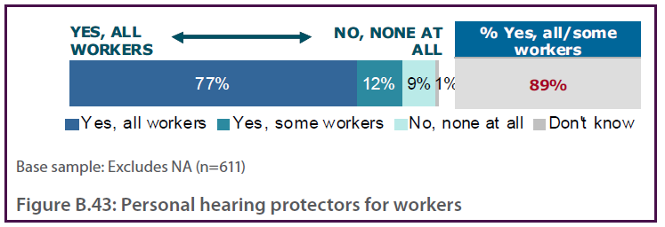
Question Is there a quiet area available for workers to take rest breaks?
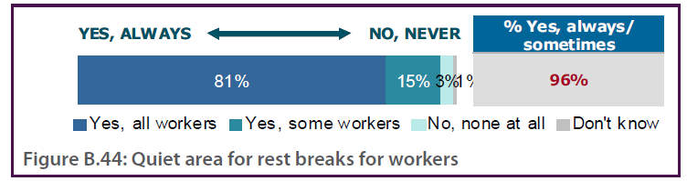

Table B.27 Noise Controls, including Hearing Protectors and Quiet Areas by business size, industry and survey mode
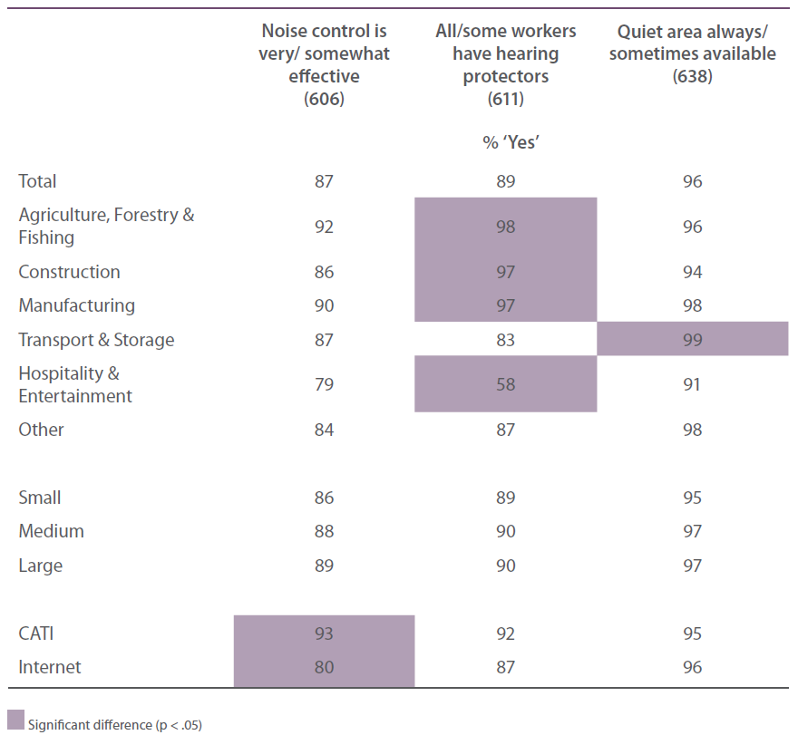

Hearing protectors and quiet areas – managers cf. workers
Base sample Workers exposed to loud noise in last 2 weeks, or typical for workplace noise (n=663) and Managers who currently or used to produce loud noise (excludes NA) (n=611)
Question Have you been provided with personal hearing protectors, such as ear muffs or plugs? (Workers)
Question Have personal hearing protectors, such as ear muffs or plugs been provided to workers who work in loud noise? (Managers)
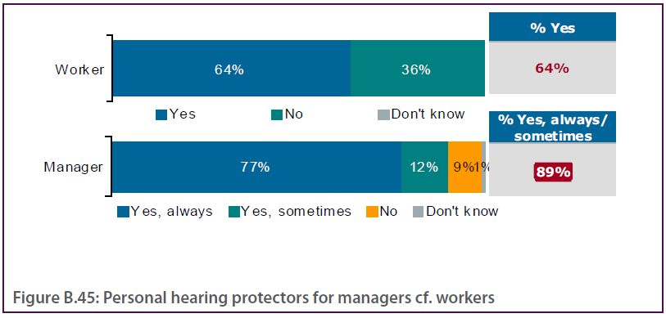

Base sample Workers exposed to loud noise in last 2 weeks, or typical for workplace noise (n=663) and Managers who currently or used to produce loud noise (n=638)

Question Is there a quiet area available for your rest breaks? (Workers)
Question Is there a quiet area available for workers to take rest breaks? (Managers)

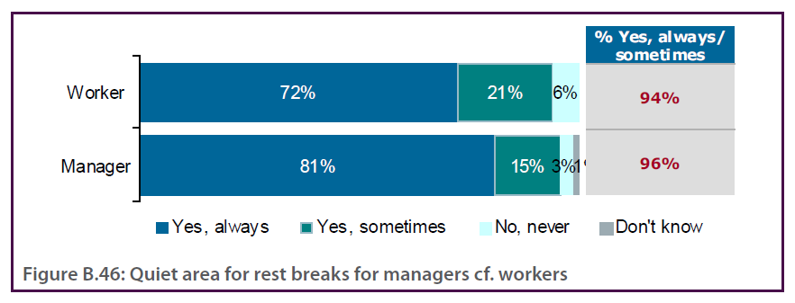

Table B.28 Hearing protectors and quiet areas – managers cf. workers
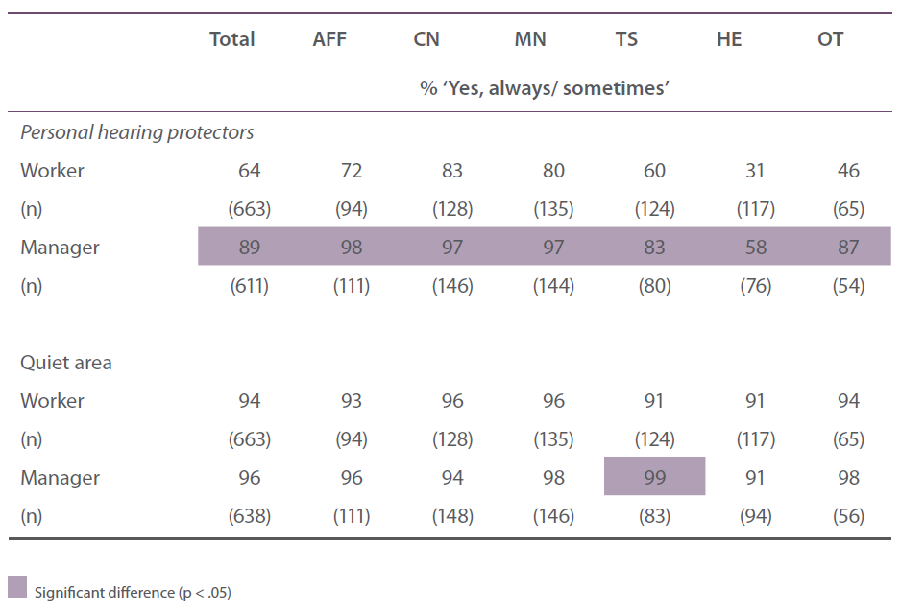

Noise controls in the workplace
Base sample Currently or used to produce loud noise (excludes NA)
Question Thinking about noise control in your company, have the following actions been taken – using a scale of yes always, yes sometimes, or no never?
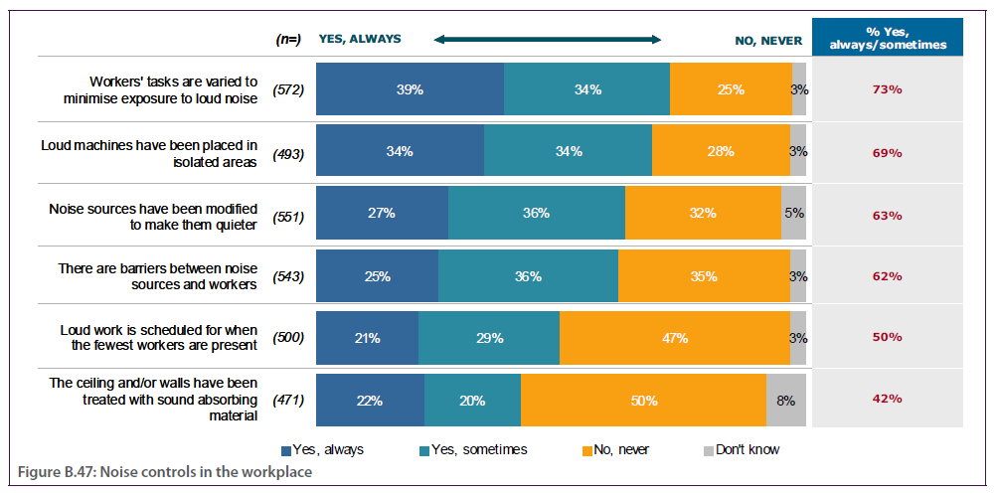

Noise controls in the workplace – in detail
Base sample Currently or used to produce loud noise (excludes NA)
Question Thinking about noise control in your company, have the following actions been taken?

Table B.29 Noise controls in the workplace by business size, industry and survey mode

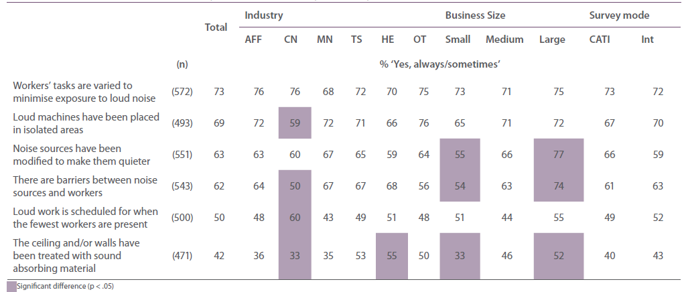

Noise controls in the workplace – managers cf. workers
Base sample Workers exposed to loud noise in last 2 weeks, or typical for workplace noise (excludes NA) and Managers who currently or used to produce loud noise (excludes NA)
Question Thinking about noise control in your workplace, have the following actions been taken?(Workers & managers)
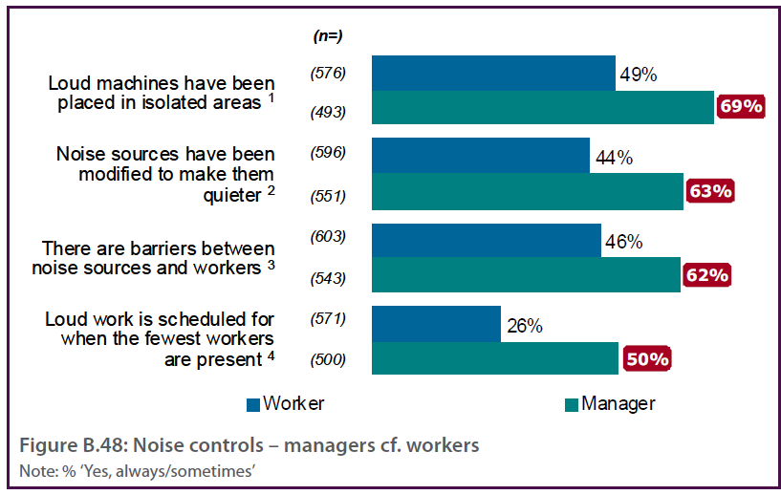

Table B.30 Noise controls in the workplace – managers cf. workers
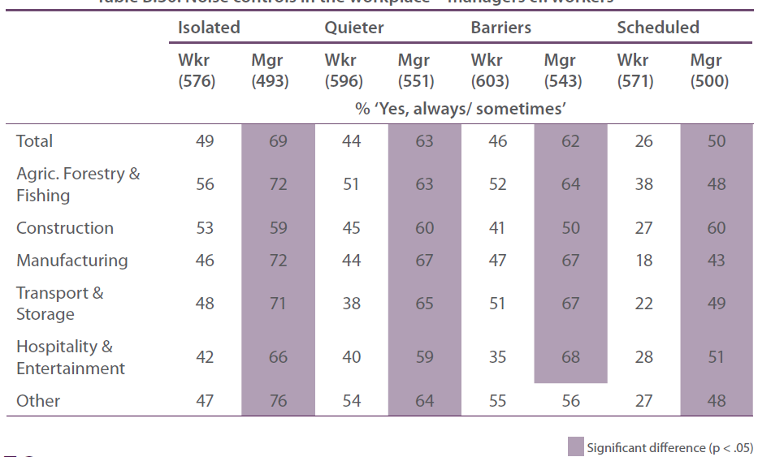

Other noise controls in the workplace
Base sample Currently or used to produce loud noise (n=638)
Question Apart from these noise controls, are there any other noise controls that you can think of that are used in your company?
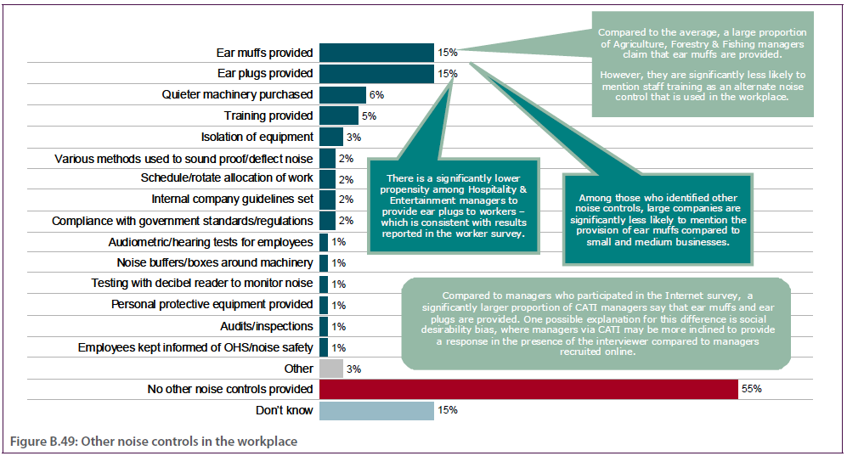

Other noise controls used in the workplace – managers cf. workers
Base sample Workers exposed to loud noise in last 2 weeks, or typical for workplace noise (n=663) and Managers who currently or used to produce loud noise (n=638)
Question Apart from these noise controls, are there any other noise controls that you can think of that are used in your workplace? (Workers & Managers)

Table B.31 Other noise controls used in the workplace – managers cf. workers
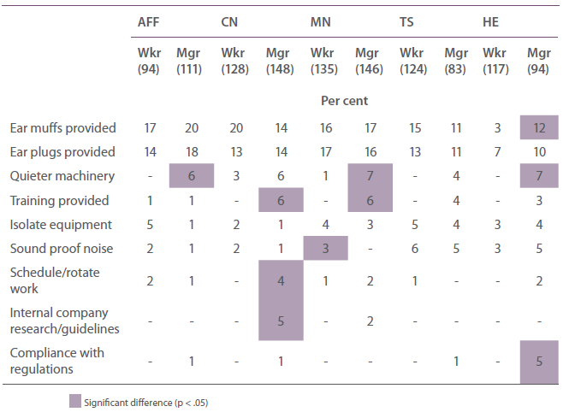
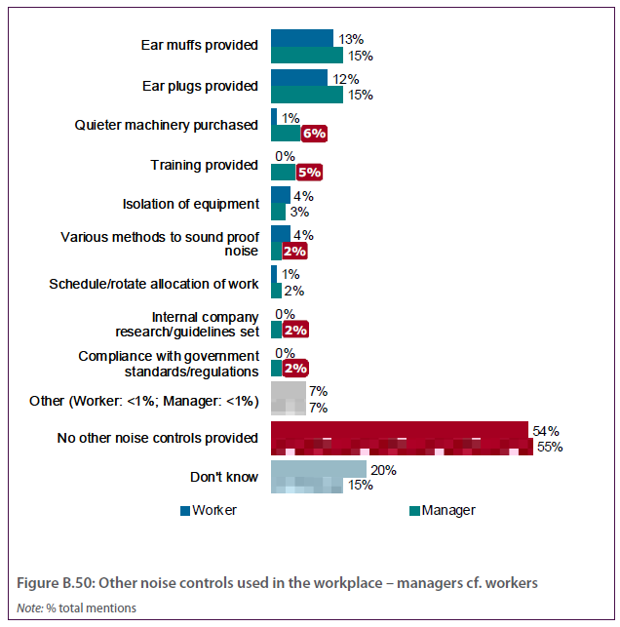

Attitudes on hearing loss
Base sample All (n=1009)
Question Thinking about hearing loss, do you think the following statements are true or false?
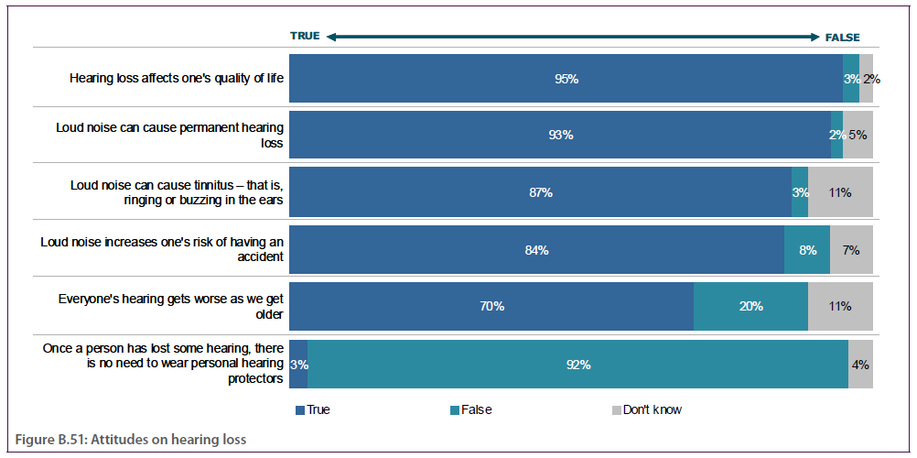

Attitudes on hearing loss – in detail
Base sample All (n=1009)
Question Thinking about hearing loss, do you think the following statements are true or false?

Table B.32 Attitudes on hearing loss by business size, industry and survey mode
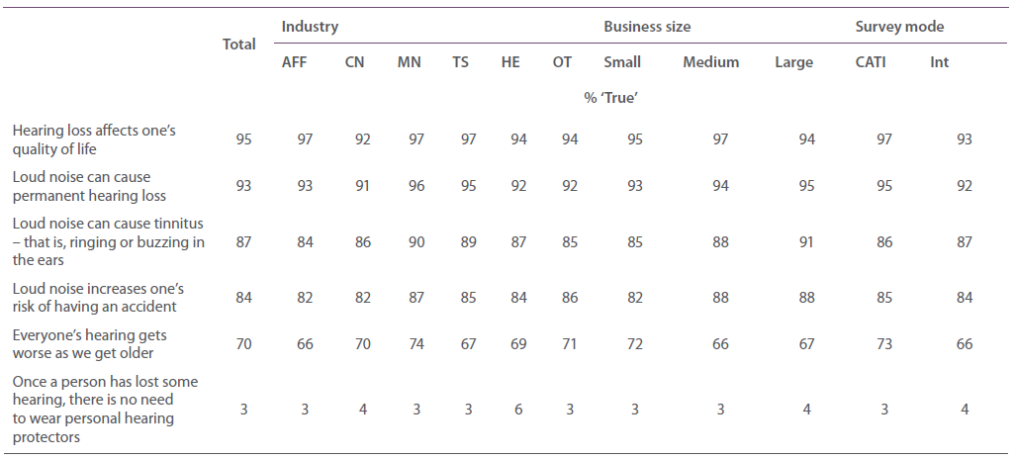

Attitudes on hearing loss – managers cf.workers
Base sample All workers (n=1108) and all managers (n=1009)
Question The following question asks about your views about hearing loss. Do you think the following statements are true or false? (Workers & Managers)
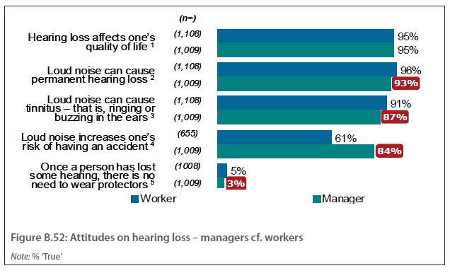

Table B.33 Attitudes on hearing loss – managers cf. workers
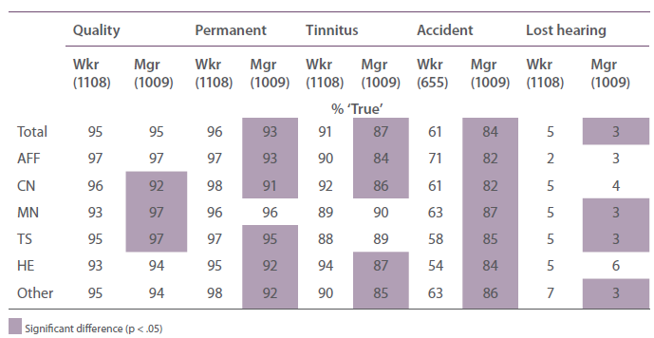

Attitudes on general OHS issues
Base sample All (n=1009)
Question To what extent do you agree with the following statements about occupational health and safety in general?
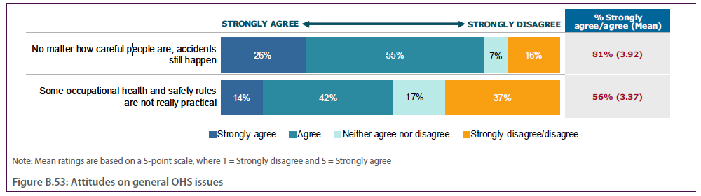

Table B.34 Attitudes on general OHS issues by business size, industry and survey mode
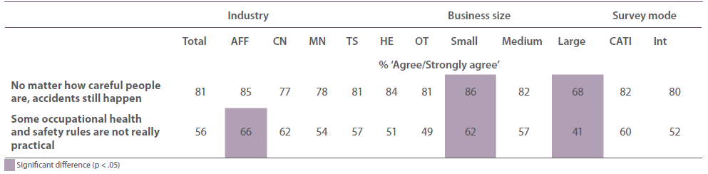

Attitudes on general OHS issues – managers cf. workers
Base sample All workers (excludes NA) and All managers (n=1009)
Question To what extent do you agree with the following statements about occupational health and safety in general? (Workers & Managers)
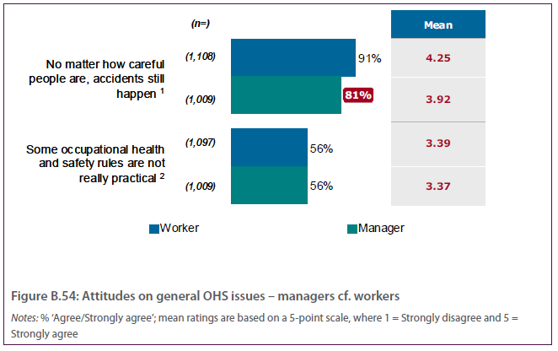

Table B.35 Attitudes on general OHS issues – managers cf. workers
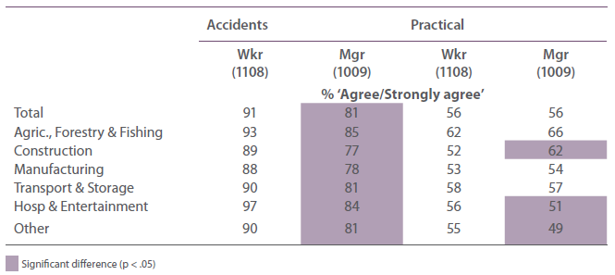

Attitudes on OHS issues in the company
Base sample All (excludes NA)
Question Now, thinking about occupational health and safety in your company, to what extent do you agree with the following statements?
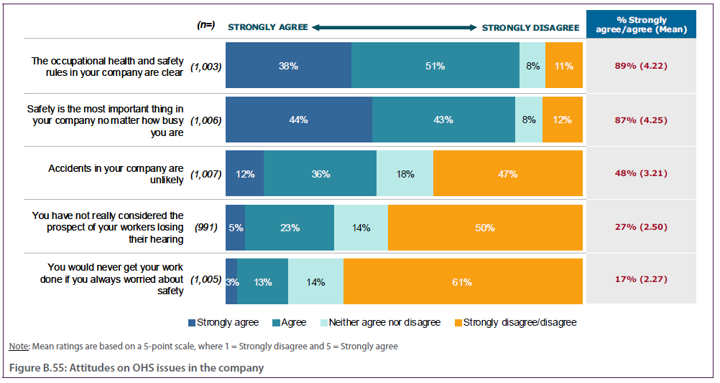

Attitudes on OHS issues in the company – in detail
Base sample All (excludes NA)
Question Now, thinking about your occupational health and safety in your company, to what extent do you agree with the following statements?

Table B.36 Attitudes on OHS issues in the company by business size, industry and survey mode
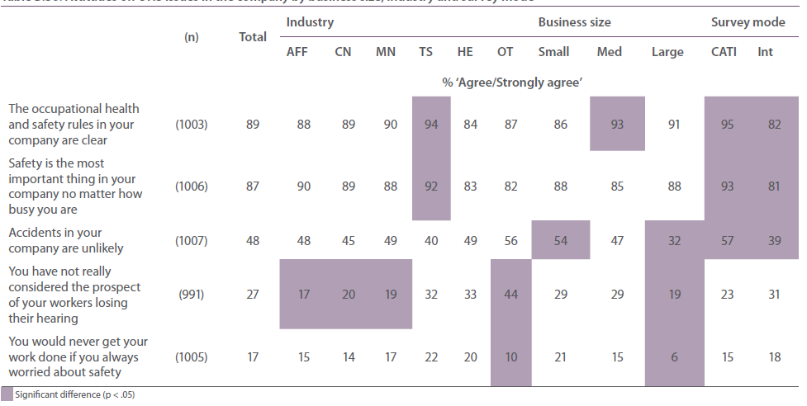

Attitudes on OHS issues in the company – managers cf. workers
Base sample All workers (excludes NA) and All managers (excludes NA)
Question Now, thinking about occupational health and safety in your workplace/ own occupational health and safety, to what extent do you agree with the following statements? (Workers)
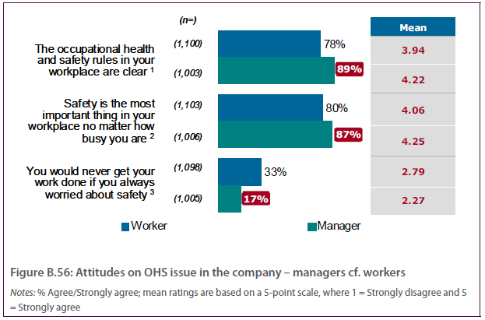

Table B.37 Attitudes on OHS issues in the company – managers cf. managers
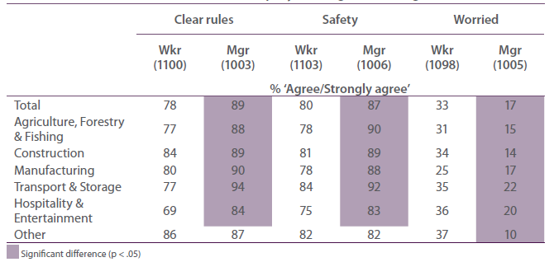

Additional comments about workplace noise or hearing loss
Base sample All (excludes those with no further comments) (n=192)
Question Is there anything you would like to add about workplace noise or hearing loss?
People need educating/more awareness
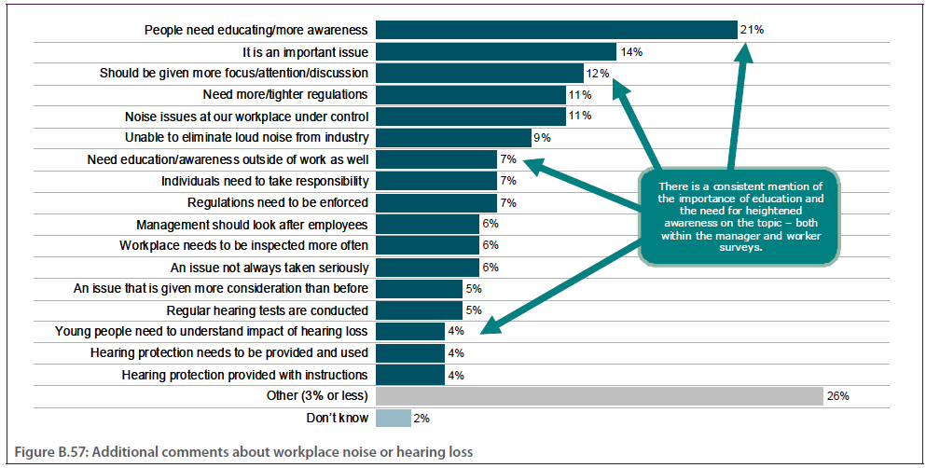

References
Abel SM (1990). The extra-auditory effects of noise and annoyance an overview of research. Journal of Otolaryngology, 19(1)1–13.
ABS (Australian Bureau of Statistics) (2006). 2004–05 National Health Survey summary of results, Australia. Cat. no. 4364.0. Canberra ABS.
ABS (Australian Bureau of Statistics) (2009). 2007–08 National Health Survey summary of results, Australia. Cat. no. 4364.0. Canberra ABS.
Access Economics (2006). Listen Hear! The economic impact and cost of hearing loss in Australia. Melbourne Cooperative Research Centre for Cochlear Implant and Hearing Aid Innovation and the Victorian Deaf Society.
Ackley RS & Limb CJ (2007). An essential guide to hearing and balance disorders. New York Routledge. Agrawal Y, Platz EA & Niparko JK (2008). Prevalence of hearing loss and differences by demographic
characteristics among US adults data from the National Health and Nutrition Examination Survey, 1999-2004.
Archives of Internal Medicine, 168(14)1522–30.
Ahmed HO, Dennis JH & Ballal SG (2004). The accuracy of self-reported high noise exposure level and hearing loss in a working population in Eastern Saudi Arabia. International Journal of Hygiene and Environmental Health, 207(3)227–34.
Ajzen I & Fishbein M (1980). Understanding attitudes and predicting social behavior. Englewood Cliffs, NJ Prentice Hall.
Ajzen I (1991). The theory of planned behavior. Organizational behavior and human decision processes, 50(2)179–211.
Albera R, Lacilla M, Piumetto E & Canale A (2010). Noise-induced hearing loss evolution influence of age and exposure to noise. European Archives of Otorhinolaryngology, 267665–71.
Andreasen A (1995). Marketing social change. San Francisco Jossey-Bass.
Aniansson G, Pettersson K & Peterson Y (1983). Traffic noise annoyance and noise sensitivity in persons with normal and impaired hearing. Journal of Sound and Vibration, 88(1)85–97.
Arboleda A, Morrow PC, Crum MR & Shelley MC (2003). Management practices as antecedents of safety culture within the trucking industry similarities and differences by hierarchical level. Journal of Safety Research, 34(2)189–97.
Arezes PM & Miguel AS (2005a). Hearing protection use in industry the role of risk perception. Safety Science, 43(4)253–67.
Arezes PM & Miguel AS (2005b). Individual perception of noise exposure and hearing protection in industry. Human Factors, 47(4)683–92.
Arezes PM & Miguel AS (2008). Risk perception and safety behaviour a study in an occupational environment. Safety Science, 46(6)900–7.
Arlinger S (2003). Negative consequences of uncorrected hearing loss a review. International Journal of Audiology, 42(Suppl 2)S17–S20.
ASCC (Australian Safety and Compensation Council) (2006). Work-related noise induced hearing loss in Australia. Canberra ASCC.
Axelsson A & Prasher D (2000). Tinnitus induced by occupational and leisure noise. Noise and Health, 2(8)47–54.
Babisch W (2008). Road traffic noise and cardiovascular risk. Noise and Health, 10(38)27–33.
Banbury S & Berry DC (1998). Disruption of office-related tasks by speech and office noise. British Journal of Psychology, 89(3)499–517.
Bandura A (1977). Self-efficacy toward a unifying theory of behavioural change. Psychological Review, 84(2)191–215.
Barr T (1886). Enquiry into the effects of loud sounds on the hearing of boiler makers and others who work amid noisy surroundings. Proceedings of the Glasgow Philosophical Society, 17223–239.
Bauer E, Spencer E, Smith A & Hudak R (2007). Reducing noise-induced hearing loss in longwall coal mine workers NIOSH’s approach. Proceedings of Longwall USA. Los Angeles.
Begg S, Vos T, Barker B, Stevenson C, Stanley L & Lopez A (2007). Burden of disease and injury in Australia 2003. Catalogue PHE 82. Canberra Australian Institute of Health and Welfare.
Belojevic G, Ohrstrom E & Rylander R (1992). Effects of noise on mental performance with regard to subjective noise sensitivity. International Archives of Occupational & Environmental Health, 64293–301.
Belojevic G, Jakovljevic B & Slepcevic V (2003). Noise and mental performance personality attributes and noise sensitivity. Noise & Health, 6(21)77–89.
Benke G & Groenewald R (1988). Compulsory screening audiometry protection for whom? Seventh Annual Conference of the Australian Institute of Occupational Hygienists. Leura, New South Wales.
Berglund B, Lindvall T & Schwela DH (1999). Guidelines for community noise. Geneva World Health Organisation.
Bhatia P, Shipra & Muhar IS (1991). Effect of low and high intensity noise on work efficiency. Psychologia, 34259–265.
Bies DA & Hansen CH (2003). Engineering noise control theory and practice. (3rd Edition). New York Spon Press.
Blake F (2000). New ideas for retail store level employees. Dallas University of Dallas and Coca-Cola Retailing Research Council.
Borchgrevink HM (2003). Does health promotion work in relation to noise? Noise and Health, 5(18)25–30. Bowes MD, Shaw GB, Trost PT & Ye M (2006). Computing the return on noise reduction investments in navy ships a life-cycle cost approach. Virginia, US Centre for Naval Analyses.
Briggs D & Crumbie N (2000). Characteristics of people working with chemical products in small firms. Contract Research Report 278/2000. Sheffield Health and Safety Executive.
Broadbent DE (1971). Decision and stress. London Academic Press.
Broadbent DE (1979). Human performance and noise. Handbook of noise control, 21–20.
BTE (Bureau of Transport Economics) (2000). Road crash costs in Australia. Report 102. Canberra.
BTE (Bureau of Transport Economics) (2001). Economic costs of natural disasters in Australia. Report 103. Canberra.
Burns W & Robinson DW (1970). Hearing and noise in industry. London HMSO.
Business Roundtable (1982). Absenteeism and turnover a construction industry cost effectiveness project report. Report C-6.
Butler M, Graveling R, Pilkington A & Boyle A (1999). Non-auditory effects of noise at work a critical review of the literature post 1988. Research report 241/1999. UK Health and Safety Executive.
Carruth A, Robert AE, Hurley A & Currie PS (2007). The impact of hearing impairment, perceptions and attitudes about hearing loss, and noise exposure risk patterns on hearing handicap among farm family members. AAOHN J., 55(6)227–34.
CDC/NIOSH (Center for Disease Control/National Institute for Occupational Safety and Health) (1988).
National Occupational Exposure Survey (NOES), field guidelines Vol. 1. DHHS (NIOSH) Publication No. 88-106 <http//www.cdc.gov/niosh/88-106.html>.
Chau N, Mur JM, Benamghar L, Siegfried C, Dangelzer JL, Français M et al. (2004). Relationships between certain individual characteristics and occupational injuries for various jobs in the construction industry a case- control study. American Journal of Industrial Medicine, 45(1)84–92.
Chesson BJ (1986). Hearing conservation programs their problems. Journal of Occupational Health and Safety - Australia and New Zealand, 2(3)198–203.
Clarke CR (1984). The effects of noise on health. In Jones DM and Chapman AJ (Eds.). Noise and society. Chichester Wiley.
Clayton A (2002). The prevention of occupational injuries and illness the role of economic incentives (Working paper 5). Canberra National Research Centre for Occupational Health and Safety Regulation.
Cohen A (1973). Industrial noise and medical absence, and accident record data on exposed workers. International Congress on Noise as a Public Health Problem. Dubrovnik, Yugoslavia.
Cohen A (1976). The influence of a company hearing conservation program on extra-auditory problems in workers. Journal of Safety Research, 8(4)146–162.
Concha-Barrientos M, Campbell-Lendrum D & Steenland K (2004). Occupational noise assessing the burden of disease from work-related hearing impairment at national and local levels. WHO Environmental Burden of Disease Series. No. 9. Geneva World Health Organisation.
Cooper BA & Nelson DA (1997). Implementation of a buy quiet policy for equipment purchases at the NASA Lewis Research Center. Journal of the Acoustic Society of America, 101(5)3077.
Cooper MD (2000). Towards a model of safety culture. Safety Science, 36(2)111–136.
Cowley S & Else D (2003). Social marketing of hazard controls increasing the rate of adoption. Safety In Action 2003 Conference. Melbourne.
Cowley S, Else D & LaMontagne A (2004). Increasing the adoption of OHS risk controls in small business can social marketing help to achieve change? Journal of Occupational Health and Safety Australia and New Zealand, 20(1)69–77.
Daniell WE, Swan SS, McDaniel MM, Camp JE, Cohen MA & Stebbins JG (2006). Noise exposure and hearing loss prevention programmes after 20 years of regulations in the United States. Occupational & Environmental Medicine, 63343–351.
Davies H, Shoveller J, Winters M, Trask CM, Hodgson MR & Knight T (2009). A multidisciplinary study of factors influencing hazard reduction strategies, using noise exposure and hearing loss as a model. Report RS2005-SC03 WorkSafeBC.
Davis AC (1989). The prevalence of hearing impairment and reported hearing disability among adults in Great Britain. International Journal of Epidemiology, 18(4)911–917.
Davison C, Frankel S & Smith GD (1992). The limits of lifestyle re-assessing ‚fatalism‘ in the popular culture of illness prevention. Social Science & Medicine, 34(6)675–685.
Demeester K, van Wieringen A, Hendrickx J, Topsakal V, Fransen E, Van Laer L et al. (2009). Audiometric shape and presbycusis. International Journal of Audiology, 48(4)222–32.
Deshaies P, Martin R, Belzile D, Fortier P, Laroche C, Girard SA et al. (2008). Noise as an explanatory factor in work-related fatality reports a descriptive study. 9th International Congress on Noise as a Public Health Problem (ICBEN).
Dias A & Cordeiro R (2007). Attributable fraction of work accidents related to occupational noise exposure in a southeastern city of Brazil. Cadernos de Saúde Pública, 23(7)1649–1655.
Dobie RA (2008). The burdens of age-related and occupational noise-induced hearing loss in the United States. Ear and Hearing, 29(4)565–577.
Donovan RJ & Henley N (2003). Social marketing principles & practice. Melbourne IP Communications. EARSA (Exhausted Air Recycling System Australia) (2008a). Illustration of improved performance with
EARS fitted <http//www.auears.citymax.com/f/EARS_Illustration.pdf>.
EARSA (Exhausted Air Recycling System Australia) (2008b). The compressed air revolution <http//www. auears.citymax.com/f/EARS_Brochure.pdf>. Viewed 24 July 2009.
EASHW (European Agency for Safety and Health at Work) (2005). Prevention of risks from occupational noise in practice. Luxembourg Office for Official Publications of the European Communities.
Econtech (2008). The cost of workplace stress in Australia Medibank Private.
El Dib RP, Verbeek J, Atallah AN, Andriolo RB & Soares BG (2006). Interventions to promote the wearing of hearing protection. Cochrane Database Systematic Review, Issue 2Article No. CD005234.
Ellenbecker MJ (1996). Engineering controls as an intervention to reduce worker exposure. American Journal of Industrial Medicine, 29(4)303–307.
Else D (1975). A note on the protection afforded by hearing protectors implications of the energy principle. Annals of Occupational Hygiene, 16(1)81–83.
Else D (1976). Hearing protectors a dilemma involving acoustics and personal safety. Birmingham University of Aston.
Else D (1981). Personal protection. In Schilling RSF (Ed.). Occupational health practice book (2nd). London Butterworths.
Elvhammar H (1981). Cost-benefit analysis of industrial noise control. International Conference on Noise Control Engineering. Amsterdam.
Eng A, Mannetje At, Cheng S, Douwes J, Ellison-Loschmann L, McLean D et al. (2010). The New Zealand Workforce Survey I self-reported occupational exposures. Annals of Occupational Hygiene, 54(2)144–53.
Environmental Jury (2009). The blue angel <http//www.blauer-engel.de/en>. Viewed 12 February 2009. EPA (Environmental Protection Agency) (1976). Economic and social impact of occupational noise exposure regulations United States.
Evans GW & Johnson D (1998). Human response to open office noise. Proceedings of the International Congress on Noise as a Public Health Problem Noise Effects ’98 Pty.
Fishbein M & Ajzen I (1975). Belief, attitude, intention and behavior an introduction to theory and research. Reading, MA Addison-Wesley.
Foster G (1996). Factors influencing the implementation of noise control programs in industry. Journal of Occupational Health and Safety - Australia and New Zealand, 12(4)471–475.
Franks JR, Stephenson MR & Merry CJ (1996). Preventing occupational hearing loss a practical guide. Cincinnati NIOSH.
Fried Y, Melamed S & Ben-David HA (2002). The joint effects of noise, job complexity, and gender on employee sickness absence an exploratory study across 21 organizations—the CORDIS study. Journal of Occupational and Organizational Psychology, 75(2)131–44.
Garvey DJ (2000). Regulatory News. Professional Safety, 45(1)12.
Gates GA, Schmid P, Kujawa SG, Nam B & D‘Agostino R (2000). Longitudinal threshold changes in older men with audiometric notches. Hearing research, 141(1–2)220–228.
Gates GA & Hoffman HJ (2008). What the numbers mean an epidemiological perspective on hearing <www.nidcd.nih.gov/health/statistics/measuring.htm>. Viewed 9 July 2009.
Gibson DC & Norton MP (1981). The economics of industrial noise control in Australia. Noise Control Engineering, 16(3)126–35.
Goldberg AT (1998). How many stitches are boots worth? The true effect of safety incentive programs. Professional Safety, 43(7)37–38.
Goldenhar L & Schulte P (1996). Methodological issues for intervention research in occupational health and safety. American Journal of Industrial Medicine, 29289–94.
Groothoff B (2007). Noise and vibration. In Tillman C (Ed.). Principles of occupational hygiene an introduction. Crows Nest Allen & Unwin.
Gun RT (1988). Self-reported hearing loss among workers exposed to industrial noise. Analysis of US surveillance data with reference to the Australia environment. Community Health Studies, 12(2)161–166.
Hale A & Else D (1984). The role of training and motivation in a successful personal protective equipment program. Second Conference on Protective Equipment. Toronto Canadian Centre for Occupational Safety and Health.
Hallberg LR-M (1996). Occupational hearing loss coping and family life. Scandinavian Audiology, 25(Suppl 43)25–33.
Hass-Slavin L, McColl MA & Pickett W (2005). Challenges and strategies related to hearing loss among dairy farmers. The Journal of Rural Health, 21(4)329–336.
Hastings G, Stead M & Webb J (2004). Fear appeals in social marketing strategic and ethical reasons for concern. Psychology & Marketing, 21(11)961–86.
Herbert AG & Miles B (1991). Investigations of machinery noise reduction at source. Research report 28/1991. Southampton Health and Safety Executive.
Hetu R (1996). The stigma attached to hearing impairment. Scandinavian Audiology, 4312–24. Hinchcliffe R (2002). Review global perspective of noise-induced hearing loss as exemplified by Nigeria. Journal of Audiological Medicine, 11(1)1–24.
Hodgkinson L & Prasher D (2006). Effects of industrial solvents on hearing and balance a review. Noise and Health, 8(32)114–33.
Hodgson J, Jones J, Clarke S, Blackburn A, Webster S, Huxtable C et al. (2005). Workplace health and safety survey programme 2005 worker survey first findings report. Caerphilly, UK Health and Safety Executive.
Holland S & Cross J (1995). Cost benefit analysis of industrial noise regulation. Economic and Labour Relations Review, 6(1)105–124.
Holmes N (1993). Risk communication in occupational health and safety scientific slogans, marketing messages or community consultation? Journal of Occupational Health and Safety Australia and New Zealand, 19(4)339–46.
Hong O, Samo D, Hulea R & Eakin R (2008). Perception and attitudes of firefighters on noise exposure and hearing loss. Journal of Occupational and Environmental Hygiene, 5(3)210–215.
Howell J, Spickett J & Hudson K (1998). The management of hazardous substances in small business in Western Australia. Journal of Occupational Health and Safety Australia and New Zealand, 14(5)457–63.
HSE (Health and Safety Executive) (1995). Sound solutions techniques to reduce noise at work. Sudbury HSE Books.
HSE (Health and Safety Executive) (2002). Sound solutions for the food and drink industries reducing noise in food and drink manufacturing. Sudbury HSE Books.
IEH (Institute for Environment and Health) (1997). The non-auditory effects of noise University of Leicester. Irwin J (1997). Occupational noise-induced hearing loss. Occupational Medicine, 47(5)313–315.
ISO (International Organization for Standardization) (1990). ISO 1999 Acoustics—determination of occupational noise exposure and estimation of noise-induced hearing impairment. Geneva.
Jones DM, Chapman AJ & Auburn TC (1981). Noise in the environment a social perspective. Journal of Environmental Psychology, 1(1)43–59.
Kateman E, Verbeek J, Morata T, Coolsma B, Dreschler W & Sorgdrager B (2007). Interventions to prevent occupational noise induced hearing loss (Protocol). Cochrane Database of Systematic Reviews, Issue 1Article No. CD006396.
Kilburn KH, Warshaw RH & Hanscom B (1992). Are hearing loss and balance dysfunction linked in construction iron workers? British journal of industrial medicine, 49138–141.
Kjellberg A (1990). Subjective, behavioral and psychophysiological effects of noise. Scandinavian Journal of Work, Environment & Health, 1629–38.
Kjellberg A & Landstrom U (1994). Noise in the office part II—the scientific basis (knowledge base) for the guide. International Journal of Industrial Ergonomics, 1493–118.
Kjellberg A, Landstrom U, Tesarz M, Soderberg L & Akerlund E (1996). The effects of nonphysical noise characteristics, ongoing task and noise sensitivity on annoyance and distraction due to noise at work. Journal of Environmental Psychology, 16123–136.
Knight JM (1973). How to reduce absenteeism. Personnel Journal, 55(6)p.295.
Kochkin S (2007). The impact of untreated hearing loss on household income. Alexandria, VA Better Hearing Institute.
Kotler P, Brown L, Adam S & Armstrong G (2001). Marketing. (5th Edition). Frenchs Forest, NSW Prentice Hall.
Kotler P, Roberto N & Lee N (2002). Social marketing improving the quality of life. (2nd Edition). Thousand Oaks, CA Sage Publications.
Kovalchik P, Matetic R, Smith A & Bealko S (2008). Application of prevention through design for hearing loss in the mining industry. Journal of Safety Research, 39(2008)251–54.
Kristensen T (1989). Cardiovascular diseases and the work environment. Scandinavian Journal of Work, Environment & Health, 15165–179.
Kujawa SG & Liberman MC (2006). Acceleration of age-related hearing loss by early noise exposure evidence of a misspent youth. Journal of Neuroscience, 26(7)2115–23.
Lamm F (1999). Occupational health and safety in Australian small business what can be done to reduce the lack of awareness and raise the level of compliance in Australian small business? Volume 41. Sydney Industrial Relations Research Centre.
Lang T, Fouriaud C & Jacquinet MC (1992). Length of occupational noise exposure and blood pressure. International Archives of Occupational & Environmental Health, 63369–372.
Larsen B (1953). Occupation deafness including some remarks on the auditory fatigue and adaptation. The Journal of Laryngology & Otology, 67(09)536–55.
Larsson T, Rechnitzer G & Lee S (1997). Strategic occupational injury prevention, „operation safety“ preventing occupational injuries through regional intervention. Policy Research Report 6 Part 3. Melbourne Victorian WorkCover Authority.
Lavie P (1981). Sleep habits and sleep disturbances in industrial workers in Israel main findings and some characteristics of workers complaining of excessive daytime sleepiness. Sleep, 4(2)147–58.
Lee FS, Matthews LJ, Dubno JR & Mills JH (2005). Longitudinal study of pure-tone thresholds in older persons. Ear and hearing, 26(1)1–11.
Léger D, Guilleminault C, Bader G, Lévy E & Paillard M (2002). Medical and socio-professional impact of insomnia. Sleep, 25(6)621–625.
Leinster P, Baum J, Tong D & Whitehead C (1994). Management and motivational factors in the control of noise induced hearing loss (NIHL). The Annals of Occupational Hygiene, 38(5)649–662.
Levy-leboyer C & Moser G (1988). Noise effects on two industrial tasks. In Berglund B (Ed.). Noise as a public health problem Swedish Council for Building Research, Stockholm.
Lindberg E, Carter N, Gislason T & Janson C (2001). Role of snoring and daytime sleepiness in occupational accidents. American Journal of Respiratory and Critical Care Medicine, 164(11)2031–5.
Loewen LJ & Suedfeld P (1992). Cognitive and arousal effects of masking office noise. Environment and Behavior, 24(3)381–395.
Lutman ME (2000). What is the risk of noise-induced hearing loss at 80, 85, 90 dB (A) and above? Occupational medicine, 50(4)274.
Lutman ME, Davis AC & Ferguson MA (2008). Epidemiological evidence for the effectiveness of the Noise at Work Regulations. RR669. UK Health and Safety Executive.
Macrae JH (1991). Presbycusis and noise induced permanent threshold shift. Journal of the Acoustical Society of America, 90(5)2513–6.
Malchaire J (2000). Strategy for prevention and control of the risks due to noise. Occupational & Environmental Medicine, 57(6)361.
Matetic R (2005). Hearing loss in the mining industry overview of the NIOSH hearing loss prevention program at the Pittsburgh research laboratory. 31st International Conference of Safety in Mines Research Institutes. Queensland Safety in Mines Testing and Research Station.
Mathers C, Smith A & Concha M (2003). Global burden of hearing loss in the year 2000. Working paper. Geneva World Health Organization.
Mathers CD, Bernard C, Iburg KM, Inoue M, Ma Fat D, Shibuya K et al. (2004). Global burden of disease in 2002 data sources, methods and results. Geneva World Health Organisation.
Melamed S, Luz J & Green MS (1992). Noise exposure, noise annoyance and their relation to psychological distress, accident and sickness absence among blue-collar workers—the Cordis Study. Israel Journal of Medical Sciences, 28(8-9)629–35.
Melamed S & Bruhis S (1996). The effects of chronic industrial noise exposure on urinary cortisol, fatigue, and irritability a controlled field experiment. Journal of Occupational and Environmental Medicine, 38(3)252.
Melamed S, Fried Y & Froom P (2001). The interactive effect of chronic exposure to noise and job complexity on changes in blood pressure and job satisfaction a longitudinal study of industrial employees. Journal of Occupational Health Psychology, 6(3)182–195.
Melamed S, Fried Y & Froom P (2004). The joint effect of noise exposure and job complexity on distress and injury risk among men and women the cardiovascular occupational risk factors determination in Israel study. Journal of Occupational and Environmental Medicine, 46(10)1023–1032.
Mital A, McGlothlin JD & Faard HF (1992). Noise in multiple-workstation open-plan computer rooms measurements and annoyance. Journal of Human Ergology, 2169–82.
Mitchell T (1992). Noise control in industry cost-effective management opportunities for the mining industry Victorian Institute of Occupational Safety & Health.
Mitchell T & Else D (1993). Noise control in mining 75 Noise Control Solutions. Ballarat University of Ballarat. Mohr PE, Feldman JJ, Dunbar JL, McConkey-Robbins A, Niparko JK, Rittenhouse RK et al. (2000).The societal costs of severe to profound hearing loss in the United States. International Journal of Technology Assessment in Health Care, 16(4)1120–1135.
Moll van Charante AW & Mulder PGH (1990). Perceptual acuity and the risk of industrial accidents. American Journal of Epidemiology, 131(4)652–663.
MOM (Ministry of Manpower) (2001). Successful cases of noise control. Singapore. MOM (Ministry of Manpower) (2004). Exposure levels
<http//www.mom.gov.sg/MOM/OHD/ar2003/wh_intro2.htm>. Viewed 30 June 2005.
MOM (Ministry of Manpower) (2010). Events, awards and incentives <http//www.mom.gov.sg/publish/ momportal/en/communities/workplace_safety_and_health/events_and_awards.html>. Viewed 28 April 2010.
Monley P (1994). Hearing impairment in the Western Australian intellectually handicapped population. Australian Journal of Audiology, 1689–98.
Monley P, West A, Guzeleva D, Dinh DA & Tzvetkova J (1996). Hearing Impairment in the Western Australian Noise Exposed Population. Australian Journal of Audiology, 16(2)57–71.
Morata TC (2003). Chemical exposure as a risk factor for hearing loss. Journal of occupational and environmental medicine, 45(7)676–82.
Morata TC (2007). Promoting hearing health and the combined risk of noise-induced hearing loss and ototoxicity. Audiological Medicine, 5(1)33–40.
NAL (National Acoustics Laboratories) (2004). Research and development annual report 2003/2004. Sydney Australian Hearing.
Neitzel R, Seixas NS, Camp J & Yost M (1999). An assessment of occupational noise exposures in four construction trades. American Industrial Hygiene Association Journal, 60807–817.
Neitzel R (2002). The noise control partnership. Seattle University of Washington & Department of Environmental Health.
Neitzel R, Daniell W, Sheppard L, Davies H & Seixas N (2009). Comparison of perceived and quantitative measures of occupational noise exposure. Annals of Occupational Hygiene, 53(1)41.
Nelson DI, Nelson RY, Concha-Barrientos M & Fingerhut M (2005). The global burden of occupational noise-induced hearing loss. American Journal of Industrial Medicine, 48(6)446–458.
Noble W, Hetu R, Getty L & Waugh R (1991). Further questions and issues in prevention of occupational noise- induced hearing loss. In Noble W, Hetu R, Getty L and Waugh R (Eds.). Occupational noise-induced hearing loss prevention and rehabilitation. Sydney National Occupational Health and Safety Commission & The University of New England, Armidale.
NOHSC (National Occupational Health and Safety Commission) (1989). Discussion paper with options for a national standard on occupational noise and draft national code of practice for noise management and protection of hearing at work. Canberra NOHSC.
NOHSC (National Occupational Health & Safety Commission) (1990). Occupational health and safety for engineers a resource for engineering education. Canberra NOHSC.
NOHSC (National Occupational Health and Safety Commission) (1991). Noise management at work control guide & management of noise at work. Canberra NOHSC.
NOHSC (National Occupational Health and Safety Commission) (2000). National standard for occupational noise (2nd Edition). [NOHSC1007(2000)] Canberra NOHSC.
NOHSC (National Occupational Health & Safety Commission) (2004). National code of practice for noise management and protection of hearing at work (3rd Edition). [NOHSC 2009 (2004)]. Canberra NOHSC.
Noweir MH (1984). Noise exposure as related to productivity, disciplinary actions, absenteeism, and accidents among textile workers. Journal of Safety Research, 15163–174.
Oxenburgh M & Marlow P (2005). The productivity assessment tool computer-based cost benefit analysis model for the economic assessment of occupational health and safety interventions in the workplace. Journal of Safety Research, 36(3)209–14.
Palmer KT, Griffin MJ, Syddall HE, Davis A, Pannett B & Coggon D (2002). Occupational exposure to noise and the attributable burden of hearing difficulties in Great Britain. Occupational & Environmental Medicine, 59634–639.
Park M & Casali JG (1991). An empirical study of comfort afforded by various hearing protection devices laboratory versus field results. Applied Acoustics, 34(3)151–179.
Parker D, Lawrie M & Hudson P (2006). A framework for understanding the development of organisational safety culture. Safety Science, 44(6)551–62.
Pascolini D & Smith A (2009). Hearing impairment in 2008 a compilation of available epidemiological studies. International Journal of Audiology, 48(7)473–485.
Pederson OJ (1989). Noise and people. Noise Control Engineering Journal, 32(2)73–78.
Peretz C, Goldberg P, Derazne E & Kahan E (1992). Assessment of the extent of implementation of the recommendations made in occupational hygiene survey reports. Annals of Occupational Hygiene, 36(3)229–38.
Phillips JD (1990). The price tag on turnover. Personnel Journal, 69(12)58–61.
Piana V (2001). Productivity <http//www.economicswebinstitute.org/glossary/prdctvt.htm>. Viewed 10 December 2009.
Picard M, Girard SA, Simard M, Larocque R, Leroux T & Turcotte F (2008). Association of work-related accidents with noise exposure in the workplace and noise-induced hearing loss based on the experience of some 240,000 person-years of observation. Accident Analysis & Prevention, 40(5)1644–52.
Poshnoi L & Carel R (2004). Noise-induced hearing loss factors affecting worker‘s decision to submit a disability claim. Harefuah, 143(2)106–9.
Prochaska JO & DiClemente CC (1986). Toward a comprehensive model of change. In Miller WR and Heather N (Eds.). Treating addictive behaviours processes of change. New York Plenum.
Prochaska JO & Velicer WF (1997a). The transtheoretical model of health behaviour change. American Journal of Health Promotion, 12(1)38–48.
Prochaska JO & Velicer WF (1997b). Response misinterpretations and misapplications of the transtheoretical model. American Journal of Health Promotion, 12(1)11–12.
Prochaska JO, Redding CA & Evers KE (2002). The transtheoretical model and stages of change. In Glanz K, Rimer BK and Lewis FM (Eds.). Health behavior and health education theory, research, and practice (3rd Edition). San Francisco Jossey-Bass.
Raffaello M & Maass A (2002). Chronic exposure to noise in industry the effects on satisfaction, stress symptoms, and company attachment. Environment and Behavior, 34(5)651–71.
Rentzsch M, Minks B & Prescher W (1991). Methodical approach for the investigation of combined effects of sound, light, and climate on mainly mental working conditions. Archives of Complex Environmental Studies, 349–56.
Riihimaki H, Kurppa K, Karjalainen A, Palo L, Jolanki R, Keskinen H et al. (2004). Occupational diseases in Finland in 2002 new cases of occupational diseases reported to the Finnish register of occupational diseases. Helsinki Finnish Institute of Occupational Health.
Rimer BK (2002). Perspectives on intrapersonal theories of health behaviour. In Glanz K, Rimer K and Lewis FM (Eds.). Health behaviour and health education theory research and practice (3rd Edition). San Francisco Jossey-Bass.
Roelofs CR, Barbeau EM, Ellenbecker MJ & Moure-Eraso R (2003). Prevention strategies in industrial hygiene a critical literature review. American Industrial Hygiene Association Journal, 6462–67.
Roeser RJ, Buckley KA & Stickney GS (2000). Pure tone tests. In Roeser RJ, Valente M and Hosford-Dunn H (Eds.). Audiology diagnosis. New York Thieme Medical Publishers.
Rogers E (1995). Diffusion of innovations. (4th Edition). New York Free Press.
Rosenhall U (2003). The influence of ageing on noise-induced hearing loss. Noise and Health, 5(20)47–53. Rösler G (1994). Progression of hearing loss caused by occupational noise.
Scandinavian Audiology, 23(1)13–37.
SafeWork SA (2008). Compliance with noise standard in South Australia. Adelaide SafeWork South Australia. Sbihi H, Davies HW & Demers PA (2008). Hypertension in noise-exposed sawmill workers a cohort study. Journal of occupational and Environmental Medicine, 65643–646.
Scannell K (1998). Low cost methods of noise control at source which increase production and reduce the risk of hearing damage. Journal of Occupational Health & Safety - Australia and New Zealand, 14(5)493–503.
Schmidt JW, Royster LH & Pearson RG (1980). Impact of an industrial hearing conservation program on occupational injuries for males and females. Unpublished paper from 99th Meeting of the Acoustical Society of America. Atlanta, Georgia Abstract in Journal of the Acoustical Society of America.
Seavey D (2004). The cost of frontline turnover in long-term care. Washington, DC Institute for the Future of Aging Services.
Shield B (2006). Evaluation of the social and economic costs of hearing impairment Report for Hear-it AISBL. Siegel JM & Steele CM (1980). Environmental distraction and interpersonal judgments. British Journal of Social and Clinical Psychology, 19(1)23–32.
Sindhusake D, Mitchell P, Smith W, Golding M, Newall P, Hartley D et al. (2001). Validation of self-reported hearing loss the Blue Mountains hearing study. International Journal of Epidemiology, 301371–8.
Sliwinska-Kowalska M, Kotylo P & Hendler B (1999). Comparing changes in transient-evoked otoacoustic emission and pure-tone audiometry following short exposure to industrial noise. Noise & Health, 150–7.
Śliwinska-Kowalska M, Zamyslowska-Szmytke E, Szymczak W, Kotylo P, Fiszer M, Wesolowski W et al. (2003). Ototoxic effects of occupational exposure to styrene and co-exposure to styrene and noise. Journal of Occupational and Environmental Medicine, 45(1)15–24.
Śliwinska-Kowalska M, Prasher D, Rodrigues CA, Zamys owska-Szmytke E, Campo P, Henderson D et al. (2007). Ototoxicity of organic solvents-from scientific evidence to health policy. International Journal of Occupational Medicine and Environmental Health, 20(2)215–22.
Smith A (1990). Noise, performance efficiency and safety. International Archives of Occupational and Environmental Health, 621–5.
Smith A (2004). The fifteenth most serious health problem the WHO perspective. IFHOH World Congress. Helsinki.
Smith AP (1988). Acute effects of noise exposure an experimental investigation of the effects of noise and task parameters on cognitive vigilance tasks. International Archives of Occupational and Environmental Health, 60307–310.
Standards Australia (2005). AS/NZS 12692005 Occupational noise management. Sydney Standards Australia.
Stephenson MT, Witte K, Vaught C, Quick BL, Booth-Butterfield S, Patel D et al. (2005). Using persuasive messages to encourage voluntary hearing protection among coal miners. Journal of Safety Research, 36(1)9–17.
Summers J, Gardiner M, Lamb CW, Hair JF & McDaniel C (2003). Essentials of marketing. Melbourne Thomson.
Sundstrom E, Town JP, Rice RW, Osborn DP & Brill M (1994). Office noise, satisfaction, and performance. Environment and Behavior, 26(2)195.
Svensson E, Morata T, Nylen P, Krieg E & Johnson A (2004). Beliefs and attitudes among Swedish workers regarding the risk of hearing loss. International Journal of Audiology, 43(10)585–93.
Swuste P, Hale AR & Pantry S (2003). Solbase a databank of solutions for occupational hazards and risks. Annals of Occupational Hygiene, 47(7)541–547.
Tafalla RJ & Evans GW (1997). Noise, physiology, and human performance the potential role of effort. Journal of Occupational Health Psychology, 2(2)148–155.
Tarantino D (2005). Measuring return on your most valuable asset. Physician Executive, 31(6)72–73.
Taylor W, Melloy B, Dharwada P, Gramopadhye A & Toler J (2004). The effects of static multiple sources of noise on the visual search component of human inspection. International Journal of Industrial Ergonomics, 34(3)195–207.
Thorne PR, Ameratunga S, Dodd G, Purdy S, Reid N & Williams W (2006). Best practice in noise-induced hearing loss management and prevention a review of literature, practices and policies for the New Zealand context. Auckland UniServices Limited.
Valente TW & Davis RL (1999). Accelerating the diffusion of innovations using opinion leaders. Annals of the American Academy of Political and Social Science, 566(1)55–67.
Valente TW (2002). Evaluating health promotion programs. USA Oxford University Press.
Velicer WF & Prochaska JO (1997). Introduction to special issue of American Journal of Health Promotion. American Journal of Health Promotion, 12(1)6–7.
Verbeek JHAM, Van Dijk FHJ & Devries FF (1987). Non-auditory effects of noise in industry. IV A field study of industrial noise and blood pressure. International Archive of Occupational Environment and Health, 5951–54.
Verma D, Purdham J & Roels H (2002). Translating evidence about occupational conditions into strategies for prevention. Occupational and Environmental Medicine, 59205–214.
Viljoen DA, Nie V & Guest M (2006). Is there a risk to safety when working in the New South Wales underground coal-mining industry while having binaural noise-induced hearing loss? Internal Medicine Journal, 36(3)180–184.
Waldman JD, Kelly F, Aurora S & Smith HL (2004). The shocking cost of turnover in health care. Health Care Management Review, 29(1)2.
Walker R & Tait D (2000). Motivating the workforce the value of external Health and Safety awards. Journal of Safety Research, 31(4)243–51.
Waugh R (1991). Occupational noise exposure, hearing impairment, and rehabilitation an overview of the present position in Australia. Occupational Noise-induced Hearing Loss Prevention and Rehabilitation. Worksafe Australia Seminar Series. Sydney National Occupational Health and Safety Commission
Weinreich N (1999a). Hands-on social marketing. Thousand Oaks, CA Sage Publications.
Weinreich N (1999b). What is social marketing? <http//www.social-marketing.com/whatis.html>. Viewed 13 July 2010.
Weinstein ND (1988). The Precaution Adoption Process. Health Psychology, 7(4)355–86.
WHO (World Health Organization) (1991). Report of the Informal Working Group on Prevention of Deafness and Hearing Impairment Programme Planning. Geneva WHO.
WHO (World Health Organisation) (1997). Prevention of noise-induced hearing loss. Report of a WHO- PDH informal consultation, number three in the series Strategy for prevention of deafness and hearing impairment. Geneva WHO.
WHO (World Health Organisation) (2009). Grades of hearing impairment <http//www.who.int/pbd/ deafness/hearing_impairment_grades/en/index.html>. Viewed 4 September 2009.
WHSQ (Workplace Health and Safety Queensland) (2003). Noise, a health issues affecting workers in the construction industry a synopsis. Brisbane Department of Employment and Industrial Relations.
Wilkins PA & Acton WI (1982). Noise and accidents-a review. Annals of Occupational Hygiene, 25(3)249–260. Williams W, Forby-Atkinson L, Purdy S & Gartshore G (2002). Hearing loss and the farming community. Journal of Occupational Health and Safety - Australia and New Zealand, 18(2)181–6.
Williams W, Purdy SC, Murray N, Dillon H, Lepage E, Challinor K et al. (2004a). Does the presentation of audiometric test data have a positive effect on the perceptions of workplace noise and noise exposure avoidance? Noise Health, 6(24)75–84.
Williams W, Purdy S, Murray N, LePage E & Challinor K (2004b). Hearing loss and perceptions of noise in the workplace among rural Australians. Australian Journal of Rural Health, 12(3)115–119.
Williams W, Purdy SC, Storey L, Nakhla M & Boon G (2007). Towards more effective methods for changing perceptions of noise in the workplace. Safety Science, 45(4)431–47.
Williams W (2007). Barriers to occupational noise management. School of Safety Science. Sydney University of New South Wales.
Williamson AM, Feyer AM, Cairns D & Biancotti D (1997). The development of a measure of safety climate the role of safety perceptions and attitudes. Safety Science, 25(1-3)15–27.
Williamson J & Weyman A (2005). Review of the public perception of risk, and stakeholder engagement. Buxton Health and Safety Laboratory.
Willich SN, Wegscheider K, Stallmann M & Keil T (2006). Noise burden and the risk of myocardial infarction. European heart journal, 27(3)276–82.
Willner P & Neiva J (1986). Brief exposure to uncontrollable but not to controllable noise biases the retrieval of information from memory. The British Journal of Clinical Psychology, 2593–100.
Wilson D (1997). Hearing in South Australia disability, impairment and quality-of-life. Department of Community Medicine. PhD thesis University of Adelaide.
Wilson D, Walsh PG, Sanchez L & Read P (1998). Hearing impairment in an Australian population Centre for Population Studies in Epidemiology, South Australian Department of Human Services.
Wilson DH, Walsh PG, Sanchez L, Davis AC, Taylor AW, Tucker G et al. (1999). The epidemiology of hearing impairment in an Australian adult population. International Journal of Epidemiology, 28(2)247–252.
Wilson PM (1990). Commercial advantages from engineering noise control case studies. Slough Industrial Noise and Vibration Centre.
Witt B (2007). Putting the personal back into PPE hearing protector effectiveness. Occupational Health and Safety, 76(6)90, 92, 94.
Witt B (2008). Bad assumptions about hearing protection. Occupational Health and Safety, 77(9)56, 58, 60. Worksafe Australia (1990). Noise management at work, control guide. Sydney National Occupational Health and Safety Commission.
Yule S, Flin R & Murdy A (2007). The role of management and safety climate in preventing risk-taking at work. International Journal of Risk Assessment and Management, 7(2)137–151.
Zhao Y, Zhang S, Selin S & Spear RCA (1991). A dose response relation for noise induced hypertension. British Journal of Industrial Medicine, 48179–184.
Zohar D (1980). Safety climate in industrial organizations theoretical and applied implications. Journal of Applied Psychology, 65(1)96–102.
Zwerling C, Daltroy L, Fine L, Johnstone J, Melius J & Silverstein B (1997). Design and conduct of occupational injury intervention studies a review of evaluation strategies. American Journal of Industrial Medicine, 32164–79.

List of Tables
Table 1.1 WHO grades of hearing impairment
Table 1.2 Prevalence of self-reported partial or complete deafness in Australia, from all causes
Table 1.3 Nonauditory effects of noise exposure and hearing loss
Table 3.1 Estimated annual costs of exposing an employee to excessive noise
Table 3.2 Costs and benefits of noise exposure, ONIHL and noise control
Table 4.1 Workers sample
Table 4.2 Summary of findings from key questions
Table 4.3 Summary of findings from attitude and belief items, all respondents
Table 4.4 Employers/managers sample
Table 4.5 Summary of findings from key questions
Table 4.6 Sample composition for face-to-face interviews
Table 4.7 Risk matrix for exposure to noise
Table 4.8 Actions taken to control noise
Table 5.1 ONIHL prevention strategies arising from studies reported in Chapter 4
Table 5.2 Possible components of a noise control cost-benefit analysis
Table 6.1 Barriers to effective noise control and ONIHL prevention
Table B.1 Time worked in loud noise in entire career by industry and survey mode
Table B.2 Length of exposure on typical day by industry and survey mode
Table B.3 Typical exposure to workplace noise by industry and survey mode
Table B.4 Feelings experienced while working in loud noise by industry
Table B.5 Provided with personal hearing protectors by industry and survey mode
Table B.6 Noise controls used at workplace by exposure, industry and survey mode
Table B.7 How often personal hearing protectors worn by industry
Table B.8 When hearing protectors fitted by industry
Table B.9 Removal of hearing protectors by industry
Table B.10 Attitudes on workplace noise by exposure, industry and survey mode
Table B.11 Attitudes on hearing loss by exposure, industry and survey mode
Table B.12 Attitudes on general OHS issues by exposure, industry and survey mode
Table B.13 Attitudes on OHS issues at workplace by exposure, industry and survey mode
Table B.14 Attitudes on personal OHS issues by exposure, industry and survey mode
Table B.15 Exposure to workplace noise by business size, industry and survey mode
Table B.16 Exposure to workplace noise – managers cf. workers
Table B.17 Typical exposure to occupational noise by business size, industry and survey mode
Table B.18 Typical exposure to occupational noise – managers cf. workers
Table B.19 Sources of loud noise in the company – managers cf. workers
Table B.20 Intentional investment in noise controls by industry
Table B.21 Intentional investment in noise controls by business size and survey mode
Table B.22 Coincidental investment in noise controls by industry
Table B.23 Coincidental investment in noise controls by business size and survey mode
Table B.20 Intentional investment in noise controls by industry
Table B.21 Intentional investment in noise controls by business size and survey mode
Table B.22 Coincidental investment in noise controls by industry
Table B.23 Coincidental investment in noise controls by business size and survey mode
Table B.24 Important considerations behind investment of intentional noise control by business size, industry and survey mode
Table B.25 Additional benefits other than noise control by industry
Table B.27 Noise Controls, including Hearing Protectors and Quiet Areas by business size, industry and survey mode
Table B.28 Hearing protectors and quiet areas – managers cf. workers
Table B.29 Noise controls in the workplace by business size, industry and survey mode
Table B.30 Noise controls in the workplace – managers cf. worker
Table B.31 Other noise controls used in the workplace – managers cf. workers
Table B.32 Attitudes on hearing loss by business size, industry and survey mode
Table B.33 Attitudes on hearing loss – managers cf. workers
Table B.34 Attitudes on general OHS issues by business size, industry and survey mode
Table B.35 Attitudes on general OHS issues – managers cf. workers
Table B.36 Attitudes on OHS issues in the company by business size, industry and survey mode
Table B.37 Attitudes on OHS issues in the company – managers cf. managers

List of Figures
Figure 1.1 Accepted compensation claims in Australia resulting from exposure to noise, 2002–03 to 2006–07
Figure 4.1 Noise controls used at workplace
Figure 4.2 Reasons why hearing protectors not always worn
Figure 4.3 Attitudes on workplace noise
Figure 4.4 Noise controls in the workplace
Figure 4.5 Types of intentional investment in noise controls
Figure 4.6 Attitudes on work health and safety issues in the company
Figure B.1 Time worked in loud noise in entire career
Figure B.2 Length of exposure on typical day
Figure B.3 Typical exposure to workplace noise
Figure B.4 Level of loud noise typical
Figure B.5 Sources of loud noise
Figure B.6 Feelings experienced while working in loud noise
Figure B.7 Hearing without hearing aids
Figure B.8 Ringing or buzzing
Figure B.9 Provided with personal hearing protectors
Figure B.10 Quiet area for rest breaks
Figure B.11 Reasons for non-exposure
Figure B.12 Noise controls used at workplace
Figure B.13 Other noise controls used at the workplace
Figure B.14 How often personal hearing protectors worn
Figure B.15 % Yes, reasons why protectors not always worn
Figure B.16 When hearing protectors fitted
Figure B.17 Reason why protectors fitted after
Figure B.18 Removal of hearing protectors
Figure B.20 Attitudes on workplace noise
Figure B.21 Attitudes on hearing loss
Figure B.22 Attitudes on general OHS issues
Figure B.23 Attitudes on OHS issues at workplace
Figure B.24 Attitudes on personal OHS issues
Figure B.25 Additional comments about workplace noise or hearing loss
Figure B.26 How long worked in loud noise in entire career
Figure B.27 Hearing without hearing aids
Figure B.28 Exposure to workplace noise – managers cf. workers
Figure B.29 Hearing without hearing aids
Figure B.30 Typical exposure to workplace noise
Figure B.31 Same work site as workers
Figure B.32 Typical exposure to occupational noise – managers cf. workers
Figure B.33 Sources of loud noise in the company
Figure B.34 Sources of loud noise in the company – managers cf. workers
Figure B.35 Intentional investment in noise controls
Figure B.36 Coincidental investment in noise controls
Figure B.35 Intentional investment in noise controls
Figure B.36 Coincidental investment in noise controls
Figure B.39 Important considerations behind investment of intentional noise control
Figure B.40 Additional benefits other than noise control
Figure B.41 Additional benefits considered before investment
Table B.26 Additional benefits considered before investment by industry
Figure B.42 Effectiveness of noise controls
Figure B.43 Personal hearing protectors for workers
Figure B.44 Quiet area for rest breaks for workers
Figure B.45 Personal hearing protectors for managers cf. workers
Figure B.46 Quiet area for rest breaks for managers cf. workers
Figure B.47 Noise controls in the workplace
Figure B.49 Other noise controls in the workplace
Figure B.50 Other noise controls used in the workplace – managers cf. workers
Figure B.51 Attitudes on hearing loss
Figure B.52 Attitudes on hearing loss – managers cf. workers
Figure B.53 Attitudes on general OHS issues
Figure B.54 Attitudes on general OHS issues – managers cf. workers
Figure B.55 Attitudes on OHS issues in the company
Figure B.56 Attitudes on OHS issue in the company – managers cf. workers
Figure B.57 Additional comments about workplace noise or hearing loss

List of Boxes
Box 1 Sound and hearing loss
Box 2 Important features of sound
Box 3 Costs and benefits
Box 4 Illustrative noise control business case study based on proposed cost-benefit analysis model

