Enabling Safe Leisure Activity Participation for Young Hearing Aid Wearers
Summary Report

Prepared for
Department of Health and Ageing
ABN 83 605 426 759
By Lyndal Carter
National Acoustic Laboratories
Research Division of Australian Hearing ABN 80 308 797 003
July 2016
Project Team
Research proposal, development and data analysis
Ms Lyndal Carter¹, Prof Deborah Black², Prof Anita Bundy², Dr Warwick Williams^{1,3}
Project governance
Ms Lyndal Carter1, Dr Timothy Gainsford1
Data collection and audiological support
Ms Lyndal Carter1 and Mrs Denise Macoun1
Statistical support and noise exposure estimations
Mr Mark Seeto1, Dr Justin Scanlan2
Leisure-noise measures
Dr Elizabeth Beach1

Affiliations
- National Acoustic Laboratories, Sydney, NSW, Australia.
- The Faculty of Health Sciences, University of Sydney, New South Wales, Australia.
- The HEARing CRC, East Melbourne, Victoria, Australia.

Acknowledgements
This research described in this report was financially supported by the National Health and Medical Council (NHMRC) GNT 10338147. An associated (foregoing) study of the hearing health and leisure-noise exposure of young people in the mainstream community (primarily found to have non-impaired hearing) was supported by the Commonwealth Department of Health and Ageing, Office of Hearing Services (OHS) REI 244/0708.
The authors also acknowledge the contribution of Katrina Freeston, Monica Gibian, Dennise Macoun, Jermy Pang, Jenny Rosen (data collection, preceding study phase), Vivian Fabricatorian (administrative assistance), John Macrae (technical advice), the parents and professionals who provided input regarding the survey content, and the many participants (including parents) who completed the surveys. The support of Australian Hearing®, in particular Alison King, Roger Hovey, and the managers and audiologists who facilitated the distribution of surveys, is also gratefully acknowledged.

Definitions
1. Loud sound experienced during leisure activities has been referred to as “leisure noise” or “social noise” (Smith et al., 2000). In this report the term ‘leisure noise’ refers to sounds at or above 80 dB (A), encountered during recreational activities (e.g., music in nightclubs, venues or exercise classes, firearms use, motor sports) or during domestic (non-work) activities (e.g., use of gardening and power tools). While the term ‘noise’ frequently denotes unwanted sound, leisure ‘noise’ is often sought after as a pleasurable experience (Hidecker, 2008 Gilliver et al., 2013). No negative connotations are implied by the use of the term ‘noise’ in this report.
2. ‘Hearing loss’ refers to the condition in which individual hearing threshold levels (HTLs) differ from a recognized (normative population) standard (e.g., ISO, 2000). The terminology surrounding ‘hearing loss’ varies among authorities, however two concepts are generally distinguished i) Threshold shift = a deviation of individual hearing threshold levels (HTLs) from a baseline either the HTL of the individual or a recognized audiometric standard and ii) Hearing impairment (or hearing disability/handicap), = the individual (functional) disadvantage in everyday life imposed by HTL shift, particularly in terms of understanding conversational speech (ISO, 1990). For the purposes of this discussion, individuals who have been prescribed hearing aids or cochlear implants as part of a hearing (re)habilitation program were assumed to have hearing impairment.

Abbreviations
dB= decibels HI= hearing impaired (impairment) HTL= hearing threshold level Pa2 h= Pascal squared hours PHP= personal hearing protector QoL= quality-of-life SN= sensorineural.

Preface
The research described in this report was conducted by the National Acoustic Laboratories (NAL) in collaboration with the Faculty of Health Sciences - University of Sydney, with the financial support of the National Health and Medical Research Council (NHMRC) and the Commonwealth Department of Health and Ageing (Office of Hearing Services, Hearing Research and Prevention Program). Findings of this research were included in a Doctoral thesis, titled ‘The implications of leisure-noise for young people with hearing impairment’ (Carter, L., unpublished dissertation, University of Sydney).
Hearing impairment (HI) is among the most common disabling condition of childhood. At December 2014, 21,968 young Australians (< 26 years of age) were receiving hearing (re)habilitation services and, during that year, 2609 < 21 year olds were fitted with hearing aids for the first time (Australian Hearing, 2015). The importance of early diagnosis of hearing loss and the fitting of hearing aids to improve language development and educational outcomes is well accepted. However, prior to this research, there was little information about young people’s use of hearing aids in everyday life, including leisure activity, and the whole-of-life noise exposure of young people with HI was unknown.
In this study, data were collected from participants with early HI that is, hearing impairment present since birth or acquired before adulthood. These data were compared with similar data obtained from age-matched participants in a foregoing study of the hearing, attitudes and behaviours of students and young workers from the mainstream population. The vast majority of participants in the preceding study were found to have clinically unremarkable (‘normal’) hearing. The background, methods and findings of this preceding research have been published previously (Carter, 2011 Carter et al., 2014 Williams et al., 2014 Carter et al., 2015 Williams et al., 2015).

Executive Summary
Much is understood about the diagnosis of hearing disorders and the appropriate fitting of hearing aids in order to optimise verbal communication and educational outcomes. However, the impacts of hearing impairment occurring in early life have generally been under-researched and the patterns of hearing aid use in dynamic, real-life situations have previously received relatively little scientific attention. Although there is significant community concern that a proportion of young people risk hearing injury during loud recreational activities (e.g., attending nightclubs and loud concerts) (Carter, et al., 2014) the risks for young people with early HI have not been widely considered.
The protocols for this study were developed, and data were collected, between 2011 and 2014. As noted, at the time the study was first envisaged, NAL was already engaged in a large-scale hearing health study of 11 – 35 year olds, funded by the Australian Commonwealth Government. In the first year of this data collection, adolescents with pre-existing HI were virtually unrepresented in the sample population. This was an important limitation, as young people with HI face significant hearing-related disadvantage in everyday life, and stand to be even more negatively impacted by leisure-noise related HTL shift than their peers with a ‘normal’ hearing baseline during childhood.
Scientific reports that hearing aid amplification could increase accumulated noise exposure (e.g., Macrae, 1991, 1994 Ching et al., 2013) have given an added cause for concern, but the lack of data about the noise exposure of young hearing aid wearers made this factor difficult to consider in perspective. In addition, prior to this research, there was also little evidence about how frequently, and markedly, the HTLs of young people with early HI deteriorate over time. Clinical audiologists, doctors, teacher and researchers had little reliable information to draw on when addressing questions from young people with HI, or their concerned parents, about leisure-noise risk. Parent beliefs about noise-risk were deemed likely to be a major influence in how leisure-noise exposure of children with HI are managed, and therefore also important to investigate and appreciate.

Research hypothesis
The preliminary hypothesis was that
There is a dose-response relationship between leisure-noise exposure and HTL deterioration (i.e., HTL ‘shift’) whereby greater noise exposure is associated with increased incidence of shift in the population, and/or magnitude of shift in individuals.
It was also hypothesized that young people with HI would have lower whole-of-life noise exposure than their peers with NH on the basis that young people with HI (and their parents) may be averse to the risk of noise-injury. Furthermore, people with HI often find loud sound painful or uncomfortable, and can also experience difficulty hearing in very noisy situations. It was recognized that the lack of scientific evidence about the implications of leisure noise for young people with HI restricted the objectivity and utility of information provided by hearing professionals. It seemed possible that in trying to fulfil a duty-of-care in preventing further hearing loss, over-conservative messages about the risks of noise-related HTL shift may be given to young people with HI. It was recognised that unequivocal, quantitative evidence about HTL shift, and its relationship to noise exposure, was needed in order that more evidence-based and balanced information counselling could be provided to young people with HI and to their parents.

Table of contents
Preface 3
Executive Summary 3
Research hypothesis 4
1 Table of contents 5
2 Objectives 6
3 Methodology 6
3.1 Participants 6
3.2 Experimental protocols 7
3.3 Survey instruments 7
3.4 Data collection and analysis 8
4 Key Results 9
Leisure participation profiles and whole-of-life noise exposure 9
Notes 10
HTL shift 10
Parent attitudes 10
Participant attitudes to leisure noise 11
5 Conclusions 12
Recommendations 13
6 Dissemination of Findings 13
Published Papers 13
Submitted Papers 13
Related Publications 14
7 References 14
8 Appendices 15

Objectives
This research had five main aims
- To compare the leisure-activity profiles of young people with HI and their peers with non-impaired, or ‘normal’, hearing (NH).
- To compare the estimated whole-of-life noise exposures of young people with HI and NH.
- To investigate the incidence of HTL shift among participants with HI.
- To examine relationships between HTL shift, leisure-noise exposure and other relevant factors, among participants with HI.
- To compare the attitudes and beliefs of parents of adolescent participants (HI and NH) about the risks of leisure-noise exposure.
- The patterns of hearing aid and personal hearing protector (PSP) use in noisy environments were also a subject of particular interest.

Methodology

Participants
There were no specific criteria for participant selection, apart from having a permanent hearing loss diagnosed prior to adulthood, and being within the defined target age group (11 – 35 years). As noted, participants were assumed to have hearing impairment (HI) on the basis that hearing aids (and/or cochlear implants) had been fitted to ameliorate the effects of the early hearing loss. Most participants were recruited via Australian Hearing®. A small number of older participants were recruited via private audiology services and support groups for people with HI. Invitation packages were distributed to most potential participants during routine follow up assessments at 15 participating Australian Hearing® centres in NSW.
A total of 290 young people with HI responded to invitations to participate. Signed consent to obtain clinical information was provided by 268 individuals (plus parents of participants < 18 years of age). Historical HTL data were obtained for a total of 260 participants, and 237 participants provided both retrospective HTL and complete survey data. Most clinical data were obtained from the records of Australian Hearing® (the national hearing service provider to young people with HI up to the age of 26 years). Approximately 80% of participants lived in the greater metropolitan area of Sydney, and the remainder in regional areas of NSW. The overall take-up rate for those invited to participate was relatively low (~14%), however the survey return rate for those providing consent to participate was high (~92%).
For nearly all participants, hearing loss was sensorineural (SN) and bilateral (affecting both ears). SN hearing loss has been described a ‘multifactorial disease’ that can result from gene mutations, exposure to damaging environmental agents (including noise exposure), or ageing. Currently, SN loss has no medical treatment (Kopecky & Fritzsch, 2011). The degree of hearing loss ranged from mild to profound and the audiometric configuration of hearing losses varied across the group. The majority of participants were diagnosed with HI before school age, and almost all by adolescence. Most participants were fitted with hearing aids. Only 8% of participants (n= 10) used cochlear implants only. As noted, detailed clinical information was collected from the participants’ Australian Hearing clinical files, or requested from other hearing services providers. In the majority of cases, continuous records from the time of first diagnosis were available. For the majority of data analyses, disability in addition to hearing impairment was the only data exclusion criterion applied (apart from age). This decision was made on the basis that preliminary statistical analysis revealed that disability in additional to HI was a confounding variable.

Experimental protocols
The research design was a cross-sectional cohort study.
De-identified audiometric results (HTLs obtained using pure tone audiometry), clinical case history information (e.g., cause of hearing loss, age at diagnosis etc.) and device fitting (i.e., hearing aid and/or cochlear implant) device details were copied from the Australian Hearing® files of participants where available. As noted, in some cases, information was obtained directly from the participant and/or their current private hearing services provider. Participants and parents of participants under 18 years of age completed comprehensive surveys, as described in the following section.
Protocols were approved by the Australian Hearing Human Research Ethics Committee (AHHREC), the Human Research Ethics Committee, University of Sydney, and the New South Wales (NSW) Department of Education and Training, Student Engagement and Program Evaluation Bureau. Participation was voluntary and there were no individual incentives for taking part.

Survey instruments
The survey instruments used were developed by NAL, with reference to previous hearing conservation/education literature, and studies (e.g., Serra et al., 2005 Biassoni et al, 2005). Many of the items included mirrored those of participant surveys and instruments used in the preceding mainstream hearing health study, in order that data for the HI and NH participants could be meaningfully compared. The participant surveys contained a large number of items pertaining to health (with an emphasis on hearing), behaviour and attitudes towards noise exposure. Paper and online versions were available to participants. Demographic and participant hearing health items for under 18-year-olds were included in a complementary parent survey. All participant survey versions included a concise, but detailed, measure of lifetime activity participation (focused on leisure activities with potential for noise exposure), plus additional questions relating to personal music listening habits (personal stereos and other amplified music experience) and the use of personal hearing protectors (PHP).
Attitudes questions were devised with reference to the “Health Belief Model” (Rosenstock et al., 1988) which purports that positive health behaviors are impacted upon by factors such as
- Beliefs about susceptibility (in this case, to hearing loss).
- Beliefs about the efficacy of health behaviours/actions (use of PHPs and other strategies).
It was also assumed that ‘social norms’ may have an influence on behavior. ‘Social norm’ theories have been described in previous literature (Blanton, 2008). In brief, it is suggested that people measure their behaviour against the behaviour of others of the same age/circumstances, that is, the peer group. Sense of personal susceptibility to risk may be influenced by an individual’s perception of their own pattern of behaviour in relation to that of their peers. If these perceptions are inaccurate (i.e., they underestimate or overestimate the group’s behaviours) then their perception of individual risk may be skewed, resulting in poorer choices as regards health behaviours/strategies. Children’s focus groups were used during development of the surveys for the preceding study and instrument piloting was carried out. Further piloting of survey versions for the current study was undertaken, to ensure content was equally appropriate for young people with HI.
Copies of surveys for participants with HI and their parents are publicly available (Carter et al., early online, in press) and in the Appendices of this report.

Data collection and analysis

Audiometric data
In the majority of cases, pure tone audiometry (PTA) records from the time of diagnosis were available. The number of audiograms per participant record was often large. To limit the scale of data collection and analysis, audiograms at specific target ages were chosen as primary data points. For 11 – 17 year olds, target audiogram ages were 5, 7, 8, 9, 10 and 15 years, for 18 – 25 year olds 5, 8, 9, 10, 15 and 20 years and, for 26 – 35 year olds 5, 10, 15, 20, 25 and 30 years. The audiogram closest to the target age (and without indication that the results were unreliable) was copied. In most cases a serial (‘continuous’) audiogram record was available on file for the audiometric frequencies 250, 500, 1000, 2000, 3000 and 4000 Hz. Where available, this record was also collected.

Data analysis
Systematic differences between the leisure profiles and noise exposure estimates of HI and NH groups were examined (Chi-squared tests). Whole-of-life noise exposures were estimated by adapting techniques described in ISO 1999 (ISO, 2013) (Williams, 2008 Carter, et al., in press). When this study was first proposed, the possibility of making objective measures of noise levels in the everyday situations of young people with HI was considered. However, data from other studies conducted by the Hearing Loss Prevention section of the National Acoustic Laboratories became available which were well suited for the purposes of calculating individual participant noise exposure in the current study. These data are publicly available in the online ‘NOISE’ (Non-Occupational Incidents, Situations and Events) database, which is a comprehensive catalogue of objective dosimetry measures obtained in a wide range of real-life environments (Beach et al., 2013a).
For a selected group of participants with HI, incidence of HTL shift was determined by calculating the differences between final (recent) HTLs and baseline HTLs and applying three criteria for HTL shift. Correlations between noise exposure and HTL shift were tested (Mann-Whitney U test). Relationships between HTL shift and noise exposure, and other personal and extrinsic factors were examined (Cox Regression model). Survival analyses (Kaplan Meier) were performed to reveal the pattern of HF HTL shift over time, and the extent of HF HTL shifts at 5, 10 and 15 years post-baseline at age 5 years. (Carter & Black, in review).
Systematic differences between parent attitudes (HI versus NH groups) were identified using Rasch-generated interval-level data and raw ordinal-level data (Chi-squared tests) (Carter, et al., early online). The attitudes and behaviours of participants (HI versus NH groups) in relation to leisure noise were also compared (Chi-squared tests).

Key Results
This was the first research to address the question “What are the implications of leisure noise for young people with hearing impairment”.

Leisure participation profiles and whole-of-life noise exposure
Leisure-activity profiles of adolescents (13 - 17 year olds) with HI and NH (research aim 1), were found to be similar. However, for young adults (18 - 24 year olds), participation was significantly lower for the HI group for 7 out of 18 leisure activities surveyed. Notably, participation in socially-orientated activities (e.g., attending pubs and clubs) was significantly lower for the HI young adult group. Activity diversity (i.e., the total number of reported activities) also differed significantly between the HI and NH young adult groups 21.6% of the HI group reported participation in four or fewer activities, compared with only 7.5% of the NH group (Carter, et al., in press).
These findings were echoed in the comparison of whole-of-life noise exposure of the HI and NH groups (research aim 3). Figure 1 (from Carter, et al., in press Figure 6) shows the individual estimated noise exposure of selected 13 – 24 year old participants, in the context of a widely accepted criterion for noise-injury risk (Williams, 2009). For adolescents, whole-of-life exposure was similar for both HI and NH groups, and few participants reported exposure above the risk criterion adopted. For young adults (18 – 24 year olds), the whole-of-life noise exposure of the HI group was lower overall than that of the NH group. Median whole-of-life exposure was 710 Pa2h, versus 1615 Pa2h for the HI and NH young adult groups respectively. As illustrated in Figure 1, although only 9% of young adults with HI were in the ‘at risk’ range, compared with 24% of their peers with NH, a substantial number of individuals in both HI and NH groups (HI < NH) reported participation in leisure activities known to involve high noise levels.
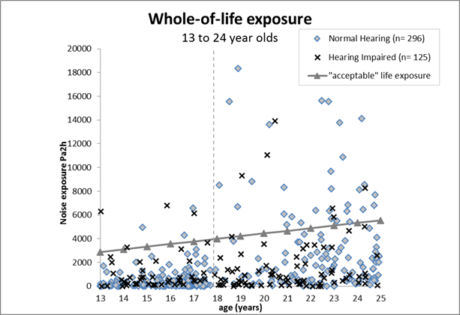
Figure 1 Estimated whole-of-life noise exposure, HI vs. NH young adults.

Notes
- “Acceptable” life exposure = 222.2 Pa2h x number of life years. Any contribution of hearing aid amplification was not included in this estimation.
- Two extreme outliers have been omitted from this figure, both from the NH group i) 24.8 years, exposure 64885 Pa2h and ii) 24.5 years, exposure 33055 Pa2h. Reproduced from Carter et al. (in press Figure 6).

HTL shift
As regards the incidence of HTL shift among participants with HI (research aim 2), HTL shift was observed in almost 50% of a selected group of HI group participants (i.e., individuals with no apparent risk factors for progressive hearing loss, apart from noise exposure). In terms of the relationships between HTL shift, leisure-noise exposure and other relevant factors, among participants with HI (research aim 4) no relationship was found between HTL shift and whole-of-life noise exposure, however, as noted above, the noise exposures of the HI group were relatively conservative. Survival analysis illustrated that high frequency HTL shift was more frequent, and occurred earlier, when high frequency hearing loss was ≥ 70 dB at the baseline test (i.e., at age approximately 5 years). Median high frequency HTL shifts at 15 years after baseline were in the magnitude of 5 - 10 dB. At the 90th percentile shifts reached 25 – 30 dB.

Parent attitudes
When comparing the attitudes and beliefs of parents of adolescent participants (HI and NH) about the risks of leisure-noise exposure (research aim 5) most parents of adolescent participants (HI and NH groups) perceived leisure noise as a significant health risk to young people in general, but few perceived their own child to be at high risk. Differences in how comfortable parents felt with their child taking part in several specific leisure activities were observed but concerns were not entirely noise-risk related. For instance, HI parents were significantly more concerned about their child’s (hypothetical) participation in swimming and water sports and contact sports which do not involve the risk of noise-injury.
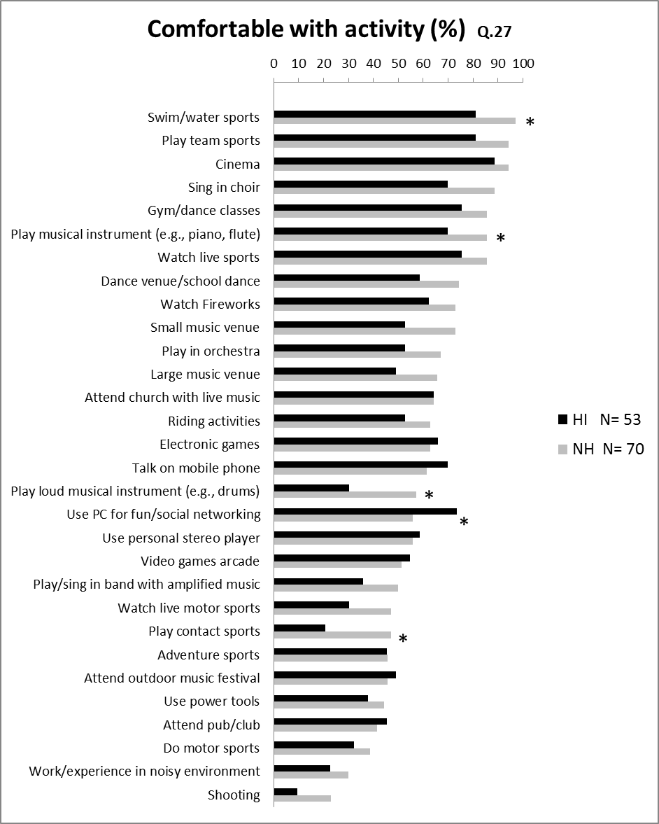
Figure 2 Activities parents comfortable endorsing
Notes Percentage = of group.
* Chi-squared test, statistically significant difference (p= < 0.05). Reproduced from Carter et al. (Carter, et al., early online Figure 4).

Participant attitudes to leisure noise
Young adult participants in both groups perceived leisure-noise exposure as a risk to hearing health, but perceived their own risk of hearing injury to be lower than that of their peers. Of seven questions probing young adults’ attitudes to leisure-noise risk, statistically significant differences between the HI and NH groups were only observed for two items. Firstly, the likelihood of one’s own hearing changing in future, and secondly the risk of leisure-noise exposure causing hearing damage to people of one’s own age. Just over one third of the HI young adult group expected no future change in their hearing compared with just under one in ten of the NH group. Approximately half the HI group perceived their peer group to be at risk from leisure noise (as did the participant quoted above), compared with 70% of the NH group.
Consistent with the findings of previous research, PHP use was low among HI and NH participants. Hearing aid use during noisy activities was frequently reported by participants with HI, as illustrated in Figure 3.
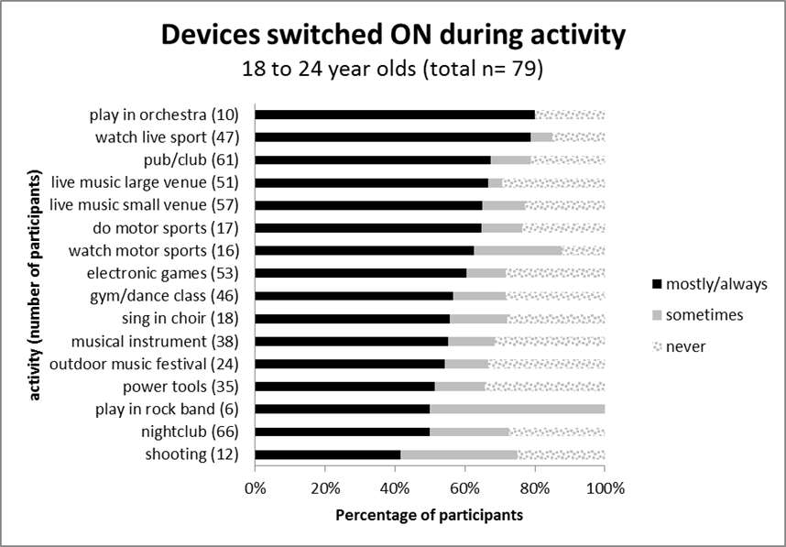
Figure 3 Hearing aid use during leisure activities. Reproduced from Carter (unpublished dissertation, Figure 7.3).

Conclusions
Only a relatively small proportion of adolescents (HI and NH), and young adults with HI, were shown to have leisure-noise exposure in excess of an acceptable risk criterion. As a consequence, determining the dose-response relationship between noise and shift in quantitative terms was unviable with the current dataset and the primary research hypothesis could not be fully addressed. The second hypothesis, that young people with HI would have lower whole-of-life noise exposure than their peers with NH was confirmed for young adult participants. No association between HTL shift and whole-of-life noise exposure for participants with HI was observed, as may be expected given the conservative noise exposure of the cohort studied in this research. Nonetheless, almost half the participants with HI (who had no particular risk factors for hearing deterioration) had experienced HTL shift prior to participation. The median high frequency HTL shifts observed were small.
With respect to the aim of preventing further hearing loss, the lower whole-of-life exposure of young people with HI may be regarded as a positive finding. However, lower noise exposure was related to less frequent participation in a number of social activities. Based on the quantitative findings and comments made by a number of participants with HI, it seems probable that some degree of disadvantage in quality-of-life (QoL) terms may be associated with restricted participation. For example, one young adult commented
“Always found it difficult socially to make friends and follow conversation because of my hearing loss. Sometimes I would not go to school or go out with friends because I had bad hearing or tinnitus….”
It was evident that participants with HI avoid some leisure situations for reasons other than concern about noise-injury risk most commonly, because of difficulty in hearing conversation. Hearing access in social environments appears to be a greater barrier to participation for young people with HI than fear of noise-injury. Therapeutic approaches, audiological, educational or psychosocial, must address the participation of young people with HI, not only to minimize the risk of noise-related HTL shift, but also to ensure the best possible outcomes in QoL terms. The findings of this research also highlight the need for more comprehensive support for parents of children with HI, to assist them in overcoming children’s barriers to participation in everyday life that arise from early hearing loss.

Recommendations
As the Australian hearing health care system continues to evolve, more systematic surveillance of HTL shift in people with early HI is needed, in order to further increase our understanding of the long-term prognosis of early-onset hearing loss and the likely impact of noise exposure over the longer term. There is also a clear need for professional support of young people with HI (and their parents) in addressing the psychosocial impacts of early hearing impairment, particularly as young people transition from adolescence to young adulthood. This research has also highlighted the need for development of assistive technology in particular, exploring the capacity for active hearing aids to provide hearing protection while still allowing reception of speech. Finally, strategies (including legislation) to reduce leisure-noise in public environments would decrease the risk of noise-injury both for young people with HI and the general population. Reduction of leisure-noise in mainstream society would also reduce the barriers to social interaction for all communication partners regardless of their age or hearing status.

Dissemination of Findings
The following publications had been completed at the time this report was prepared. It is anticipated that further publications will arise from the data collected in this research.

Published Papers
Carter L., Williams W., Black D. and Bundy A. (2014). The leisure-noise dilemma hearing loss or hearsay? What does the literature tell us? Ear and Hearing 35(5) 491-505. doi10.1097/01.aud.0000451498.92871.20
Carter, L., Black, D., Bundy, A., & Williams, W. (early online). Parent perceptions of children's leisure and the risk of damaging noise exposure. Deafness Education International.
Carter, L., Black, D., Bundy, A., & Williams, W. (in press). An estimation of the whole-of-life noise exposure of adolescent and young adult Australians with hearing impairment. Journal of the American Academy of Audiology.

Submitted Papers
Carter, L., & Black, D. (in review). Hearing threshold shifts among 11 - 35 year olds with early hearing impairment. Ear and Hearing.

Related Publications
Williams, W., Carter, L., Seeto, M. (2015). Hearing loss and leisure noise How significant is exposure to leisure noise when considering changes in population hearing threshold levels? Noise Health 17, 78 358-363.
Williams W., Carter L. and Seeto M. (2014). Hearing thresholds for a population of 11 to 35 year old Australian females and males. International Journal of Audiology 53(5)289-93. doi10.3109/14992027.2013.873957.
Carter L. (2011). Prevalence of Hearing Loss and its relationship to Leisure Sound Exposure. Report prepared for the Office of Hearing Services, Department of Health and Ageing. http//www.nal.gov.au

References
Australian Hearing. (2015). Demographic Details of young Australians aged less than 26 years with a hearing impairment, who have been fitted with a hearing aid or cochlear implant at 31 December 2014. Retrieved from http//www.hearing.com.au Downloaded 5/3/2016.
Blanton, H., Köblitz, A, McCaul, KD. (2008). Misperceptions about Norm Misperceptions Descriptive, Injunctive, and Affective ‘Social Norming’ Efforts to Change Health Behaviors. Social and Personal Psychology Compass, 2(3), 1379-1399.
Carter, L. (2011). Prevalence of hearing loss and its relationship to leisure-sound exposure. Retrieved from http//www.nal.gov.au.
Carter, L., & Black, D. (in review). Hearing threshold shifts among 11 - 35 year olds with early hearing impairment. Ear Hear.
Carter, L., Black, D., Bundy, A., & Williams, W. (early online). Parent perceptions of children's leisure and the risk of damaging noise exposure. Deafness Educ Int.
Carter, L., Black, D., Bundy, A., & Williams, W. (in press). An estimation of the whole-of-life noise exposure of adolescent and young adult Australians with hearing impairment. J Am Acad Audiol.
Carter, L., Williams, W., Black, D., & Bundy, A. (2014). The leisure-noise dilemma hearing loss or hearsay? What does the literature tell us? Ear Hear, 35(5), 491-505.
Carter, L., Williams, W., & Seeto, M. (2015). TE and DP otoacoustic emission data from an Australian cross-sectional hearing study. Int J Audiol, 54(11), 806-817.
Ching, T. Y., Johnson, E. E., Seeto, M., & Macrae, J. H. (2013). Hearing-aid safety a comparison of estimated threshold shifts for gains recommended by NAL-NL2 and DSL m[i/o] prescriptions for children. Int J Audiol, 52 Suppl 2, S39-45.
Gilliver, M., Beach, E. F., & Williams, W. (2013). Noise with attitude Influences on young people's decisions to protect their hearing. Int J Audiol, 52 Suppl 1, S26-32.
Hidecker, M. J. C. (2008). Noise-Induced Hearing Loss in School-Age Children What do we know? Semin Hear, 29(1), 19-28.
ISO. (1990). ISO 1999 Acoustics - Determination of occupational noise exposure and estimation of noise-induced hearing impairment. Second edition. Geneva International Organization for Standardization.
ISO. (2000). ISO 7029 Acoustics - Statistical distribution of hearing thresholds as a function of age, Second edition (pp. 1 - 9). Geneva, Switzerland ISO.
Kopecky, B., & Fritzsch, B. (2011). Regeneration of Hair Cells Making Sense of All the Noise. Pharmaceuticals (Basel), 4(6), 848-879.
Macrae, J. H. (1991). Permanent threshold shift associated with overamplification by hearing aids. J Speech Hear Res, 34(2), 403-414.
Macrae, J. H. (1994). Prediction of asymptotic threshold shift caused by hearing aid use. J Speech Hear Res, 37(6), 1450-1458.
Rosenstock, I. M., Strecher, V. J., & Becker, M. H. (1988). Social Learning Theory and the Health Belief Model Health Educ Behav 15, 175-183.
Smith, P. A., Davis, A., Ferguson, M., & Lutman, M. E. (2000). The prevalence and type of social noise exposure in young adults in England. Noise Health, 2(6), 41-56.
Williams, W. (2008). Life-time leisure noise exposure - is it time to look at the bigger picture? . Acoust Aust, 36, 64-65.
Williams, W., Burgess, M. (2009). The combination of workplace and leisure noise exposure. Acoustics Bulletin, 34(2), 30-33.
Williams, W., Carter, L., & Seeto, M. (2014). Hearing threshold levels for a population of 11 to 35 year old Australian females and males. Int J Audiol, 53(5), 289-293.
Williams, W., Carter, L., & Seeto, M. (2015). Pure tone hearing thresholds and leisure noise Is there a relationship? Noise Health, 17(78), 358-363.

Appendices

